**Name________________________________________________Period_______Date______________**

**Chapter 5-The Structure of Matter and Bonding**

**Guided Notes**

**I-Molecules and Compounds**

* A ____________________ is a substance made of ___________________________________ that are chemically combined by __________________________
* __________________are made of different substance that are just placed together, each substance in the mixture ______________________________________________

What is a chemical Bond?

* An ________________ between the ________________________________ ____ of different ___________________ that binds them together
* Bonds form in order to
  + ________________________________________
  + ________________________________________

Stability

* Most atoms form bonds in order to form ______________________________________
* ____________________________
* Like the _________________________
  + Stability is the driving force behind __________________________________

Becoming Stable

* All neutrons want to be stable like a noble gas
* They either _____________________________________________________
  + ___________________; _______________charged
  + ____________________: __________________charged
* CATIONS: they have more ______________charge than ________________, they __________ electrons
* ANION: they have more _______________charge than ___________________they __________ electrons



**II: Ionic and Covalent Bonding**

**Covalent Bonds**

* ______________________________________________________
* Bonds form by the _______________________________ electrons



**Ionic Bonds**

* ______________________________________________________
* Bonds form by the _______________________________ of electrons

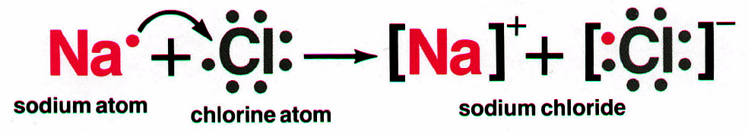

Review cations + anions

* What is the charge of Na____________________
* What is the charge of Cl_____________________
* The final compound must be ___________________________________
* Na+1 + Cl-1 = _____________________________
  + It takes __________________________ to balance ______________________________
* Cs+1 + O-2=________________________________
  + It takes _____________________________ to balance the ____________________
  + We use the ________________ to depict how many atoms of each _______________ must be used for this compound

The criss-cross method

* Write an addition problem with the charges included with your element
* Switch the superscripts to make new subscripts

Practice:

Different ions

* Not all ions are ____________________________________
* Some are made of more than __________________________________(____________________)

**Naming ionic compounds**

* Steps
  + Write the name of the _______________________________, just the way it is
  + Write the name of the _______________________________, change the _____________ _____________________
    - Nitrogen=___________________
    - Oxygen=______________________
    - Chlorine=_____________________
    - Carbon_________________________
* Name the following compounds:
  + MgCl
  + CaO
  + CaBr2
  + SrF2
* Give the compound formulas for the following compounds:
  + Potassium Iodide
  + Aluminum sulfide
  + Sodium chloride
  + Magnesium nitride

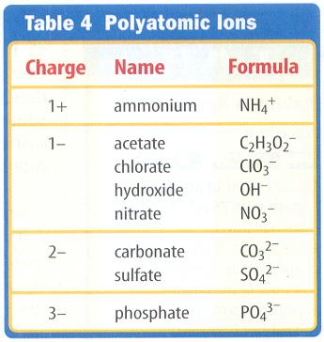

Naming compounds with Polyatomic Ions

* Write the name of the ________________________________, just the way it is
* Isolate the polyatomic anion-____________________________________________
* Write the name of the polyatomic ion, ____________________________

Name the following compounds:

* Ca(OH)2
* Na2(CO3)
* Na(C2H3O2)
* Ca(SO4)
* Na(NO3)
* Na (ClO3)
* Mg3(PO4)2
* Mg(OH)2

Stock System of Nomenclature

* Some ______________________________ carry more than ___________
  + Ex:________________________________________
* Depicted with _____________________
  + Ex:__________________________________________
  + Ex:__________________________________________
* Some metals always have a definite charge
  + Ex:________________________________________
* Transition metals charge can ________, so it is always written in the formula:
  + Ex: Copper (II) Chloride

Name the following Compounds or give formulas:

* CuBr2
* FeS
* Fe2O3
* Copper (II) Oxide
* Tin (IV) Iodide
* Iron (II) Chloride

More Practice:

* K2O
* Ca(OH)2
* Na(NO3)
* KClO3
* NaI
* CaCl2
* K2S
* Ca3(PO4)2

**Covalent Bonds**

* Compounds that are made of _____________________________________
* Bonds that are formed by _____________________________________________



* Electrons are shared from the _____________________, still want it ___________
* But electrons are not always shared __________________
  + When two chlorine atoms bond, they are ______________________ to the positive nucleus of each atom=___________________________________covalent bond
  + When not shared equally= __________________________covalent bond

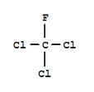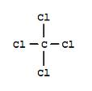

* Can share more than _____________ of electrons
  + _________________________shares _________ pair of electrons
  + ________________________shares ________pair of electrons
  + ________________________shares __________ pair of electrons

**Naming Covalent Compounds**

* Different rules than ionic compounds
* _________________ are only used for the first atom if it is more than _______________
* Second element is named using a ________________ to indicate how many
* Second element’s name ending chaned to _____________________
* The _____________ at the end of a prefix is _________________ when used in the name, followed by a vowel
* Two nonmetal atoms form a covalent bond because they have ___________________ after they bonding

Diatomic Molecules:

* _________________ that exist as diatomic (come in 2)
* Are ______________________________________________________________________

Use the name of the element to name the following diatomic molecules

* H2=___________________________________________
* N2=_____________________________
* Cl2=_____________________________
* O2=_____________________________
* I2=______________________________

Naming Binary Covalent Compounds

* Two ________________________________
  + _________________________
  + End the last element in ______________
  + Add prefixes to show more than one (don’t use _____________ on _____ element, but on all others)
* Prefixes
  + Mon=___________________
  + Di=_________________
  + Tri=___________________
  + Tetra=___________________
  + Penta=___________________
  + Hexa=_____________________­
* Practice:
  + CO=____________________________
  + CO2=___________________________
  + PCl3=___________________________
  + CCl4=___________________________________________
  + N2O=_____________________________
* P2O5=___________________________________________________
* Cl2O7=_________________________________
* Cl2=___________________________________

More examples!!!!

* SO3=__________________________________________
* ICl3=__________________________________________
* PBr5=_________________________________________

AND MORE!

* CI4=___________________________________
* PCl3=__________________________________
* N2O3=_________________________________
* P2O3=_________________________________
* CSe2=_________________________________
* S2Cl2=_________________________________

Now backwards!

* Phosphorous pentabromide=_____________________________
* Sulfur trioxide=__________________________________________
* Trinitrogen pentachloride=________________________________

**Naming Acids (Honors Only)**

* Acid: Compounds that form ______________in water
* Formula usually begins with ________________
* Examples: __________________________________

|  |  |
| --- | --- |
| **Anion ending** | **Acid Name** |
|  | -(stem)- |
|  | (stem)- |
|  | (stem) |

* Practice
* HBr __________________________________
* H2CO3________________________________
* H2SO3________________________________
* Hydrofluoric acid: _____________
* Sulfuric Acid: _________________
* Nitrous Acid: _________________

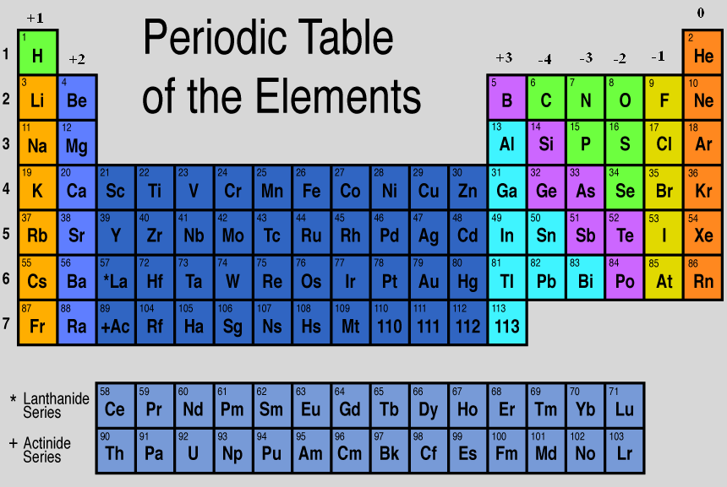**Periodic Table Charges**