Name____________________________________Period____Date_____________

Acids & Bases Review

Part I: Vocab/Theory

Match the following definitions to the words on the right

- This type of substance usually has OH at the end of its formula
- When this is reached during titration, there is equal amount of acid as base
- This is how bases taste
- This is how bases feel
- This is how acids taste
- This is what color bases turn all colors of litmus paper
- This is what color acids turn all colors of litmus paper
- An acid has a pH of
- A base has a pH of
- A neutral substance has a pH of
- This process allows you to find the concentration of an unknown solution
- This is something that changes color in acids or bases
- An acid is known as a proton
- A base is known as a proton
- This type of substance usually has an H at the beginning of its chemical formula

- Acid
- Base
- Sour
- Bitter
- Slippery
- Red
- Blue
- Equivalence point
- Titration
- Donor
- Acceptor
- Below 7
- Above 7
- 7
- indicator

Answer the following questions:

- What are the three definitions for acids?

- What are the three definitions for a base?

- What is the difference between strong and weak?

- Label the following as weak acid, strong acid, weak base, or strong base

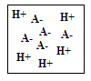
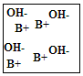
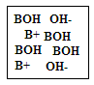
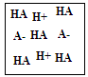

- Can something be weak and concentrated? Explain your answer?

- Can something be strong and dilute? Explain your answer?

- What is pH?

- What are always the reactants of a neutralization reaction?

- What are always the products of a neutralization reaction?

- Will the following be acidic, basic, or neutral when reacted:
  - Strong Acid + Strong Base: _________________________
  - Strong Acid + Weak Base: __________________________
  - Weak Acid + Strong Base: __________________________

- Label the following as: strong base + strong acid, weak acid + strong base, strong acid + weak base.
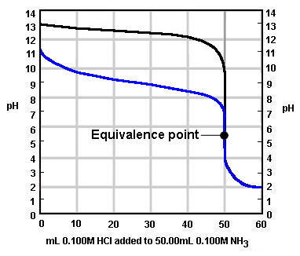
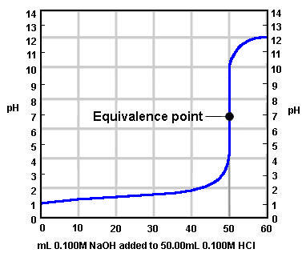
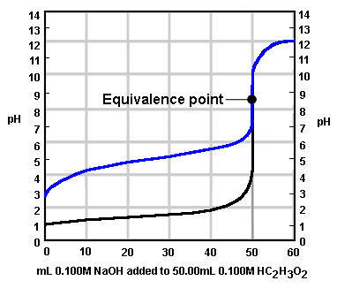

- How does soap work?

- What is ammonia found in?

- Why shouldn’t you use shampoo or other products that are too acidic on your face or skin?

- How do antacids work?

Part II: pH Calculations
- Which is the most acidic: 1,4,8,10

- Which is the most basic: 1, 4, 8, 10

- How much more acid is a pH of 3 than 6?

- How much more basic is a pH of 10 than 9?

- What is the pH of something with an H⁺ concentration of 0.0000001 M

- What is the pH of something with an H⁺ concentration of 0.001 M

- What is the pH of something with an H⁺ concentration of 1.0 M

- What is the pH of something with an H⁺ concentration of 1.0 x 10⁻⁵ M

- What is the pH of something with an H⁺ concentration of 1.0 x 10⁻⁸

- What is the pH of something if the solution is made with 0.00004 moles and 4 L of solution

- What is the pH of something if the solution is made with 0.001 moles and .1 L of solution

- What is the pH of something if the solution is made with 0.006 moles and .06 L of solution

- Find the H⁺ concentration of a solution with pH of 10

- Find the H⁺ concentration of a solution with pH of 4

- Find the H⁺ concentration of a solution with pH of0

Neutralization

- True or False: Neutralization always means pH 7?

- Predict the products:
  - HNO₃ + K(OH) → ___________________________
  - HCl + Na(OH) → ____________________________
  - HBr + Li(OH) → ____________________________
  - H₂SO₄ + Mg(OH)₂ → _________________________

