**Activity Series**

**Most**

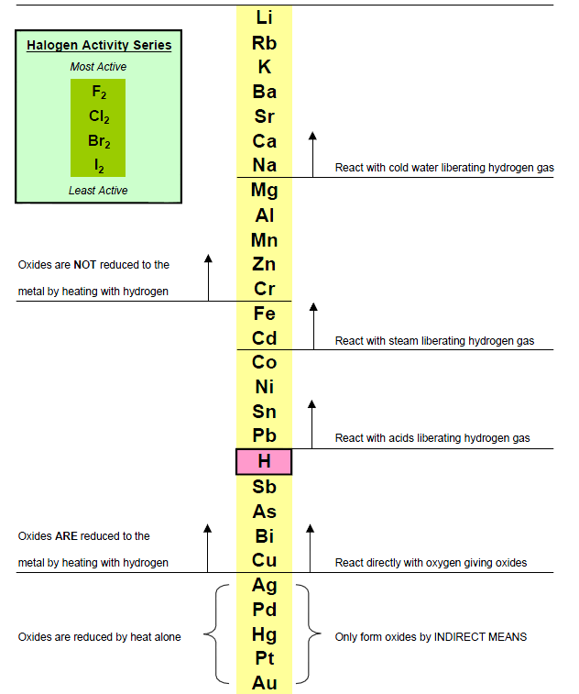

**Least**