Name_________________________________________Period________Date_____________

Geology Lab/Activity #1: Topographic Maps
Building a Topographic Map from Cardboard
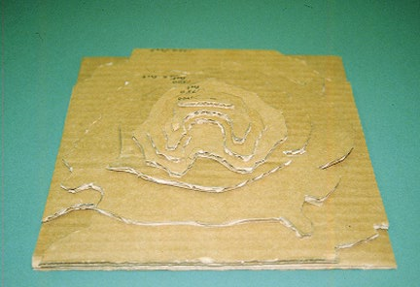

Background Info: Topographic maps are available for all volcanoes in the United States. They can be ordered from the U.S. Geological Survey. Many local bookstores and outdoor recreation stores also sell topographic maps. Today we will be constructing a topographic map of the volcano Mount St. Helens. See Ms. Price for a detailed topographic map. I am providing you with a simplified version of the topographic map showing the area after 1980 (after the big eruption).

Objective: Construct a topographic map out of cardboard of Mount. Saint Helens

Materials:

- Handout of Topographic Map
- Cardboard
- Scissors
- Glue sticks
- Markers

Procedure:

- Get a handout of the simplified topographic map. This photo shows the original topographic map with specific contours lines (lines of equal elevation) highlighted. The highlighted lines will serve as a simplified topographic map.

- The number of layers (pieces of cardboard) to your volcano depends on the scale (contour interval) of your map and the amount of time you wish to invest in making your model.

Your map has a contour interval of:___________________
(subtract two layers 1250-1000= ? )

Number of Layers your model will need:_____________________
(# of different elevations)

- Cutting the Layers-

Use the handout as a guide to cut out the layers. Start with the lowest elevation, which should be the largest piece. Then cut to the next elevation. Repeat for each layer.
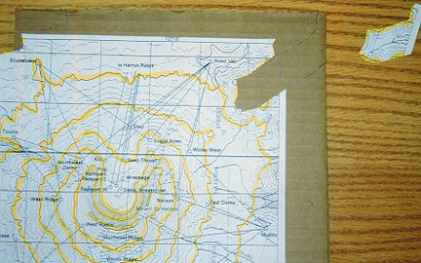

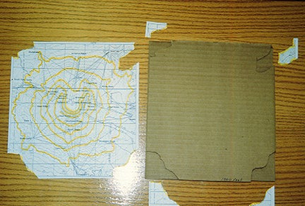
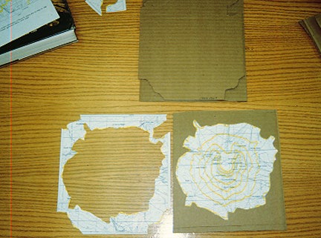

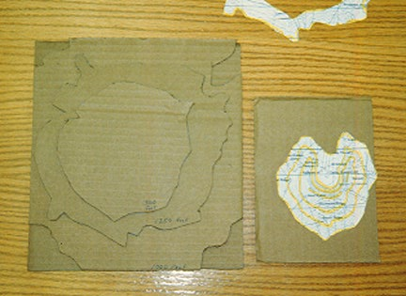

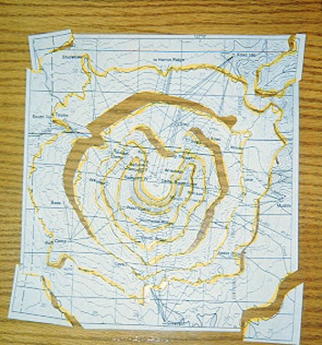
By the time you are done you will cut out a pattern for each elevation, trace it on the cardboard, cut it out and stack it. You'll be tired of cutting out cardboard!

- Making the map: Stack the layers in order of descending elevation.

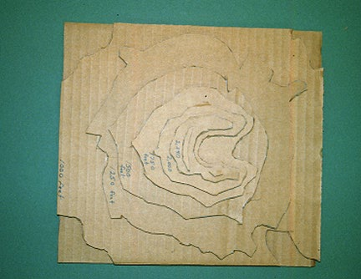

Glue the layers in the appropriate (descending elevation) order. Label the elevation of each layer. Color each layer a different color with markers.

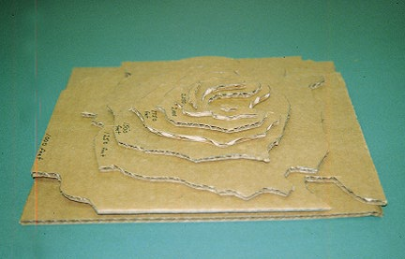
Questions:

- On the actual topographic map, notice the crater and the major river valleys cut into the volcano. Compare your model to actual photos of Mount St. Helens. Compare your 3-D map to the original simplified topographic map.

- What is the scale of the actual detailed topographic map?

- Using the chart below, how many feet does the one inch of the scale correspond to?

Scale | 1 Inch Represents
1:24,000 | 2000 feet
1:20,000 | 1667 feet
1: 62,500 | 1 mile

- What is the difference in elevation between the second and fourth layers of your model.

- Define contour line

- Define contour interval

