Name________________________________________________Period_______Date_____________

Geology Guided Notes
Unit 4: Volcanoes and other Igneous Activity

Text Reference: Ch 10-pg 279-299
Origin of Magma
- When solid rock located in the _____________________________________, partially melts
- Can form because of heat, pressure, or water
- Role of Heat:
  - ________________________________: the change in temperature with depth
- Role of Pressure: Pressure _____________________ with depth
- Role of Water: Water causes rock to melt at ____________________ temperatures
- Magma forms _________ ways
  - When heat is __________________when a magma body from a ____________ source intrudes and _______________rock in the ______________
  - A ____________________ in pressure (________________the addition of ________) can result in ____________________________________ melting
  - Water can _________________ the melting temperature of _______________rock to form magma
Factors Affecting Eruption
- Three factors:____________________________________________________________ ________________________________________________________________________
- These factors actually control the _____________of a given magma
- Viscosity
  - A substance’s ________________________________________
  - More viscous=_____________________________________
  - Less viscous=_______________________________________
  - The _____________ the temperature, the __________ it flows _______viscous
  - High _______________ in magma=_____________viscosity (______________lava)
  - Low silica in magma=____________viscosity (___________________lava)
- Dissolved Gases
  - Mostly ________________________________________________
  - Gases ___________________ near the surfaces
  - A _______________is an opening in the surface of the Earth through with ______________________________________________ are released
  - Gases trapped in magma provide the ___________to eject molten rock from vents
- Violence of an eruption is related to how easily gases ___________ from magma
  - Easily escape from ____________________________________________
  - Highly viscous magma produces ______________________________________
- Magma Composition
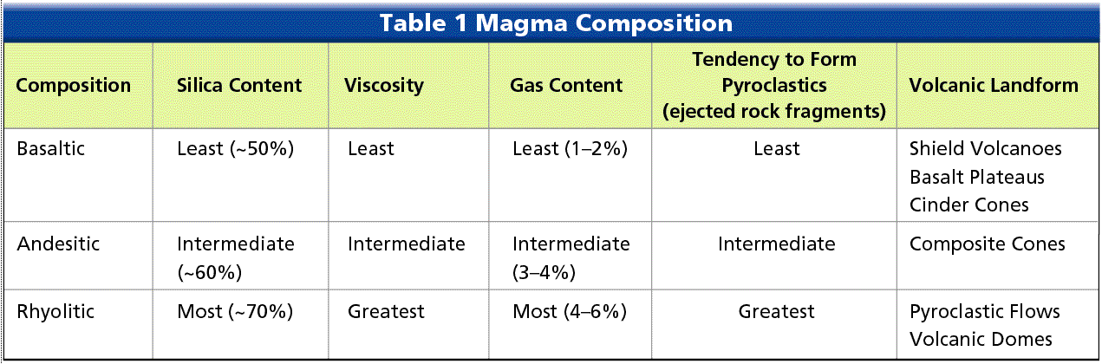
- ______________lava=mild eruptions
- _________________________________lavas=explosive eruptions
Volcanic Material
- _________________________________
  - ______________________lavas are more fluid, _________silica content
  - ____________________________lavas are less fluid, ________ silica content
- Types of Lava
  - ________________________lava (resembles braids in ropes
  - ____________(rough jagged blacks)
- Gases
  - Gas portion of most magmas is about ___________of total weight
  - Usually in the form of ______________________________________
  - Composition of gases is important because they have contributed to the gases in ___________________________________
- _____________________materials-“___________________________________”
- Types of pyroclastic debris
  - ______________________-_______________________________________
  - __________________________-___________________________________
  - _____________________________-_________________________________
  - _____________________________-________________________________
  - Particles larger than lapilli
    - _________________________:____________________________
    - _______________:_________________________________________
Features of Volcanoes
- Opening at the summit of a volcano
  - ______________________: summit depression ___________in diameter
  - _________________: summit depression ______in diameter
- ________________: surface opening connected to the magma chamber
- _______________________: emit only _________________________________
Types of Volcanoes
- ___________________ Volcano
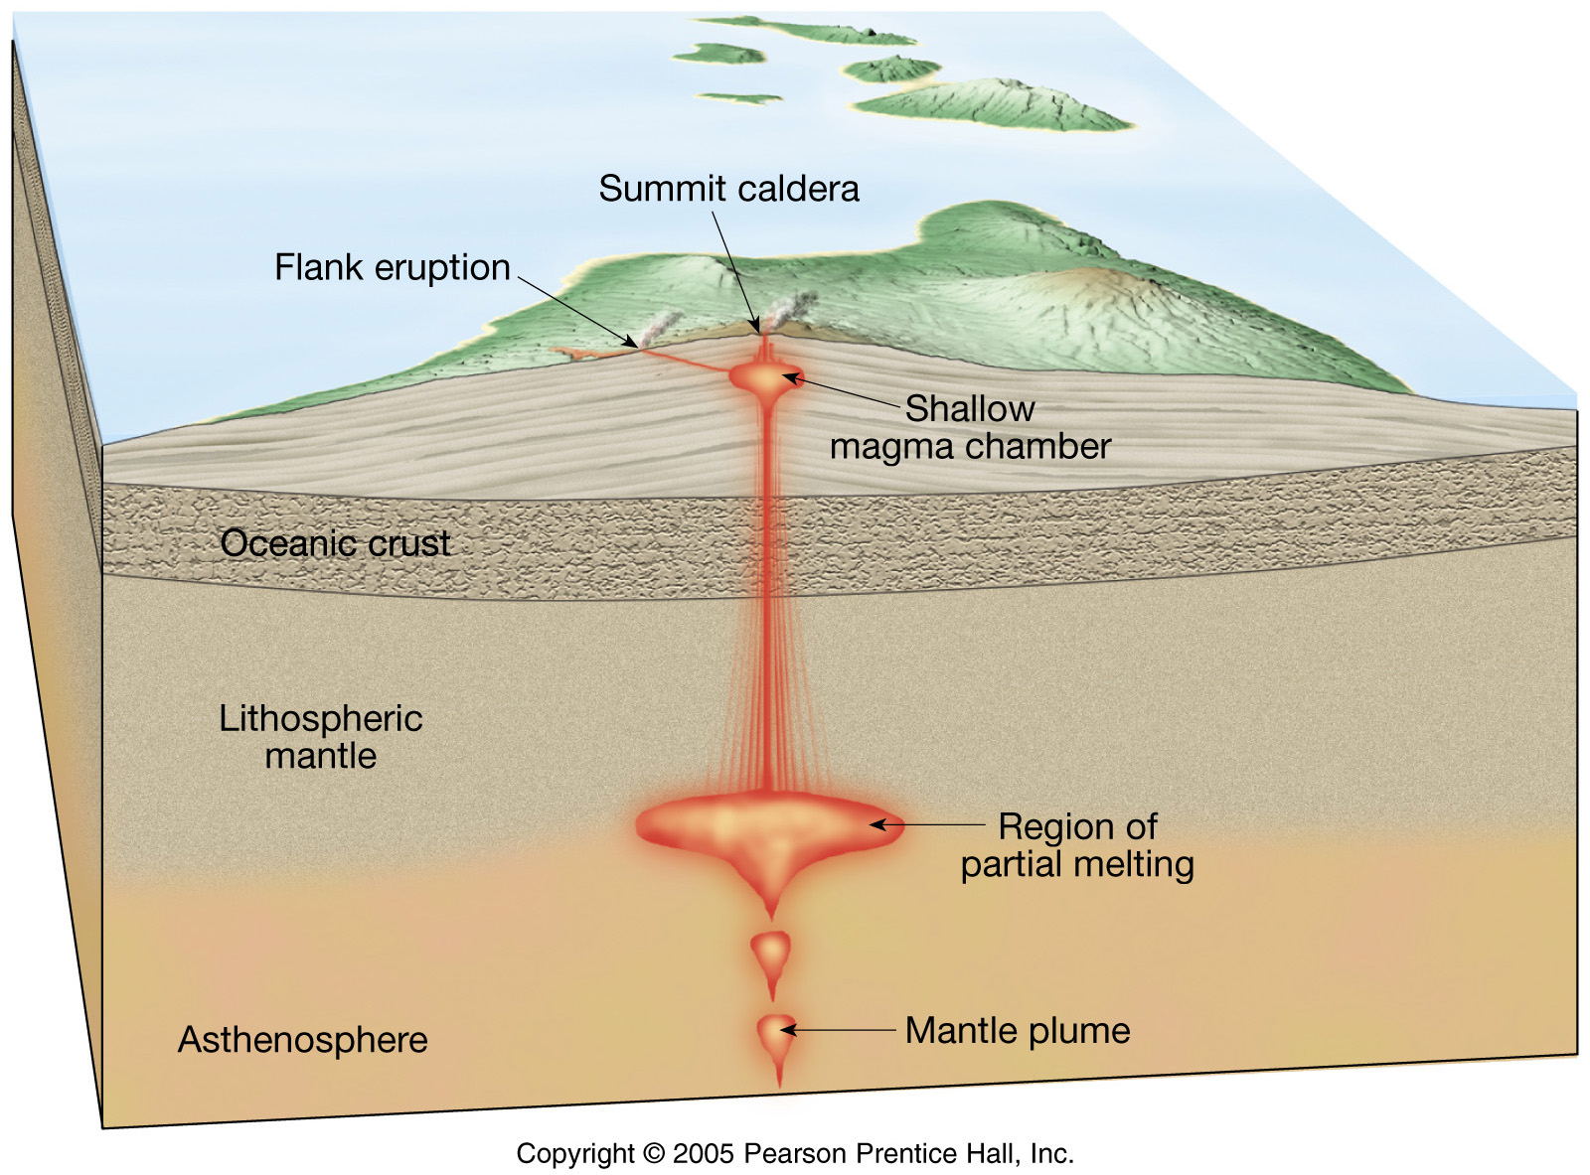
  - ________________________________-shaped
  - Generally cover _________________areas
  - Produced by _____________ eruptions of large volumes of _________________ lava
  - Have ________________________openings
  - Example: Mauna Loa on Hawaii

- ____________________________________
  - Built from ejected lava (mainly cinder-sized) fragments
  - _________________slope angle
  - _____________size
  - Frequently occur in ____________________
  - Only active for _____________ period of time (weeks-few years)
  - Pyroclastic material: __________________________________
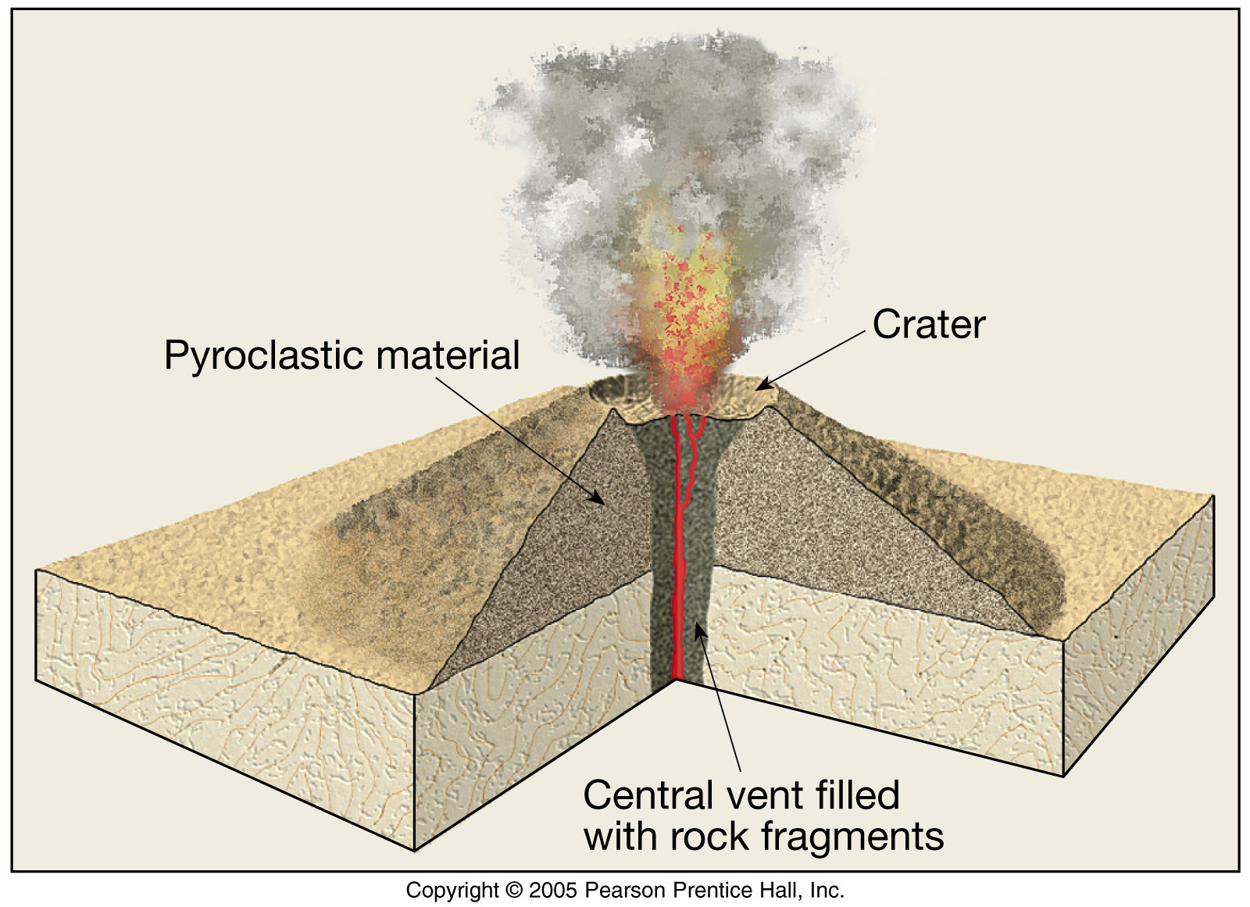
  - ________________________magma

- _____________________________________ (________________________________)
  - Most are located adjacent to the __________________ ocean (e.g. Fujiyama, Mt. St. Helens)
  - _________________, classic-shaped volcanoes (1000s of ft. high and several miles wide at base)
  - Composed of __________________________________________________________ _____________________________________________________________________
  - Most _______________type of activity
  - Magma mostly __________________________________
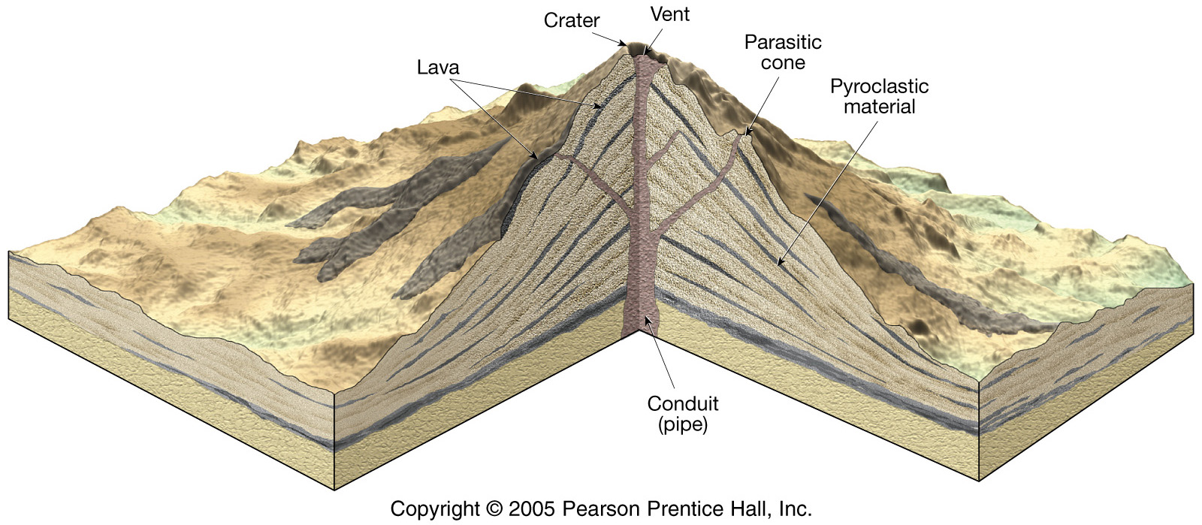

Volcanoes in the US
- Cascade Volcanoes
  - There are ________ potentially active volcanoes in the Cascade Range of the Northwestern United States
- Mt. Saint Helens
  - Big eruption in ______________
  - A _______________________________________reduced lateral and vertical confinement, triggering the eruption
  - Ashfalls from the eruption covered most of the country, even parts of NM (but not Bloomfield)
  - The eruption shot volcanic ash to an altitude of _________________feet
Volcano Features
- ____________________________-a deadly _________________________flow
  - Fiery pyroclastic flow made of hot ___________infused with _____________ and other __________________
  - Also known as glowing avalanches
  - Move down slopes of a volcano at speed up to _____________ per hour
- ________________________-volcanic _______________________
  - Mixture of _____________________________and ____________________
  - Move down ___________________________________, often with destructive results
Other volcanic landforms
- ________________________________________________________________
  - Fluid _________________ lava extrude from __________________fractures called _________________________
  - Example: Columbia River Plateau
- ___________________________
  - Bulbous mass of congealed lava
  - Associated with _____________________eruptions of ________-rich magma
Intrusive Igneous Activity
- As magma _________________________, it will begin to ____________ within the Earth’s crust
- Once ___________________________________, these masses of _______________igneous rocks are referred to as ____________________________________
- We will talk about several types of igneous plutons
- Nature of plutons
  - Shape-_________________________________________________
  - Orientation with respect to host (________________________________)_________
    - Concordant vs discordant
- Types of Intrusive igneous features
  - ____________: a relatively _____________igneous intrusion formed as mamga _________________________ rock fractures and solidifies into _________________ ________________________
  - ______________: ________________, like dikes, but they tend to be much _____________, and form as magma intrudes in between layers of _______________ rock, then cools. ________________________________________________________
  - _________________: begins as a ______________, since material fills in between rock layers
    - Because of ______________________, some sills can _____________ the overlying sediments, creating a _____________________shaped rock body
    - Tend to form at ___________________________________
  - _______________________
    - ___________plutons ______________ a specific ______________
    - Form as huge quantities of magma intrude into country rock, ____________ ___________, and ___________their way towards the ________________
    - Most remains_________________________________
    - Largest batholiths can be over ________________________________
- _________________
  - Short conduit(connections) that connect a ________________________________ to the ________________________
- _______________________________(e.g. _______________________________)
  - Resistant vents left standing after ________________has removed the ____________________________________________
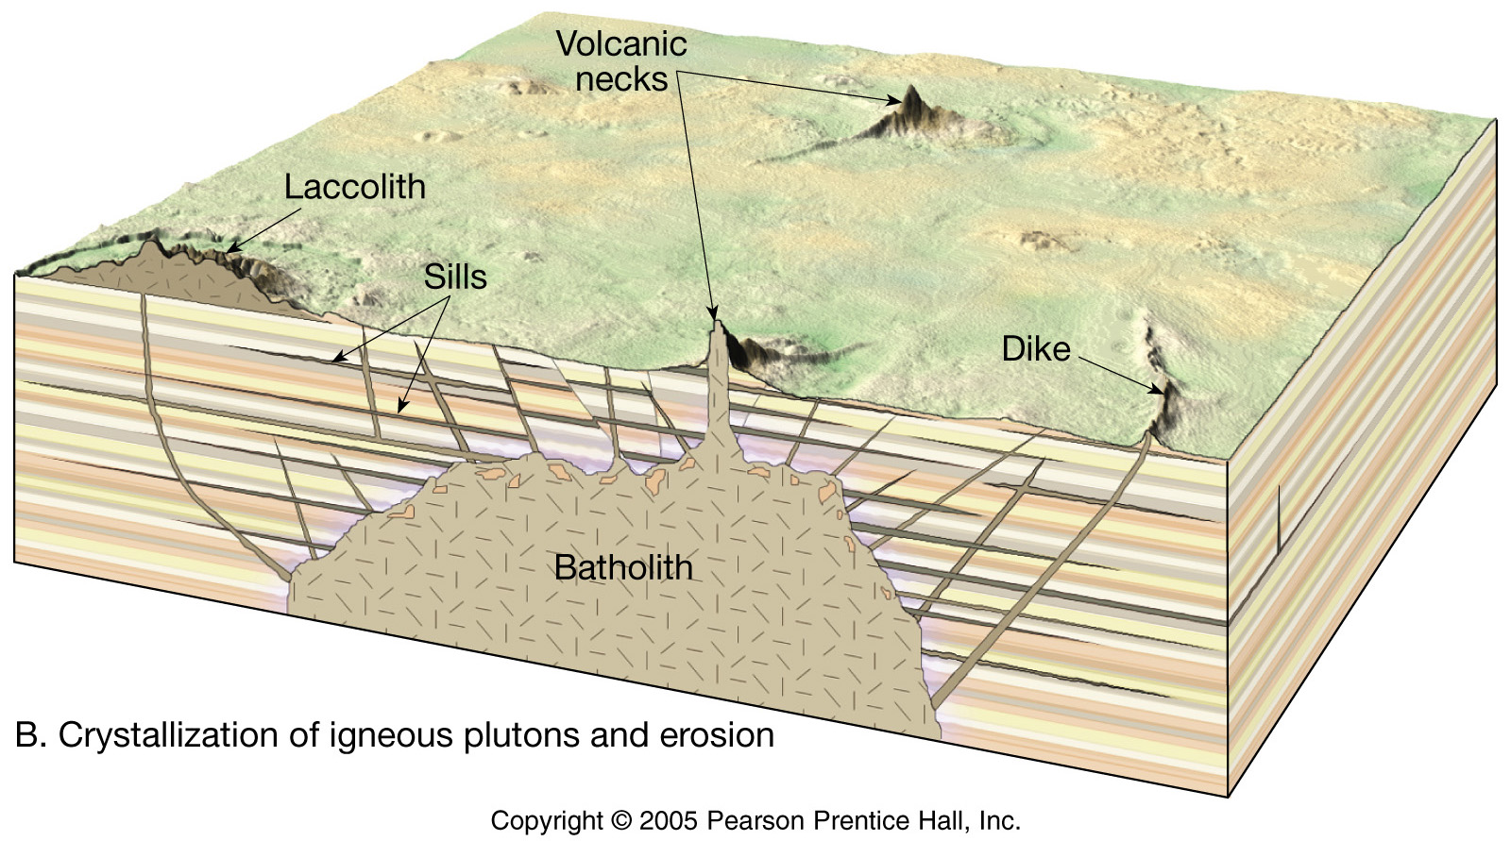

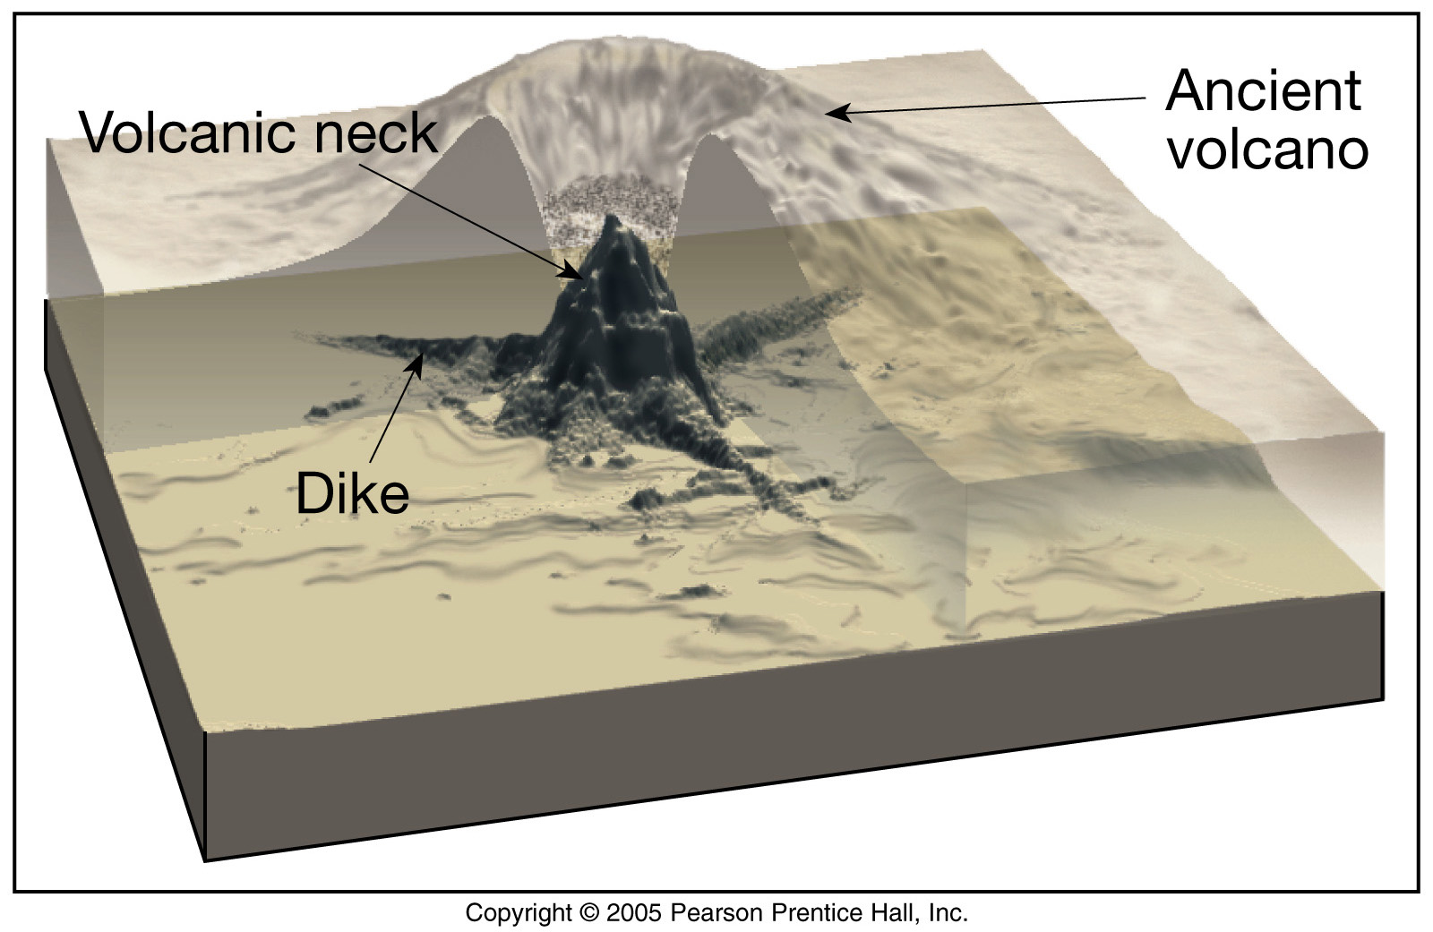

Volcanoes & Plate Tectonics
- Most volcanoes occur in a region known as the ____________________________________
- Volcanoes can form at ___________________________________________plate boundaries
- Volcanoes can also occur ________________a plate which can result in _________________ and form island chains like _______________________________________________
Volcanoes & Climate
Take your own notes below:

