Name______________________________________________Period______Date___________
Geology Unit 8 Notes: Deformation of the Earth’s Crust
Folds, Faults, Mountain Building

Text Reference: Ch 11 pg 307-325
11. 1 Rock Deformation
- Factors that influence the strength of a rock and how it will deform include: ________________________________________________________________________
- Deformation: a general term that refers to all changes in the _______________________ and/or ____________ of a rock body
  - Most _____________________occurs along ____________margins
- Stress: is the ________________ per unit _______________ acting on a solid
- Strain: is the change in __________________________ of a body of rock as a result of _________________
- Temperature and Pressure
  - Rocks deform permanently in two ways __________________________________ ____________________________
  - Brittle deformation: the ______________of an object once its strength is exceeded
  - Ductile deformation: a type of ______________________________ that produces a change in the ___________________________ of an object without ____________________________ the object
- Rock Type
  - Mineral __________________________________ of a rock also greatly affect how it will deform
  - Rocks like ________________________ usually fail by __________ deformation
  - ___________________ rocks loosely cemented or _________________________ rocks with foliation usually fail by ______________________ deformation
  - Strong bonds=brittle deformation
  - Weak bonds or Medium strength bonds=ductile deformation
- Time
  - Forces that are ________________ to deform rock with first applied may cause rock to flow if the force is maintained over a _____________ period of time
- Types of Stress:
  - Three main types
  - ____________________ Stress: when rocks are ___________________________
  - ____________________Stress: caused by rocks being ____________ in __________________________ directions
  - __________________Stress: causes a body of rock to be ___________________
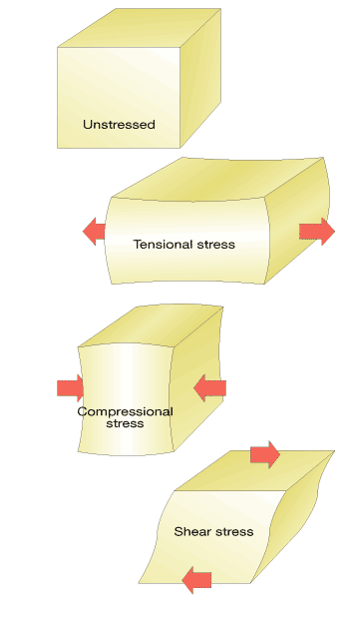
- Folds
  - _______________________ are most commonly formed by the ______________, or arching, of rock ________________
  - __________________________ are ___________ downfolds in ______________ strata
    - Synclines are often found in association with anticlines
  - _________________________ are large ___________________ folds in otherwise ________________________ sedimentary strata
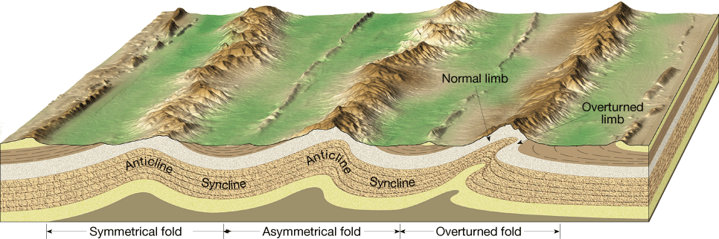

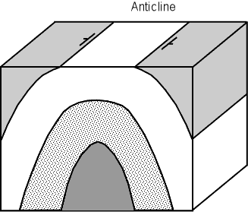
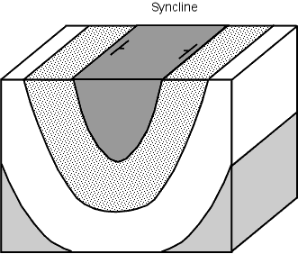

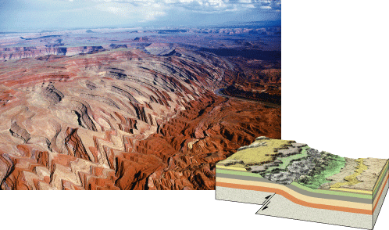
Monocline
- Faults
  - _____________ faults occur when the ___________________ moves _________ relative to the __________________ block
  - ___________________ faults are faults in which the ____________ wall block moves ______ relative to the ____________ block
  - ____________ faults are ____________ faults with dips less than _________
  - ________________________ faults are faults in which the movement is __________________________ and __________________ to the trend, or ___________, of the fault surface
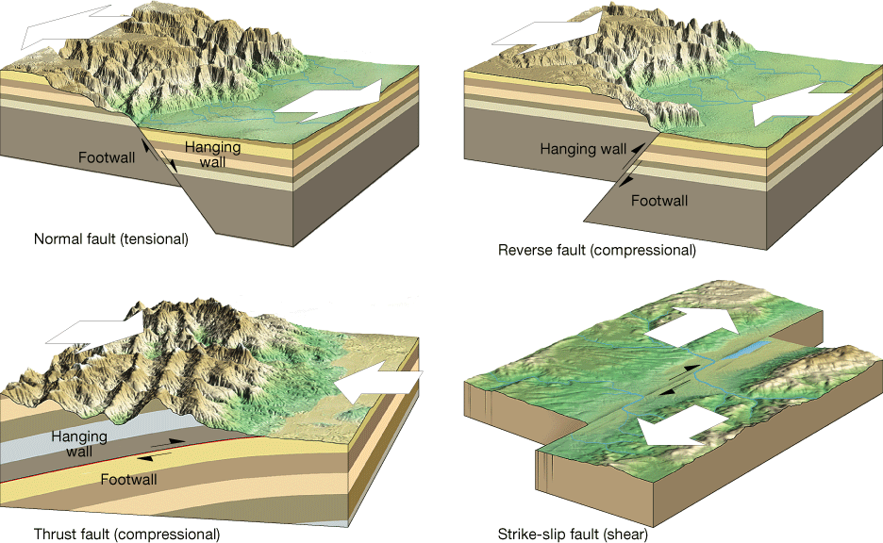
- Joints
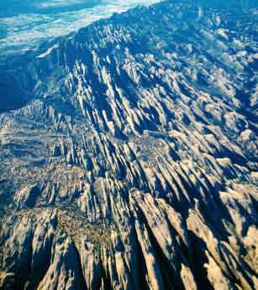
  - Are ____________ along which ____ appreciable ________________ has occurred

11.2 Types of Mountains
- Folded Mountains
  - Mountains are classified by the dominant processes that have formed them
  - ______________________________: is the collection of processes that result in the forming of mountains
- Mountains that are formed primarily by __________ are called _____________ mountains
- Major force is ____________________ stress
- Ex: ____________________________________________________________________
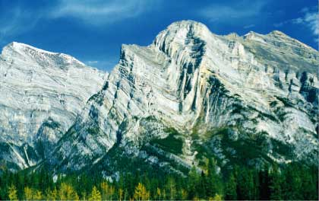
- Large scale _____________ faults are associated with structures called ___________________________________ mountains
- Fault-block mountains: are formed as ___________ blocks of ___________ are uplifted and ______________________ along normal faults
- ___________________: formed by the downward displacement of fault-bounded blocks
- ___________________: elongated, uplifted blocks of crust bounded by faults
- Major Force is _________________________ stress
- Ex: ____________________________________________________________________

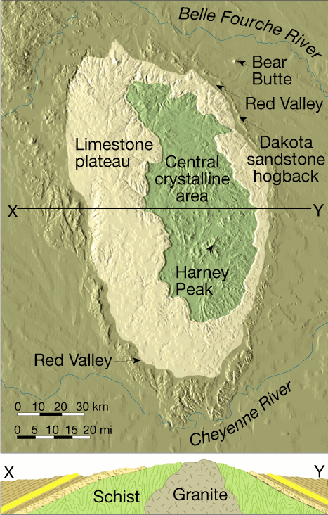
- When _____________________ produces a ____________ or _____________________ structure, the feature is called a ___________________
- __________________ mountains are circular or elongated structures
formed by the _____________________ of underlying ______________
____________________rock
- Ex: _________________________________________________________

11.3 Mountain Formation
- Most mountain building occurs at _________________________ plate boundaries
- ______________ plates provide the compressional forces that fold, fault, and metamorphose the thick layers of ________________ deposited at the __________ of landmasses
- Mountain Building at Convergent Boundaries
  - _____________________________________ Convergence
    - Mainly produces _______________________________(like Aleutian islands in Alaska)
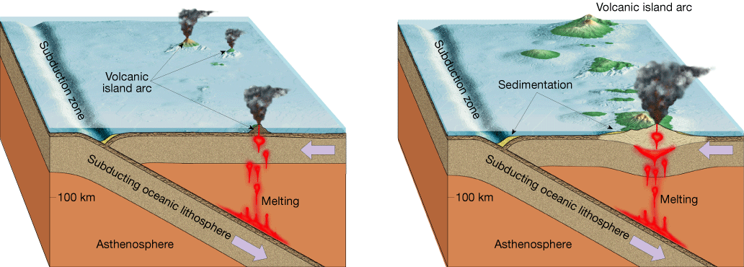
  - ________________________________________ Convergence
    - The types of mountains formed are _______________________________ and __________________________________________ (like Andes)
    - An ____________________________ is the ____________________ of different _________________________________________ rocks with some scraps of ____________________
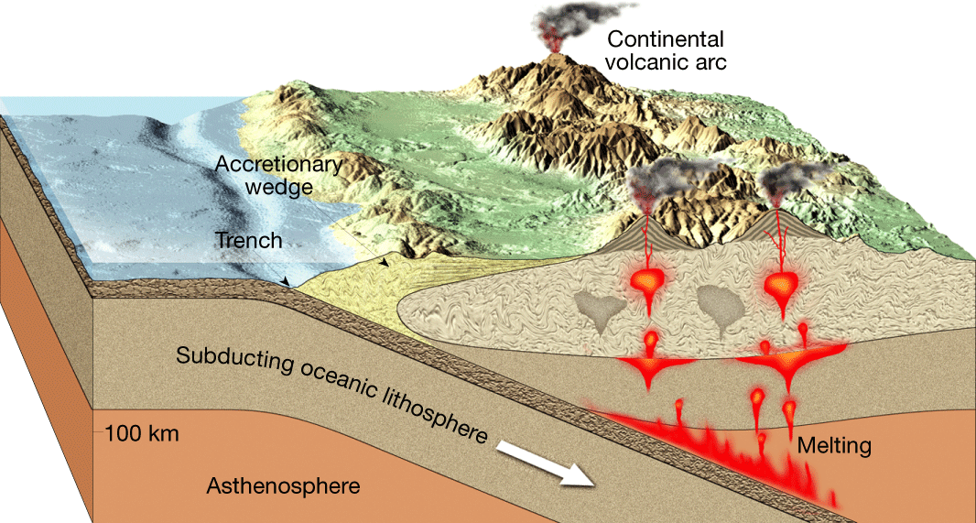
  - ____________________________________________________ Convergence
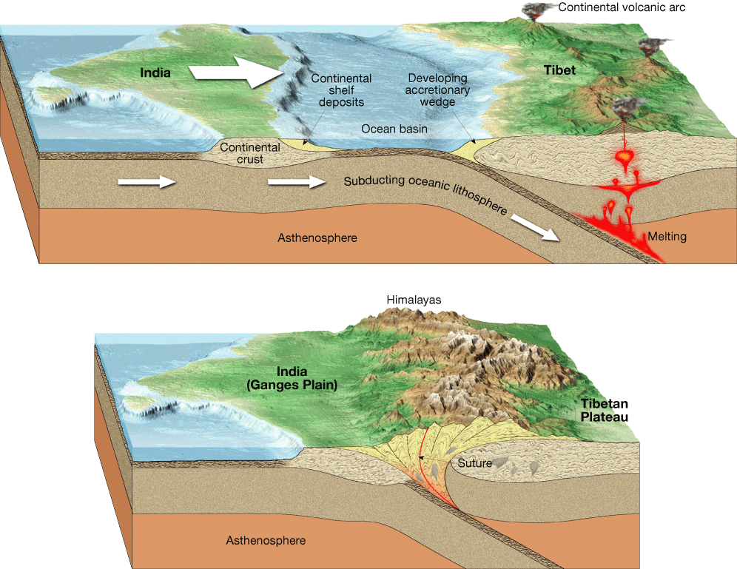
    - A collision will result and form ___________________________________
    - Ex: Himalayas

- Mountain Building at Divergent Boundaries
  - The mountains that form along ______________________ at ______________ plate boundaries are _______________________ type mountains
  - Ex: Mid Atlantic Ridge
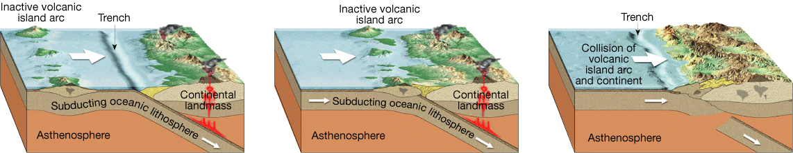

- Non-Boundary Mountains
  - Not all mountains are formed by plate boundaries. Some are formed by ____________________ or regional ____________________________________
  - Example: Hawaiian Islands
- Continental Accretion
  - _____________________ is a process that occurs when _____________________ collide with and stay ______________________ to a ___________________ plate
  - Terranes:
    - Any _____________ fragments that have a geologic history distinct from that of the _________________________________
    - Terranes occur along the ______________________ coast
- Principles of Isostasy
  - Isostasy is the concept that Earth’s __________ is __________________ in gravitation balance upon the material of the ________________________
  - Because of isostasy, _______________________________________________ will undergo regional _______________ both during mountain building and for a long period afterward.
  - _____________________________________: the process of establishing a ____________________ of ___________________________________________
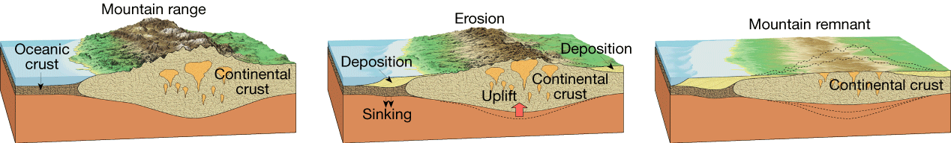
This drawing indicates how wooden blocks of different thickness float in water. Like this, thicker crust floats higher than thinner crust.

