**Name___________________________________Period_____Date____________**

**Geology Ch 18 & 19 Guided Notes**

**Moisture, Clouds, and Precipitation & Air Pressure and Wind**

**18.1 Water in the Atmosphere**

* ____________________ is any form of ________ that falls from a _________
* When it comes to understanding atmospheric processes, ___________________ is the most important gas in the atmosphere

Changes of State

* Solid to Liquid
  + The process of changing state, such as __________ ice, requires that _____ be _________________ in the form of ________
  + ____________________: is the energy ___________________________ during a change in state
* Liquid to Gas
  + ___________________: is the process of changing a _________________
  + ____________________: is the process where a _______, like water vapor, changes into a ______________, like water
* Solid to Gas
  + ___________________ is the conversion of a solid ___________ to a gas without passing through the liquid state
  + _________________________: is the conversion of a __________ directly to a ____________



Humidity

* _______________ is a general term for the amount of ______________________ in the air
* ____________________
  + Air is saturated when it contains the _____________ amount of water vapor that it can hold at any given _____________________________________
  + When saturated, _______air contains __________ water vapor than _______ saturated air

Relative Humidity

* _________________________ is a _______ of the air’s actual water vapor content compared with the amount of water vapor air ____________ at that ________________________________________
* To summarize, when the water vapor content of air remains __________, __________ air temperature causes an __________ in relative humidity, and raising air temperature cause a _____________________________________________

Dew Point: is the _________________ to which a parcel of air would need to be _______________ to reach ______________________

Measuring Humidity

* A ________________ is an instrument to measure __________________________
* A ______________________ is a hygrometer with dry and wet bulb _______________________. ___________________ of water from the wet bulb makes air temperature appear ________ than the dry bulb’s measurement. The two temperatures are compared to determine the relative humidity.

**18.2 Cloud Formation**

Adiabatic Temperature Changes

* When air is allowed to ___________, it _________, and when it is _______________ (squeezed together), it _____________

Expansion and Cooling

* __________________________ is the rate of cooling or heating that applies only to __________________________ air
* _____________________________ is the rate of adiabatic temperature change in __________________________ air

***Cloud Formation***

* There are _____ mechanism that cause air to ________________
  + _____________________
  + _____________________
  + ______________________
  + ______________________

Orographic Lifting

* __________________________ occurs when _______________ act as barriers to the _______________________, forcing the air to ascend
  + The air cools ______________, ___________________________ may result

Frontal Wedging

* A __________ is the ______________ between two adjoining ________________ having contrasting characteristics

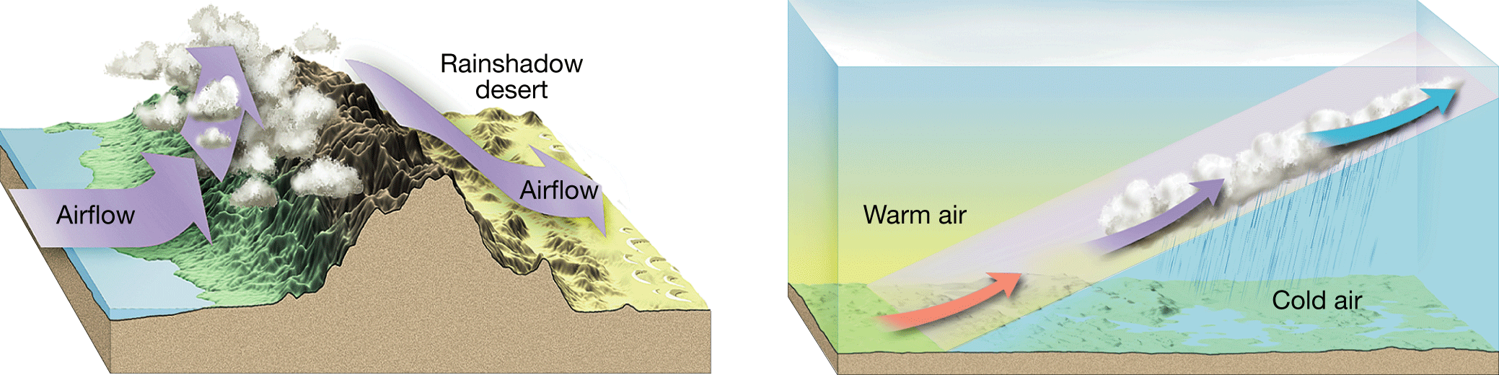

Convergence

* ______________________ is when air flows_______________________________

Localized Convective Lifting

* Localized ________________ lifting occurs where ____________surface heating causes pockets of air to rise because of their __________________________

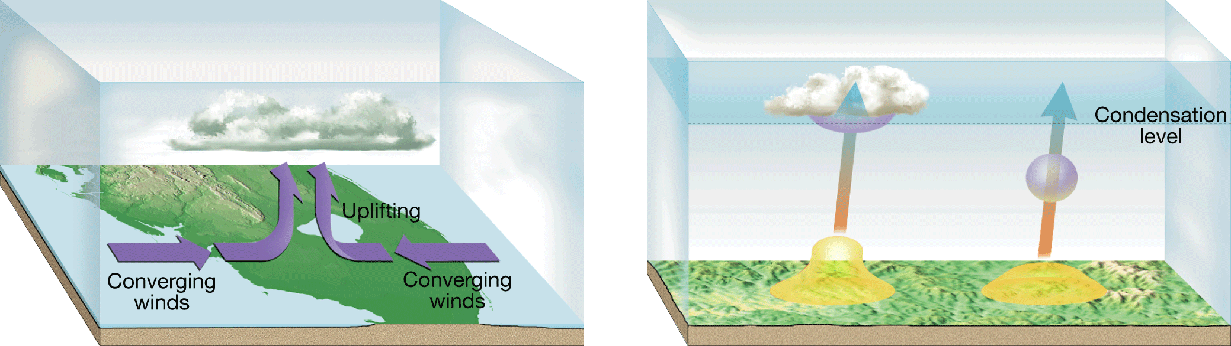

Density Differences

* __________ air tends to remain it its ____________ position, while __________ air tends to rise

Stability Measurements

* Air stability is determined by measuring the temperature of the atmosphere at _________________________
  + The rate of change of air temperature with height is called the ______________ _______________________________________

Degrees of Stability

* A _______________________ occurs in a layer of limited depth in the atmosphere where the temperature ________________ rather than ______________ with height

Stability and Daily Weather

* When stable air is forced _________ the Earth’s surface, the clouds that form are widespread and have little _____________________ compared to their horizontal direction

Conditions for Condensation to Occur

* For any form of ___________________ to occur, the air must be ________________
* Types of Surfaces
  + Generally, there must be a surface for water vapor to condense on
  + ________________________ are tiny bits of particulate matter that serve as __________ on which water vapor condenses when condensation occurs in the air

**18.3 Cloud Types and Precipitation**

* Clouds are classified on the basis of their __________________________
  + ______________(cirrus=curl of hair) are clouds that are _________________ _______________
  + _______________(cumulus=a pile) are clouds that consist of ______________ _________________________
  + ________________(stratus=a layer) are clouds best described as __________ __________________________________________________
* High Clouds
  + _____________________________________________________
  + _____________________________________________________
  + _____________________________________________________
* Middle Clouds
  + ____________________________ are composed of ____________ masses that differ from ________________________ clouds in that altocumulus clouds are __________________________
  + _____________________ clouds create a ___________________________ __________ covering the sky with the sun or moon visible as bright spot
* Low Clouds
  + _____________ clouds are best described as ________________________ that cover ______________________
  + ______________________ have a ______________bottom that appear as _____________________________________________________
  + __________________ clouds are the main _____________________ makers

Fog

* ______ is defined as a _________ with its base at or very near the ___________
* Fog caused by cooling
  + As the air cools, it becomes ____________ and drains into low areas such as _____________, where _________ fog accumulations may occur
* Fog Caused by evaporation
  + When cool air moves over _________________, enough ____________ may evaporate from the water surface to produce __________________

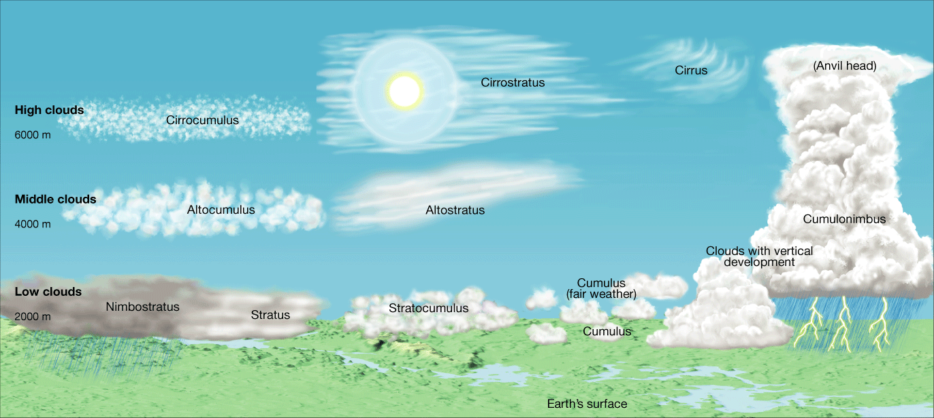

Precipitation

* For precipitation to form,_________ droplets must grow in ________ by roughly _______________________
* Cold cloud precipitation
  + The __________________________ is a theory that relates the __________ of precipitation to ______________________________________________ ______________________________________ of ice and liquid water
  + __________________________ is the condition of water droplets that remain in the ________ state at temperatures well below _________________
  + _________________________ air is the condition of air that is ________ concentrated than is normally possible under given _______________________ ________________________ conditions
* Warm cloud Precipitation
  + The __________________________________________ is a theory of _____________ formation in _______ clouds (above _____) in which large cloud droplets ______________________ together with smaller droplets to form a raindrop

The type of precipitation that reaches earth’s surface depends on the temperature profile in the lower few kilometers of the atmosphere

* Rain means drops of water at least ______in diameter; snow is made of crystals with ___ sides
* ____________ is the fall of clear-to-translucent ice
* _________ is produced by ________________________ clouds
* ________________ begin as small ice pellets that grow by collecting _________________ water droplets as they fall through a cloud

**Chapter 19-Air Pressure and Wind**

**19.1 Understanding Air Pressure**

* _______________ is the pressure exerted by the __________ of air
* Air pressure is exerted in _______ directions. The air pressure pushing _______ on an object exactly ____________ the air pressure pushing _____ on the object
* A ______________________ is a device used for measuring air pressure
* When air pressure ______________, the mercury in the tube ______. When air pressure ___________, so does the _______ of the mercury column

Wind

* _______ is the result of ________________ differences in ___________________. Air flows from areas of ____________ pressure to areas of __________ pressure
* The ________________________ of Earth’s surface generates pressure differences. _____________________________ is the ultimate energy source for most wind
* Three factors combine to control wind: _____________________________________ _____________________________

Pressure Differences

* A pressure ___________ is the amount of pressure change occurring over a given ______________
* Closely spaced ______________, lines on a map that connect places of ___________ ____________________, indicate a __________pressure gradient and ______ winds. Widely spaced isobars indicate a _______pressure gradient and ________ winds

Coriolis Effect

* The ___________________describes how _______________________ affects __________objects. In the ____________ Hemisphere, all free-moving objects or fluids, including the wind, are deflected to the __________ of their path of motion. In the __________ Hemisphere, they are deflected to the _____________

Friction

* __________ acts to ________ air movement, which ___________ wind ____________
* ______________ are ______-moving rivers of air that travel between ______________ kilometers per hour in a _________________________ direction

**19.2 Pressure Centers and Winds**

* _________________ are centers of ______________________
* ____________________ are centers of ________________________
* In cyclones, the pressure _______________ from the outer isobars toward the center. In anticyclones, the values of the isobars _____________ from the outside toward the center

Cyclonic and Anticyclonic Winds

* When the pressure gradient and the Coriolis effect are applied to pressure centers in the _____________Hemisphere, winds blow _____________________ around a ______. Around a ________, they blow __________________.
* In either hemisphere, ______________ causes a net flow of air _____________around a __________ and a net flow of air _______________around an __________________.

Weather and Air Pressure

* _____________ air is associated with _________ formation and precipitation, whereas _______________ air produces ______________ skies.

Weather Forecasting

* Weather reports emphasize the locations and possible paths of cyclones and anticyclones.
* ­­­­­­­­­­­­________________pressure centers can produce bad weather in any season.

Global Winds

* The atmosphere balances these differences by acting as a giant heat-transfer system. This system moves ________air toward ______ latitudes and ________air toward the ____________.
* Non-Rotating Earth Model
  + On a hypothetical non-rotating planet with a smooth surface of either all land or all water, ____________________________________ produced cells would form.

Rotating Earth Model

* If the effect of rotation were added to the global circulation model, the two-cell convection system would break down into ________________cells.
* **_________________** are _____ belts of winds that blow almost constantly from ____________ directions and are located on the _______________________ sides of the ____________________________.
* **_____________**are the dominant ___________________ motion of the atmosphere that characterizes the regions on the poleward side of the subtropical highs.
* **_____________________** are winds that blow from the polar high toward the subpolar low. These winds are ___________________ like the trade winds.
* A **______________** is a _________ frontal zone ___________________ air masses of _________ origin from ___________air masses of __________ origin.

Influence of Continents

* The only truly continuous pressure belt is the ___________________ in the ______________ Hemisphere. In the Northern Hemisphere, where land masses break up the ocean surface, large seasonal temperature differences disrupt the pressure pattern.
* **_____________** are the _____________________________ associated with ______ continents, especially Asia. In winter, the wind blows from land to sea. In summer, the wind blows from sea to land.

**19.3 Regional Wind Systems**

Local Winds

* The local winds are caused either by __________________effects or by variations in _____________________, land and water, in the immediate area
* Land and Sea Breezes
  + In coastal areas during the warm summer months, the land surface is heated more intensely during the daylight hours than an adjacent body of water is heated. As a result, the air ___________________________________________________ _____________________________________________________________
* Valley and Mountain Breezes
  + In mountainous regions during daylight hours, the air along the slopes of the mountains is heated more intensely than the air at the same elevation over the valley floor. Because this ________ air on the mountain slopes is _____ dense, it glides up along the slope and generates a ________breeze. After sunset the pattern may reverse.

How Wind is Measured

* Wind direction
  + The ___________________ is the wind that blows more often from one ________________ than from any other
  + In the US, the _________________ consistently move weather from _______ _____________ across the continent
* Wind speed
  + An _________________ is an instrument that resembles a cup and its commonly used to measure wind ___________

El Niño

* _____________ is the name given to the periodic __________ of the ________ that occurs in the _________________________________
* At irregular intervals of _______ years, these warm countercurrents become unusually strong and replace normally ______ offshore waters with ______ equatorial waters
* A major El Niño episode can cause _________weather in many parts of the world

La Niña

* Research have come to recognize that when surface temperatures in the __________ Pacific are ___________ than average, a ________________ event is triggered that has a distinctive set of weather patterns