Name_________________________________________Period_______Date_______________

Physical Science: Chapter 3 Review

Pressure=Force ÷ Area | P₁V₁=P₂V₂ | P₁T₂=P₂T₁
0°C=273 K | V₁T₂=V₂T₁

- What is the difference between a solid and liquid?

- What is the difference between a liquid and gas?

- What is the difference between a gas and plasma?

- Which particles move faster? Heavier or or Lighter?

- Which state of matter has the most kinetic energy? The least?

- Which states of matter can be fluids?

- What do all of the states of matter have in common?

- Temperature is a measure of what kind of energy?

- What does the law of conservation of mass and energy say?

- What is thermal expansion?

- What are the following processes called?:
  - Solid to gas______________________________
  - Solid to liquid____________________________
  - Liquid to solid___________________________
  - Liquid to gas (below boiling point)________________________________
  - Liquid to gas (above boiling point)________________________________
  - Gas to liquid__________________________________________________

- Label B-F. At point A, the substance is a solid.
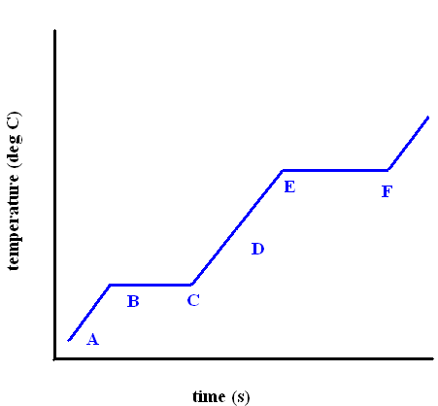

- What is a buoyant force?

- What does Archimedes’ Principle say?

- What does Pascal’s principle say?

- If you decrease the pressure of a fluid, its speed:

- Bernoullis’ principle states that the faster an object is moving, the pressure exerted on it by a fluid:
- Boyle’s Law relates ___________________________________

- Charles’ Law relates __________________________________

- Gay-Lussac’s law relates _______________________________

- If you increase pressure, you _____________________ volume (at constant temperature)

- An object weighs 25N. It displaces a volume of water that weighs 100 N. What is the buoyant force on the object? Does it float or sink? Explain

- What is viscosity? How does temperature affect viscosity?

- A gas occupies a volume of 100 mL at pressure of 200 kPa. Find its volume at a pressure of 300 KPa.

- A gas occupies a volume of 324 cm³ at 400 Kelvin temperature. Find its volume at 450 Kelvin.

- A gas’ pressure is 1.3 atm at 23 degrees Celsius (don’t forget to change to Kelvin). At what temperature will the pressure be 0.75 atm?

