Name________________________________________________Period_____Date__________

Geology Unit 12 Notes
Soils & Mass Movements

Text Reference: Ch 5 133-149

PART I: SOIL

- Importance of Soil
  - An important product of _______________
  - Covers most land _______________
  - One of earths _______________________resources
- Characteristics of Soil
  - Soil is part of the _______________ that supports the growth of __________
    - Regolith: the layer of _____________________________________ that covers most of earth’s land surface
    - Includes Soil Composition, Texture, Structure, Formation
- Soil Composition
  - Soil has __________ major components
  - ____________________-broken down rock
  - Organic Matter (_____________)- the __________________ remains of organisms
  - ____________: provides the ______________ for chemical reactions to occur to sustain life
  - ____________: source of _________________ plants use to produce sugar during ________________________________
- Composition by volume of good quality soil
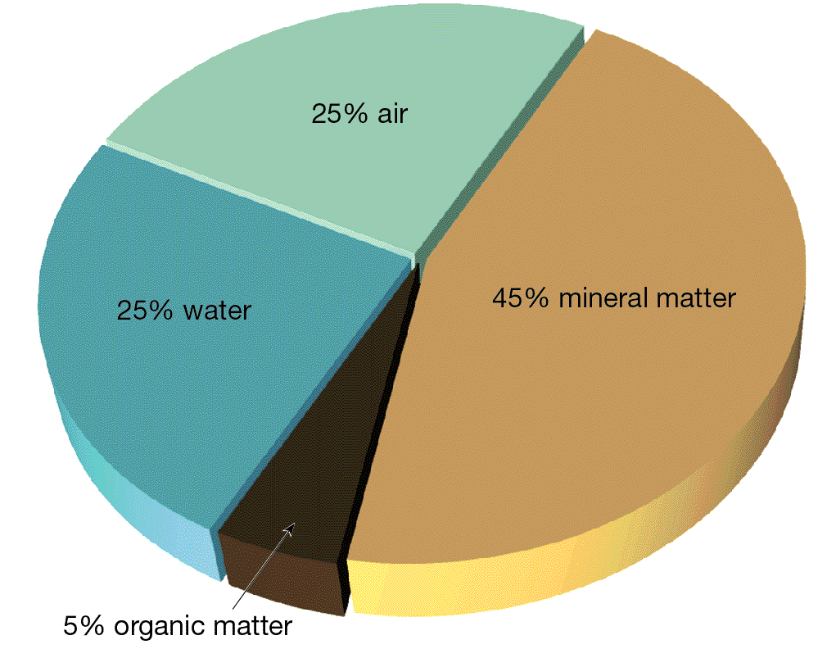
- Soil Texture
  - Texture refers to the proportions of different particle sizes. ________(large size), silt, ________(small size)
  - __________________ ( a mixture of all _____ sizes) is best suited for plant life
  - Sandy soils may __________ and dry ________________
  - Clay rich soils drain _____________________
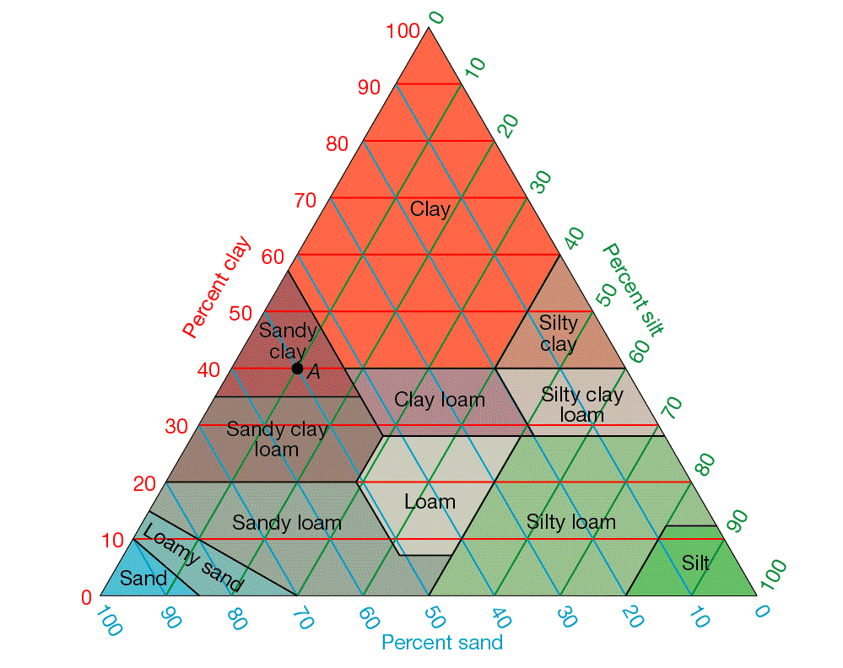
- Soil Structure
  - Soil particles __________ together to give soil its structure
  - Determines how quickly soil can be _____________ and how susceptible it is to _______________
  - Affects how easily _______________penetrates soil
- Soil Formation
  - The most important factors in soil formation are: ________________________________ ________________________________________________________________________
    - Parent Material
      - Source of _____________________________
      - Residual soil: parent material is the _______________________
      - ___________________ soil: parent material has been carried from elsewhere and _________________ by gravity, wind, water or ice
      - Influences on Soil: affects the ______________________ of soil formation, affects soil fertility(___________________________________________)
    - Time
      - The ____________ a soil has been forming the ___________ it becomes
      - Parent material mostly determines characteristics of ___________ soils
      - As time and weathering continues, the influence of parent material _____________________
    - Climate
      - _____________ effect on soil formation
      - Different ________________________________ affect rate, depth, and type of weather
      - In the same amount of time: __________________: thick layer of chemically weathered soil and a _______________________: thin layer of mechanically weathered soil
      - Amount of __________________influences soil fertility and the rate at which nutrients are _________________ from soil
      - Affects types of organisms that can live ________________ in the soil
    - Organisms
      - ______________________ affect soil’s physical and chemical properties
      - ___________ are main type of organic matter in soil. Contributes to soil ___________________. (remember the humus layer of soil)
      - Microorganisms ___________________ dead plants and animals
      - Burrowing animals ______- the organic and mineral matter and help ____________________ penetrate into the soil
    - Slope
      - One a steep slope: erosion has _______________________, often have _____________ developed soils because little _________ can soak in and can’t hold moisture for _____________________-__
      - Flat areas: _________ erosion and poor __________________
      - Optimum slope: __________________________upland surfaces
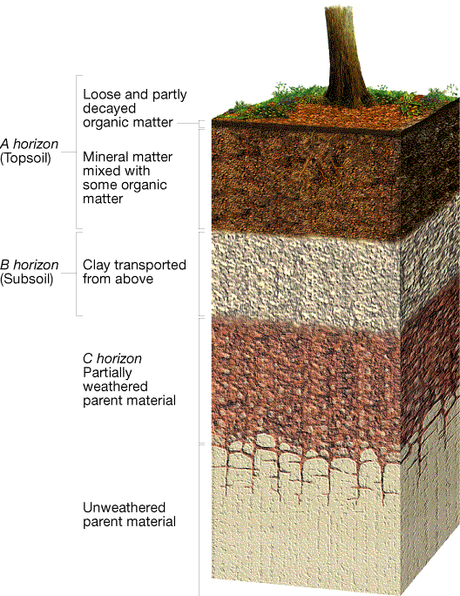
- The Soil Profile
  - Soil varies in composition, texture, structure, and color and different ____________. _______________________ are zones or layers of soil. A soil ___________ is a vertical section through all the soil horizons
    - The _____ horizon is commonly known as _______________
    - The ____ horizon is __________ and contains clay particles washed out from the _____ horizon
    - The ____ horizon is between B horizon and unaltered _____________ material
- Soil Types: _______________ common are ____________, ________________, and ______________
  - Pedalfer
    - Best developed under ___________ vegetation
    - Usually forms in the temperate areas that receive >______cm of rain per year (mostly __________ US states)
    - Accumulation of __________ and _____________-rich clays in the ___ horizon
    - Remember ______=aluminum and ______=iron on periodic table
    - _____________________ in color
  - Pedocal
    - Accumulates __________________
    - Associated with ___________ grasslands
    - Found in ______________________ US states
    - Contains _____ clay than pedalfers because of _______climate and ______ chemical weathering
    - ________________ in color
  - Laterite
    - ___________________climates
    - Intense _____________ weathering
    - Large amounts of _____________ removes most of the _____________________
    - _______________________________________ are left behind
    - _________________ in color
- Soil Erosion
  - ________________ Erodes soil
  - Rates of Erosion
    - Human activities that remove natural vegetation such as _____________________ _______________ have greatly accelerated erosion
    - Between wind and water, ________ erodes more quickly
  - Sediment Deposition
    - Another problem caused by excessive soil ______________
    - ______________ fill with sediment
    - Sediments are contaminated by ________________________
- Controlling Erosion
  - Planting rows of trees called _____________________
  - Terracing hillsides
  - Plowing along the ___________of hills
  - __________________________
PART II: MASS MOVEMENTS

- Transfer of ________________________ due to ________ is called mass movement
- Among the factors that commonly trigger mass movements are the _______________________ _______________________________________________________________________________________________________________________
The role of Gravity
  - ___________________is the force of gravity acting on an object on a slope
    - Always pulls _______________________________________________________ _________________________________
    - Objects move _____________________________________________________
- Resistance to movement
  - __________________________: the _____________________of an object to move downhill; _________________
    - Cohesion, ____________________of particles
    - Plat roots, cementation,etc
The role of water
- ___________may act to _______________________________________________________
  - ______________________________________________________________________
  - _______________________________________________________________________
  - _______________________________________________________________________

- Types of Mass Movements
  - Geologist classify mass movements based on the kind of material that moves, _____ it moves, and the ____________ of movement
  - __________________
    - A rockfall occurs when rocks or rock fragments ____________ through the air
    - Sometimes trigger other mass movements
  - _______________
    - In a slide, a block of material moves ____________ along a _______________________ surface
  - _______________
    - A slump is the _________________ movement of a block of material along a __________________ surface
    - __________________ can trigger slumps
  - ________________ are mass movements of material containing a large amount of __________
    - _____________ move quickly and carry a mixture of _______________________ _____________________________________ that has a consistency of wet concrete
    - _____________move relatively ________ and carry _______-rich sediment

