Name________________________________________________Period______Date______________

Geology-UNIT Guided Notes
Earthquakes

Text reference: ch 8 pg 217-232

Section 1: What is an Earthquake?
- _________________: vibration of earth produced by the rapid release of ___________
- Often caused by slippage along break in the earth’s _____________
- _______________: point within earth where the EQ starts; the _________ of the Earthquake
- _______________: location on the _________________________________the focus
- _________________: _____________ in the earth where _________________ has occurred
- ___________________________________
  - Most EQs are produced by the rapid release of ______________________ stored in rock that has been subjected to great forces
  - As rock is __________________, it ___________, _____________ elastic energy. Once the rock is strained ______________ its breaking point, it ruptures and release the ____________________ in the form of ___________________(seismic waves) of earthquakes
- ______________________: small earthquakes __________a major earthquake
  - Can happen __________________________ before the major quake
- _________________________: movements that _______________ a major earthquake
  - _________________ than the major EQ
  - Can sometimes _____________ structures weakened by the major earthquake
- Earthquake Zones
  - ________ of all occur in circum _____________________
    - Most result from ______________ margin activity
  - _________ occur in _____________________________
  - _________ occur in the interiors of plates and on spreading ridge centers
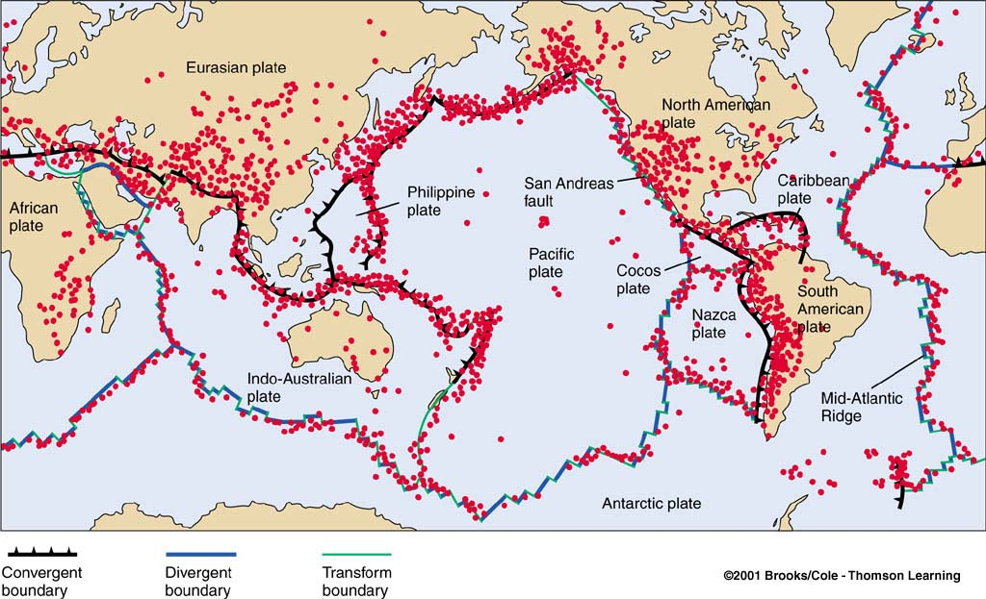

Section 2: Earthquake Waves
- Measuring Earthquake Instruments
  - _______________________: instruments that record EQ waves
  - ________________________: traces of amplified, electronically recorded ground motion made by seismographs
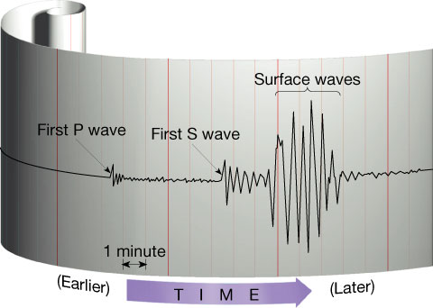
Types of Waves
- _______________ waves (____ waves)
  - Travel along earth’s _________________
  - Especially damaging to buildings
  - _________ destructive of the 3 types of waves
  - ______________________________ movement (think of ocean wave movement)
- ____________________waves
  - _______________________ motion
  - ___________________________ waves-material is moved in the ________ direction as the wave moves
  - ______________ moving wave
  - Travel through _____________________________________
- __________________________waves
  - _____________ than ______ waves, ____________ than ____________ waves
  - Travel through _______________ only
  - Move _______________________(90 degrees) to wave movement
Locating an EQ’s Epicenter
- ______ waves arrive ______, then _____ waves, then _____________
- Earthquake distance
  - Epicenter is located using the difference in the arrival times of _____________ wave recordings which are related to distance
- Earthquake direction
  - ____________________ graphs from ________ or more seismograph can be used to find the exact location of an earthquake epicenter

Section 3: measuring Earthquakes
- Two different types of measurements: ________________________________
- Intensity: based on ____________ of ground shaking on ____________________________ ________________________
  - Varies from place to place within disturbed region depending on the location of the observer with the respect to the EQ ______________________
- Magnitude: related to the amount of ____________________________________ at the hypocenter of the earthquake
  - Based on __________________of EQ waves recorded on instruments
Scales
- Richter Magnitude Scale
  - Range from _______________________

  - <2.0:_____________________
  - ~4.0:_____________________
  - 6.0-6.9:___________________
  - 7.0-7.9:___________________
  - 8.0-9.9:___________________
  - 10+:______________________

- Modified Mercali Intensity Scale
  - Developed in ______________
  - _______ Different Levels:

  - I:________________________
  - II:________________________
  - III:_______________________
  - IV:_______________________
  - V:________________________
  - VI:_______________________
  - VII:______________________
  - VIII:______________________
  - IX:_______________________
  - X:________________________
  - XI:_______________________
  - XII:______________________

- Moment Magnitude
  - Derived from the amount of _________________that occurs along the fault zone
  - Most widely used measurements for EQS because it is the only magnitude scale the estimates _____________________________________ by earthquakes
  - Measures very large earthquakes
  - Calculated by different factors including
    - ____________________________________
    - ____________________________________
    - ____________________________________
      - A x B x C=measure of how much energy rock can _________ before it slips and ________________ energy during an earthquake

Section 4: Destruction from Earthquakes
- Damage to buildings and other structures from earthquake waves depends on several factors including:
  - _________________________________________________________
  - ________________________________________________________________
  - _____________________________________________________
- Factors that determine structural damage:
  - ___________________________________________
  - __________________________________________________
    - Most serious safety threat
  - ___________________________________________________
  - ___________________________________________________
- _____________________
  - Saturated material turns to _________________
  - Underground objects may float to _________________
  - Occurs when _________________________________ saturated with ___________ are shaken by EQ waves
- Tsunamis
  - Japanese for _________________________________
  - Causes:
    - Triggered by an _______________
    - Occurs where a slab of the _______________________ is displaced ____________________ along a fault
    - Can also occur when the vibration of a EQ sets an ______________________ in motion
  - A tsunami is generated by movement of ocean floor. The _________of a wave moving across the ocean is related to the __________________________
- Tsunami Warning System
  - Large EQs are reported to Hawaii from ____________________________________
  - Although tsunamis travel quickly, there is sufficient time to evacuate all but the area _________________ to the epicenter
  - On average only _____________ destructive tsunamis worldwide per year
  - ON average, only _______ tsunami every ______ years causes major damage and loss of life
- Predicting Earthquakes
  - Short range:
    - Not successful yet
  - Long range forecasts
    - Data can be important for updating _______________________________
    - Scientists don’t yet understand enough about how and where earthquakes occur will occur to make accurate long term predictions
    - A _______________________ is an area along a fault where there has not been EQ activity for a long period of time
- Other Dangers
  - ____________________:
    - Results from the violent shaking of EQs, causing the ___________________ on slopes to fall
    - The _________________ cause of structural damage
  - ___________________:
    - In the San Francisco earthquake of 1906, most of the destruction was caused by fires that started when gas and electrical lines were cut

