**Name________________________________________Period_____Date___________**

**Physical Science Guided Notes**

**Work, Power, & Machines**

***Work, Power, and Energy***

* ______________
  + ___________________________________________________
  + ___________ exerted through a _____________
    - * W:________________

**W**

* + - * F:_________________
      * d:_________________

**d**

**F**

_______________________

* Problem: Brett’s backpack weighs 30 N. How much work is done when he lifts is 1.5 m from the floor to his back?
* Problem: A dancer lifts a 40 kg ballerina 1.4 m in the air and walks forward 2.2 m. How much work is done on the ballerina during and after the lift?
* ____________
  + __________at which ________ is done; how much work is done at at a given time.

**W**

* + - * W________________

**t**

**P**

* + - * P_________________
      * t:_________________

**_________________________**

* Problem: It takes 100 kJ of work to lift an elevator 18 m. If this is done in 20 s, what is the average power of the elevator during the process?

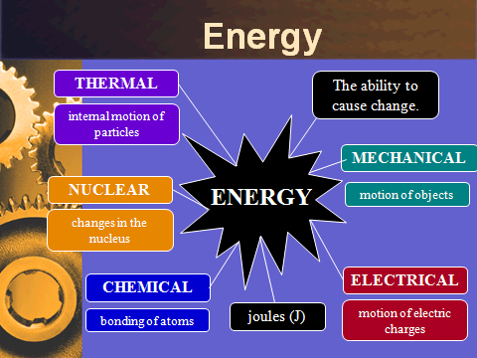

* _____________Energy
  + Energy in the form of _____________________
  + Depends on _____________________________
  + Which has the most KE?
  + Which has the least KE?
    - * Kinetic energy depends more on ________ than _________
      * Problem: What is the kinetic energy of a 44 kg cheetah running at 31 m/s?
* _____________ Energy
  + _______________energy
  + Depends on ____________________________________________ of an object
  + Which boulder has a greater

gravitational PE?

* + What are other ways can an object

store energy?

* + - * + m=______________, g=___________________ ____________________, h=_______________
        + On earth g=___________
* Problem: A 65 kg rock climber ascends a cliff. What is the climber’s gravitational potential energy at a point 35 m above the base of the cliff?
* Law of ___________________ of Energy
  + Energy may _____________, but it cannot be _________________ _______________ under ordinary conditions.
  + Ex:
    - __________________________
    - __________________________
    - __________________________

***Machines***

* A device that makes ________________________
* Changes the ________________________________________________ ___________________________________

Force

* **____________**Force (______)
  + Force applied _______ the machine
  + _____________________________
* __________________Force (_____)
  + Force applied _____ the machine

Work

* ___________________________
  + Work done _______ on a machine
* _____________________________
  + Work done _________ a machine
* Conservation of Energy
  + Can ____________ get more work out

than you put in

* + Trade-off between _______________

__________________________________

* In an ideal machine,
* But in the real world, some energy is _____________ as _____________

Mechanical Advantage (_____)

* _________ of times a machine ____________ the _______________

MA >1 : ____________________________

MA <1 : ____________________________

MA =1 : ____________________________

Fr=___________________________________________________________________

Fe=___________________________________________________________________

* Problem: A worker applies an effort force of 20 N to open a window with a resistance force of 500 N. What is the crowbar’s MA?
* Find the effort force needed to lift a 2000 N rock using a jack with a mechanical advantage of 10.
* If you do NOT have forces given, you can solve using distance

De=___________________________________________________________________

Dr=___________________________________________________________________

* Example: Using a block and tackle pulley, a boy pulls a rope 10 m to move up a weight 2 m. Find the MA
* Efficiency (HONORS ONLY)
  + _________________________________________
  + ________________________________________________
    - Many lose efficiency due to ___________________________
  + If a machine is _________efficient, it means it loses _________ of the energy to another form
  + Formula:
  + ______________ is always _________ than the ________ work

**Simple Machines**

6 types

* __________________
* __________________
* __________________
* __________________
* __________________
* __________________

*Levers*

* _________: A ______ that is _______________ about a _____________ point, or __________________
* ___________________________________________(________)
  + _________________machine



* + _________ must be ______________ than ______ in order to ___________ the force

1. You use a 160 cm plank to lift a large rock. If the rock is 20 cm from the fulcrum, what is the plank’s IMA?
2. You need to lift a 150 N box using only 15 N of force. How long does the lever need to be if the resistance arm 0.3 m?

*Classes of Levers*

* __________________________
  + _____________________ in the middle
  + Can __________________________________________________
  + Changes ______________________________________________
  + Ex: ___________________________________________________

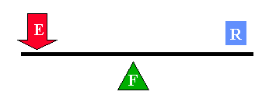

* _____________________________________
  + _________________ in the middle
  + ____________________________________________
  + Ex: ___________________________________________________

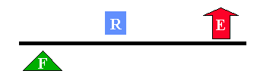

* _________________________________________
  + ___________________ in the middle
  + _______________________________________________
  + Ex: ___________________________________________________

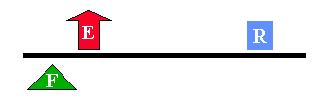

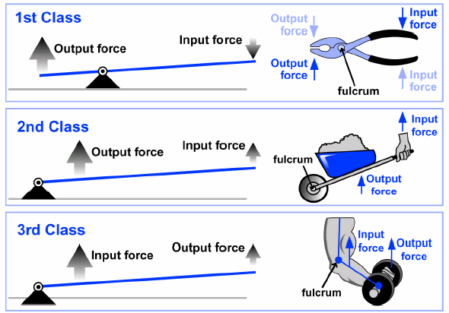

*Pulleys:*

* __________: a ______________________________________________ __________________________________________
* A “__________________________________________”

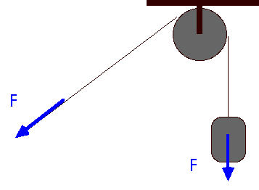

* Ideal Mechanical Advantage
  + Equal to the ____________________________________________
  + 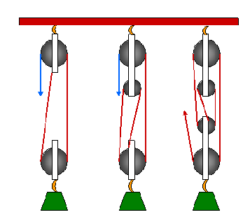Only count the end rope if pointing __________________________

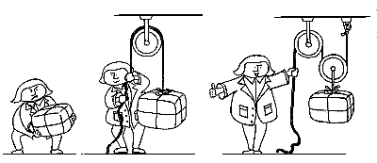

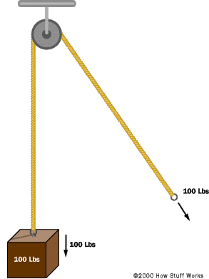

* _______________________________
  + IMA=_______________
  + Does ___________________________

_____________________

* + Changes direction of _______________

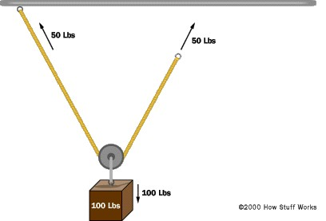

* ___________________________________
  + IMA=___________
  + _______________________________
  + _______________________________
* ____________________________________
  + Combination of ___________________________ pulleys
  + 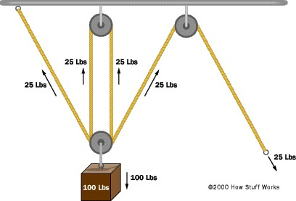Increases ___________(IMA=________)
  + May or may not change _____________

*Wheel and Axle*

* 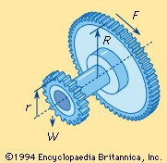______________________: ___________________________________ _________________________
* A pair of _________________________________
* ________________________________________
  + ________________ is usually applied to ________
  + _________ moves __________________________

But with _______________________________

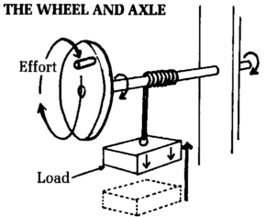

*Example Problems*

1. A crank on a pasta maker has radius of 20 cm. The turning shaft has a radius of 5 cm. What is the IMA of this wheel and axle?
2. A steering wheel requires a mechanical advantage of 6. What radius does the wheel need to have if the steering column has radius of 4 cm?

*Inclined Plane*

* _____________________: ____________________________________ ____________________________

*Screw*

* ____________: _____________________________________________ _________________



*Wedge*

* __________: _______________________________________________ ____________________

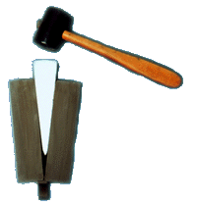

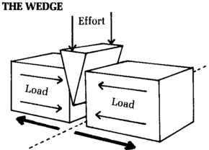

* ___________________
  + ______________________________________________________
  + ______________________________________________________

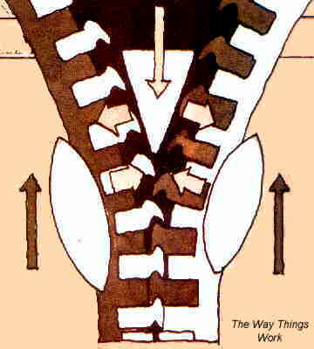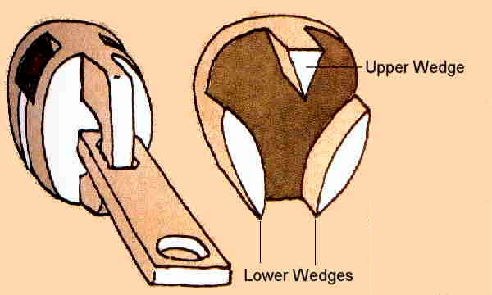

Problem: How much force must be exerted to push a450 N box up a ramp that is 3 m long and 1.2 m high?

**____________Machines:** a machine made up of ______________________ _________________________________________________

* Ex: scissors, car, bicycle, wheelbarrow