Name__________________________Period____Date_______

Unit 15 Guided Notes
Earth’s History

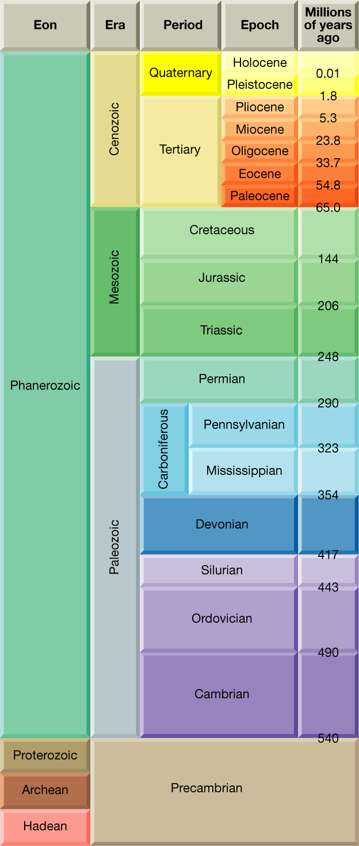
Text Reference: Ch 13 363-385

Geology Time Scale
- Based on interpretations of the rock record, geologists have dived the Earth’s _________________________ history into units that represent specific amounts of time. Take together, these time spans make up the _______________________________________

- ___________ represent the ____________ expanses of time. Eons are divided in ______________. Each era is subdivided into _______________. Finally, periods are divided into smaller units called ______________.

- _________________-derived from Greek meaning _____________________

- There are ____ eras within the _____________________ eon; the ______________ which means _________________; the _______________ which means __________________; and the ______________ which means __________________ life
- Each period within an era is characterized by somewhat ________ profound chage in life as compared with the changes that occur during an era
- The periods of the _______________ era are divided into epochs.
- _________________ Time
  - _____________million years ago
  - Represents _________ of earth’s time history
  - During Precambrian time, there were fewer life forms. These life forms are more difficult to identify and the rocks have been disturbed often.
  - ______ eons within this time: starting from most recent: _____________, __________________,______________________

Precambrian Time: Vast and Puzzling
- Encompasses the ________ geologic time from about _______________ years ago until the start of the ___________ period, ___________________years later
- All time between ____________of earth and _________________
- Most Precambrian rocks _____________ contain ______________
- Much of what we know about Precambrian rocks comes from _______ _____________from shields
  - Shields=_____________ relatively, ________ expanses of ancient _________________rock within the stable continental interior
  - Ex. Iron, nickel, gold, silver, copper, chromium, uranium, and diamond mines have provided samples
- Oldest Rocks/Fossils=_________________________
- Earth’s original atmosphere wad made up of gases similar to those released in _______________ eruptions today-__________________ ___________and several trace gases but _______________________
- Later, primary plants evolved that used _____________________ and released ____________________
- At first, most oxygen combined with ____________ to make _______
- Oxygen began to accumulate about _________________________
- The most common Precambrian Fossils are _____________________
- Stromalites are distinctively ______________________ or columns of ______________________. They are NOT the remains of actual organisms but the material deposited by ______________.

Paleozoic Era: Life Explodes
- Following the long Precambrian time, the most recent 540 million years of Earth’s History are divided into three eras:
  - Paleozoic
  - Mesozoic
  - Cenozoic
- The _____________ era encompasses about ____________________
- Before the Paleozoic, life forms possessed _____________________ like _____________________________________
- Paleozoic contains many __________________________ due the emergence of life forms with _______________________
- Paleozoic is divided into ___________ Paleozoic & ________ Paleozoic

  - Early Paleozoic Periods
    - ______________
    - ______________
    - _______________

  - Late Paleozoic Periods
    - ________________
    - _________________
    - _________________
    - _________________

- Early Paleozoic History
  - Consists of ________________________time span that includes ______________________________________ periods
  - During this time, the vast southern continent of Godwanda encompassed _______ continents: _______________________ ____________________________________________________
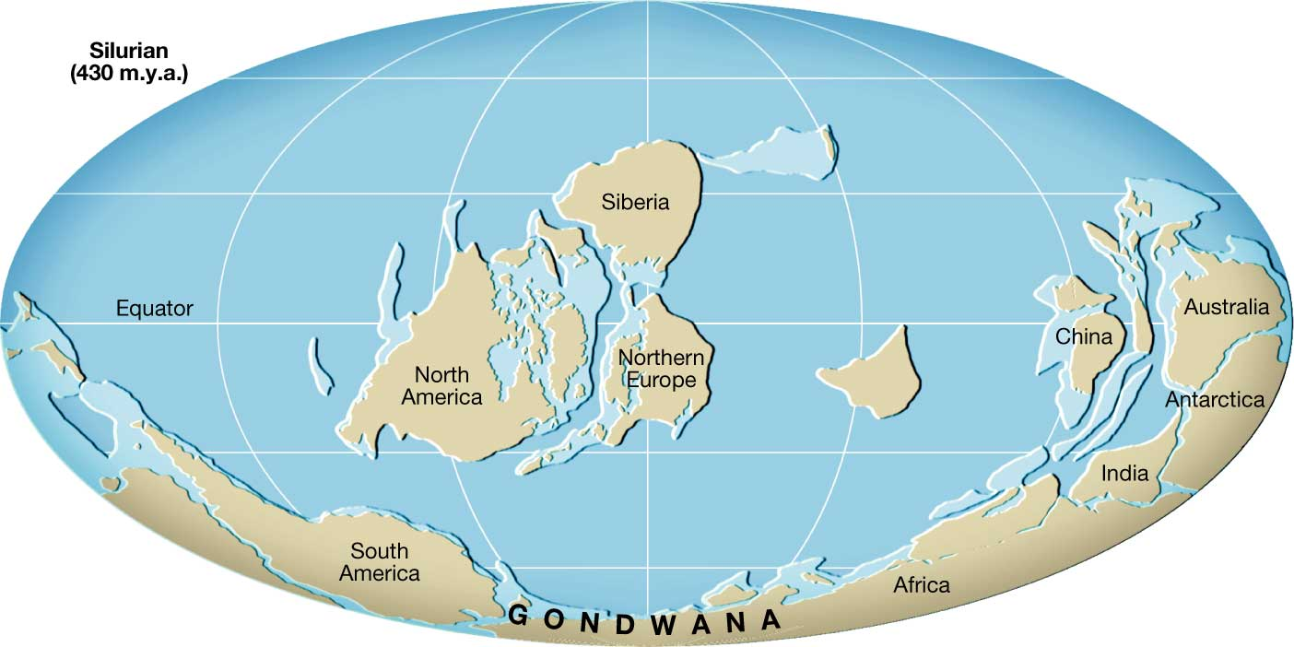
- Early Paleozoic Life
  - Early Paleozoic Life was ________________________________
  - No ___________________ had evolved, so all were ___________________________
  - Beginning of Cambrian time-1st animals with hard parts like _________________________________________________
  - By end of Cambrian time-______________________
  - By Ordovician time-____________________________________
    - Cephalopod-_____________________________________ _______________________________________________
    - _______________ organism on earth
- Late Paleozoic History
  - Spans about ________________________
  - Includes _____________________________________________ _______________________________ periods
- _________________ is the continental mass that formed the ______________ part of ______________, consisting of the present-day _________________________________________
- As Laurasia was forming, ______________ moved _______________
- By the end of Paleozoic, all of the continents had _________ into the ____________________ of ________________________
- This changed climate __________________, Most of the interior of Pangaea became ______________
- Late Paleozoic Life
  - During this time organisms diversified dramatically
  - Some ________________________, plants that had adapted to survive at _____________ began moving ______________, becoming _________________________
  - Earliest land plants were about the size of ________________, by ________ of Paleozoic, had ________ with trees _________ of _______________ high
  - Ocean life developed ________________________________
  - During Devonian-________________________________
  - Devonian age known as _____________________________
  - By end of Devonian, ____________________ started to emerge
  - The amphibians rapidly developed and diversified because they had _______________________________ from other land dwellers
  - By the end of ____________________ period, large tropical _____________ extended across _________________________ ___________________________
  - ____________ deposits originated in these swamps
  - ____________________ appeared
- The Great Paleozoic Extinction
  - The world’s climate became very _______________ probably causing the dramatic ____________ of many species
  - During the Permian Period-______________
  - The Late Paleozoic Extinction was the greatest of at least _____ mass extinctions over the past _________ million years
  - By end of _______________ period, ________ species of amphibians gone, at least _________ of marine life gone
  - Cause is uncertain
    - Sea levels had ___________ because of climates
    - Climate changes from ________________
    - At least ________________ cubic yards of ______ flowed across _______________
    - May have been from impact from ___________________ body
Mesozoic Era: Age of the _______________
- Spanned about _______________________________
- Divided into _______ periods:
  - ____________________
  - _____________________
  - _____________________
- Beginning of the breakup of Pangaea continued for _______ million years through the Mesozoic and into the Cenozoic era
- ______________ became dominant and remained challenged for over _____________ million years
- Mesozoic History
  - Began with most of the world’s land __________ sea level; then shallow seas invaded much of western _____________, the ___________________, and _________ coastal regions
    - These shallow seas created great swamps like those of the Paleozoic era forming _________________________ deposits that are important in _______________________
  - As Pangaea __________________, __________________ plate began to override _______________. Lead to forming ____________________ of __________________. By end of Mesozoic, _______________ began to form
- Mesozoic Life
  - When era began, life forms were the _____________ of the great ________________ in the _______________ era
  - The _______________________ are ____________________ plants that do not depend on ________________ for fertilization
    - Quickly became the ______________ plants of the era
    - Ex-_____________________________
  - The _______________________
    - Unlike amphibians, reptiles have shell-covered eggs that can be _______________________
    - The elimination of a ____________________________ was an important evolutionary stage
  - Because of the shelled egg, ____________ quickly became the dominant land animals
  - Some ________________ were _____________________(____ ____________); some were __________________(__________ ___________________)
  - Not all dinosaurs were ______________
  - Some began to ______________
  - Some returned to the ________________
  - By end of the Mesozoic era-many reptiles groups became ____________
  - After extinction, only a few reptiles survived to recent times-___________________________________________________
  - Extinction of dinosaurs and other animals most likely caused by _________________ that collided with Earth
  - They think the impact created ___________ quantities of _________ that blocked out the _____________
  - Without the sun, ___________________, then ______________ died, then _________________ died.
Cenozoic Era: Age of ______________________
- Cenozoic era-“era of ___________________”
- Encompasses the past _________________________
- Post-dinosaur era, the time of _______________, including ________
- Divided into periods of very ________________ distribution, the ____________________ period (______million years) and the _______________________period (____________ million years)
- Cenozoic North America
  - _______________________ during the Cenozoic era caused many events of ____________________________________ ______________________________________
  - The _________________________ coastal regions were far removed from and ________ plate boundary, so they were __________
- Cenozoic Life
  - Even though Cenozoic is called the age of mammals, it could also be called the age of ___________________________
    - Angiosperms: _______________ plants with ___________ seeds replaced gymnosperms as dominant land plants
    - Influenced evolution of _____________________________
  - Mammals replaced
  - Mammals bear _______________ and _____________________ temperature
  - Even though mammals and dinosaurs emerged at the ________ time in the late _____________ period, mammals remained _________________________________
  - Adaptations like being ___________________ (could search for food during any ____________ or ___________ of day), developing ____________________________, and having more ________________________________ allow mammals to lead more active lives than reptiles
  - Some groups of mammals became very _____________
  - Many were common up to ______________________ years ago
  - However, a wave of late ______________________ extinctions rapidly eliminated these animals from the landscape (during the last _______________)
  - In North America, the _____________________________ both relatives of the elephant became extinct
  - Cause of extinction is debatable
  - Some think it is because of the last ice age
  - BUT-the animals had ____________ other ________________ advances and other __________________ periods
  - Some scientists believe that _________________ hurried the decline of these animals by _________________________ large forms
New Mexico Geologic History
Precambrian
- ________________________________________ rocks of more than ____________________ years old have been found
- These rocks form the _________ of ________________ along the east side of the __________________
- Oldest of the Precambrian rocks found in the ____________ part of the state in the ___________________________________________ ______________ mountains dating _______________ years old
- Most likely have been _________ and later ___________ by the __________ of mountain chains and _______ of sediments
- During Precambrian=NM had _____________ activity, mountain building, and episodes of ______________ under the _______
- Only remnants of these old mountain systems remain
Paleozoic
- State was covered by vast shallow _______, from which large deposits of ___________________________________________ accumulated
- During later part of Paleozoic, _________ mountains formed, uplifting the central part of the state
- Toward ___________ part of NM, a _______________________ developed. As the reef was cut of from the sea, the evaporation of water left deposits of ____________________________________ that can be found today
Mesozoic
- _____________ trend
- ________________ roamed much of the state
- Many of the rocks of the __________ part of the state included the colorful red, green, gray, brown, and white sandstone and shale were deposited by ___________ that flowed toward the _______
- Later in the era, the inland ______ once again returned and NM was on the western shore of a great shallow __________ covering most of the _____________________
Cenozoic
- Much change in the NM Landscape
- _________ mountains rose and ____________ produced a thick layer of _____________rock that covered much of NM
- ______________ was formed about __________________
- In addition, stresses in the ___________ produced the ________________ _____________ that divides that state in half called the ___________________________
- Within the last _________________ years, NM has seen tremendous volcanic eruptions, such as those that produced the __________________ ___________________________________________
- The continuous ___________ and ______________ of sediments in recent times have produced many of the more scenic landscapes of the stae, such as its colorful mesas _________________________________________

