**Name___________________________________________Period_______Date_________________**

**Physical Science-Guided Notes**

**Ch. 14-Waves**

**Waves**

* ____________: rhythmic disturbance that carry ___________ through matter or space
* ______________: material through which a wave ___________________________
  + Can be ____________________________________________
  + ______________________________waves don’t need medium (e.g. ______________________)
* Waves that require a medium are called ______________________________
* Almost all waves are mechanical except ______________ waves
* Waves transfer ______________
* Energy =the ability to exert a _____________ over a ____________________
  + Also known as the ability to do _________________
* Energy may ___________________ as a wave travels
  + Think of throwing a stone into a pond
  + It makes circles called ________________________
  + Each wave front has the ___________ amount of ________, just over a larger __________________
* Sound waves travel in ______________________
* Waves are related to ______________________________
  + Most waves are caused by ________________________ objects
* In mechanical waves, the particles in the ________________ also _______________ as the wave passes ________________ the medium
* Vibrations involve _____________________________________
* Whenever a spring is ________________________________________________, it is exerting a __________ that pushes the mass almost back to the _____________ position
  + As a result, the mass will continue to bounce _____________________________
  + This type of vibration is called __________________________________________
* A vibration that _________________ as energy is transferred from one object to another is called ________________________________________

**Types of Waves**

* Two types:______________________________________________________________

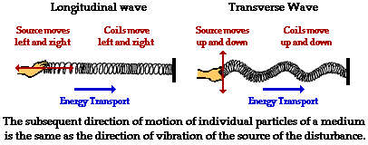

* Transverse:
  + ______________ moves _____________________ to the direction of wave movement
  + Like the wave in a stadium; _________________ waves are transverse
* Transverse Wave anatomy



* + ____________: Highest Point in a wave
  + ____________: Lowest point a wave
  + _________________: the __________ distance that the particles of wave’s medium vibrate from their ________________________
  + ____________________: distance from any point on a wave to an ___________________ ___________ in the next wave
  + ______________: time it takes to ______________________ or wave oscillation to occur
* Longitudinal Waves (aka _________________________________)
  + Medium moves in _________________________ as wave motion
  + ____________________ are longitudinal
* Longitudinal Wave Anatomy

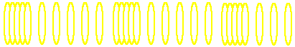

* _____________________: crowded or bunched up areas of the wave
* ____________________________: stretched out areas
* Amt of _____________________ corresponds to the amt of energy ~_______________

**Measuring Waves**

* _______________________(___)
  + _____ of waves passing a point in 1 second; SI unit: __________(1/s)
  + _________ wavelength=______________frequency=____________ energy
* ____________________(_____)
  + ___________of a wave as it moves forward
  + Depends on

$v=λ×f$ ________________________________________
  + v=______________, λ=_________________, f=________________
  + Speed (______________) of waves depends on __________________
    - Why? 🡪________________________________
      * In gases, molecules are ___________ apart so has to go through lots of _________________. Waves usually do _______ travel as fast in gases
      * In liquids, molecules are closer together. Waves are usually ________ in liquids than in _____________
      * In solids, molecules are really close together, These are usually the _______________ moving waves
* Measurement triangle for solving wave problems
* When have 2 things on bottom given in a problem, multiply them to get the answer
* If you have 1 thing on top & 1 thing on bottom given in a problem, divide the top by the bottom
* Example #1: Find the velocity of a wave in a wave pool if its wavelength is 3.2 m and its frequency is 0.60 Hz.
  + Given: Work:
* Example #2: An earthquake produces a wave that has a wavelength of 417 m and travels at 5000 m/s. What is its frequency?
  + Given: Work:

**Wave Interactions**

* ____________________: the bouncing back of waves when they hit a surface that they do not go through
  + If waves reflect at a ____________________________
  + 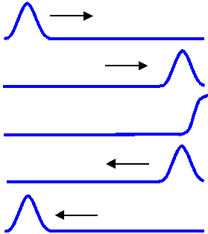The reflected wave is ________ like original wave except traveling in _________________ direction
  + 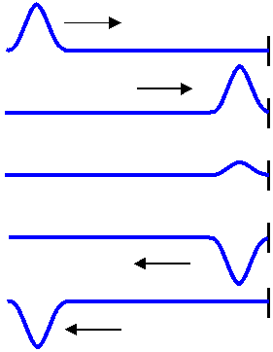If the wave is ________________ to something, then it is not a free boundary
  + Wave will reflect and turn upside down
* ____________________: a change in the _________________ of a wave when the wave finds an obstacle like an edge, such as an opening



* _____________________: the ______________ of a wavefront as the wavefront passes between two substances (________________) which the speed of the wave differs
  + Like when it looks like a straw is bent in water
* Interference:
  + The combination of __________________ waves of the same _________________ that results in a ________________ wave
  + Two types:__________________________________________
* Constructive
  + Any interference in which waves ______________ so that the resulting wave is _______________
  + Constructive interference ________________________________

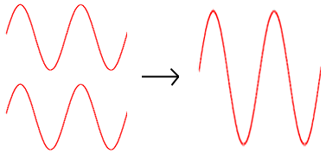

* Destructive Interference
  + Any interference in which waves _______________ so that the resulting wave is ________________ than the largest of the original waves. (may ______________________ completely)
  + Destructive interference ________________________________

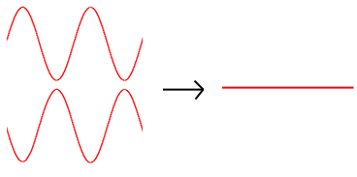

* Waves also can interfere in another way. Suppose you send a wave down a rope tied at the end. The wave is reflected from the wall and travels back along the rope. If you keep doing this, the wave traveling forward will _________ with those traveling back
* _________________ can form when a wave is reflected at the boundary of a __________
* Interference of the ______________ wave causes the medium to _____________ in a stationary pattern that resembles _________________________
* __________=points with ________ vibration; This is the point of complete ___________________ interference
* 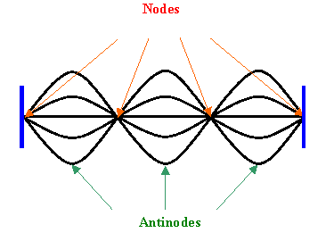_________________=points of _______________ vibration;

This is the point of complete

_____________________ Interference