Name________________________________Period____Date__________
Chapter 17-The Atmosphere

Section I: Atmosphere Characteristics
Composition of the Atmosphere-Major Components

- Has changed dramatically throughout Earth’s history
- ___________ started to accumulate about _______________-
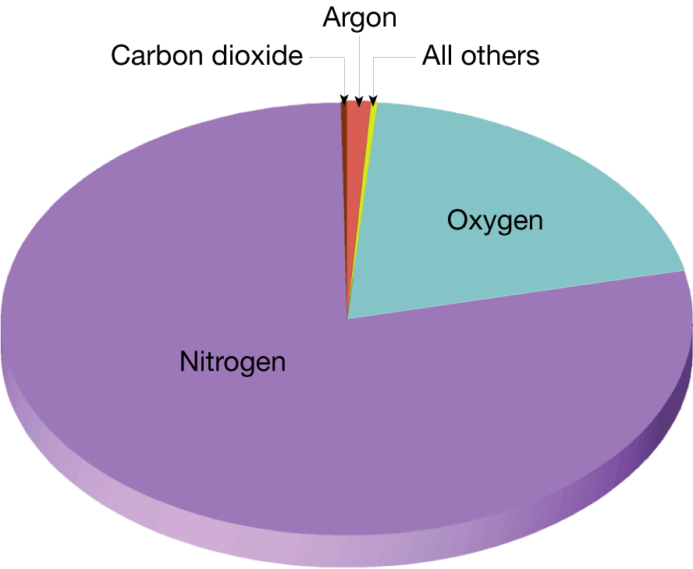
- _______ is a mixture of different ___________________, each with its own physical properties
- Composition
  - _________________
  - _________________
  - _________________
    - ________________
    - ________________
    - ________________
- _____________ is an active ____________________ given off by earth, so it plays a significant role in the ______________________________________

Composition of the Atmosphere-Variable Components
- Important materials that __________from time to time and place to place include:
  - ___________________
  - ____________________
  - _____________________
- Amount of ______________ varies from ___________________________ by volume
  - Water vapor is the source of all ______________________________
  - Like CO2, water vapor ________________________________________ ___________________________________________-
- __________________ of the atmosphere allow _________________ and other solid particles to be ________________ in it. Dust we see in the sky is too _______ to stay in the air very long. Still, many particles are microscopic and remain suspended for larger amounts of time.
- _____________ is another variable component of the atmosphere
- Ozone is a form of __________ that combines ______ oxygen atoms for every molecule ____________
  - Oxygen we breathe is __________
- There is very _______ ozone in the atmosphere and its _____________________, located in the _____________________
- The ozone layer is critical to _________ on earth
  - Ozone ___________potentially harmful __________________ from the sun
- If ozone didn’t filter out most of the UV radiation and all of the sun’s UV rays reached the surface of the planet, our planet would be uninhabitable for many living organisms

Human influence on the Atmosphere
- Air pollutants are __________________________________ that occur in concentrations large enough to endanger _____________ of organisms
- ___________ pollutants include: _____________________________________ ______________________________________________________________
- Emission from ______________________vehicles account for almost _______ of all primary pollutants
- ____________ pollutants are __________________________directly in the air
- They form when ___________ take place among _______________________ and other substances
  - Ex: Sulfur dioxide enters atmosphere, combines with oxygen to give sulfur trioxide, sulfur trioxide combines with water to create sulfuric acid (acid rain)
- Reactions triggered by _____________ are called ___________________ reactions
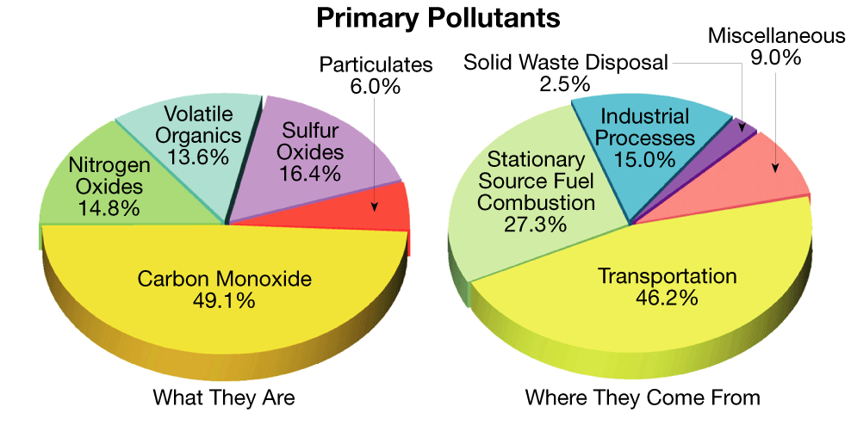
Height and Structure of Atmosphere
- The atmosphere rapidly _____________ as you travel ________ from earth until there are too ________ gas molecules to detect
- ___________ Changes
  - Atmospheric pressure is the ________________________
  - Atmospheric pressure is _________near sea level, and _______ in the mountains
- _______________ Changes
  - The atmosphere can be divided vertically into ____ layers based on ___________
    - _____________________
    - _____________________
    - _____________________
    - _____________________
_________________________
- _____________ layer of the atmosphere, ___________ to earth’s surface
- About _____________ high into the air
- _______________ layer of the atmosphere
- ________________________________ mostly occur here
- Gets ________________ as you go up in altitude
  - Decreases about 6°C for every km of altitude
- The ________________ exists as the ____________ of the troposphere
  - This is where temperature ______________________________
  - Tropopause keeps ____________________________________________
- Though it is generally warmer near the surface, _____ air sometimes gets ___________ beneath ________ air, called a _____________________
  - Can cause _________________________
____________________________
- Layer ___________ the troposphere
- Extends about ____________ into the air (so about _________ miles thick)
- Has little ____________, few _________, and no_______________
- Gets________________ as you go up in altitude
  - Remains at about -67ºF from the top of tropopause to about 16 mi
  - Then it starts to increase to about 32ºF
- The ___________ layer exists at the_______ of the stratosphere
________________________
- Layer ____________the ________________________
- Extends to about _____________ into the air, so its about ________ thick
- Temperature ___________ as you go_____in altitude (like in the _____________)
- This is the _______________ layer in the atmosphere; temperatures fall below -112ºF
- This layer has no well-defined upper limit
- This is where we see _________________ – meteors burning up as they fall to Earth

________________________
- The layer that exists between the ________________________________________
- In this layer, _______________ is absorbed and electrically charged ions are formed
- Electrons in the ionosphere ____________________, allowing them to be _____________over long distances
- Without the ionosphere, most radio signals would travel _____________________
- Because the ions require solar energy, the ionosphere is _______ (thicker) during the ___
- This means radio waves can travel ___________ into the atmosphere at ________ before being reflected.
- The radio waves return to Earth’s surface farther from their source than they do in the daytime
- The ionosphere is also where ________________ take place
  - Auroras form when energetic ions from the sun hit atoms and molecules in the ionosphere
  - Are seen encircling Earth’s Magnetic poles

_________________________
- Layer above the ______________, extends to about _____________ into the air, so it is about_____________thick
- This is the ______________ layer of the atmosphere
- Temperatures start to________________
  - Temperatures in this layer average around ______________
- The ______________ portion of the thermosphere at about 298 miles up, is known as the _____________________
  - Some gases escape the __________________ of the Earth and escape into ___________. Some gases are pulled in by gravity from space and add to the Earth’s atmosphere
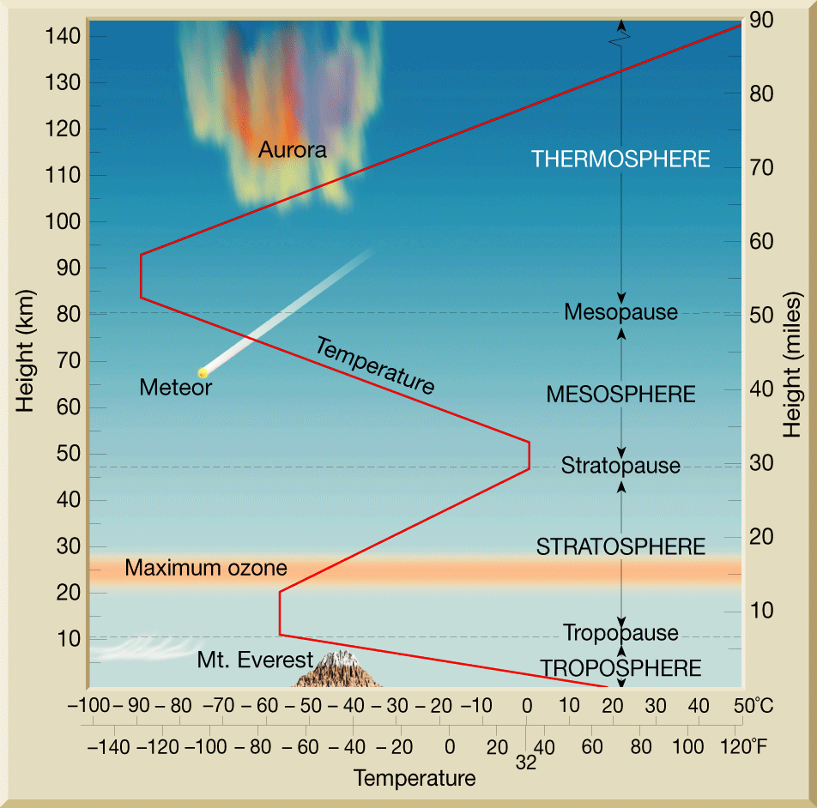
_______________________
- Region in ____________ (so ________ really a part of the atmosphere) whose ______ is determined by ___________________________________________________ ______________________________________________________________
- Here, a mix of free ions and electrons from ________________________________ is confined by __________________________________________
- Provides protection to ____________________

Section II: Heating the Atmosphere
Energy Transfer as Heat
- ________ is the ________________________ from one object to another because of _______________ in the object’s ___________________
- ________________ is a measure of the ____________________________ of the individual atoms or molecules in a substance
Electromagnetic Waves
- The _____ is the ultimate source of ________ that creates our ___________
- The sun emits ______________________________________________
Three Mechanisms of Heat Transfer
- ___________________
  - the transfer of heat _______________________________________
  - Energy is transferred through ______________ from one molecule to another
  - Heat flows from the __________ temperature matter to the _________ temperature matter
  - ________ are _______ conductors, _______ are ____________ conductors
  - This is the __________________ mechanism of heat transfer for the atmosphere
- ___________________
  - Much of the heat transfer that occurs in the atmosphere is carried on by convection
  - Transfer of heat by ____________________________________________ _____________________
  - Takes place in ________________________________________________
- ___________________
  - Radiation is the transfer of heat ____________________________________ __________________________________________________________
  - Unlike convection and conduction, which need material to travel through, radiant energy can travel ____________________________________
  - There are ____ laws governing radiation
  - ________________________________________________________
  - ________________________________________________________ ________________________________________________________
  - ________________________________________________________
  - ________________________________________________________
    - The atmosphere does not absorb certain wavelengths of radiation, but it is a good absorber of other wavelengths
What happens to solar radiation?
- Usually there are three different results
  - _______________________________
  - _________________________________________________________ _________________________________________________________
  - ____________________________________________________________________________________________________________________

- ______________________ occurs when light __________________ an object. Reflection radiation has the _________ intensity as ______________ radiation
- __________________ produces a ________ number of __________________ that travel in _______________ directions
- ___________________: about _____ of the solar energy that strikes the top of the atmosphere ________________________________________
- The __________________________ is the ________ of Earth’s surface and atmosphere from solar radiation being absorbed and emitted by the atmosphere, mainly by __________________________________
Section III: Temperature controls
- A _______________________________ is any factor that causes temperature to _________from place to ___________________________________.
- Factors other than latitude that exert a strong influence on temperature include heating of land and water, altitude, geographic position, cloud cover, and ocean currents

Land vs Water
- Land heats ____________ and to _________________ than water
- Land _______________ and to _______________ than water

Geographic Position
- Geographic setting can greatly influence temperatures at a specific location
  - Leeward-wind blows from ___________________________
  - Windward-wind blows from __________________________
  - Which has greater temperatures extremes:___________________
- Influence of mountains
  - Moutains act like __________________
  - Which will show more extremes: near coast or near mountains

Altitude:
- ______________________=________________________

Cloud Cover and Albedo:
- ___________ is the _________of ________ radiation that is reflected by any surface
- Many clouds have _______ albedo and therefore reflect back to space a significant portion of the sunlight that strikes them
- When have ____________________________________________________

World Distribution of Temperature
- _______________ are lines that _________ points that have the ______ temperature
- Isotherms generally trend from ______________ and show a __________ in temperatures from the _____________________

