Name_______________________________________Period_______Date_______________
Geology-Chapter 20&21 Notes
Weather & Climate

Differences between weather and climate
- _______________________
  - ______________________________________________
  - __________________________________________________________________ __________________________________
- _________________________
  - _____________________________________
  - _____________________________________
  - ______________________________________________________________________________________________
  - ______________________________

Chapter 20
20.1-Air Masses
- __________________: is an immense body of air that is characterized by _______________ _______________________________________________________________________________________________________________
- Movement of air masses
  - As it moves, the characteristics of an air mass ___________ and so does the _______________ in the area over which the air mass _____________
- In addition to their overall temperature, air masses are classified according to the _______ ______________________________________________
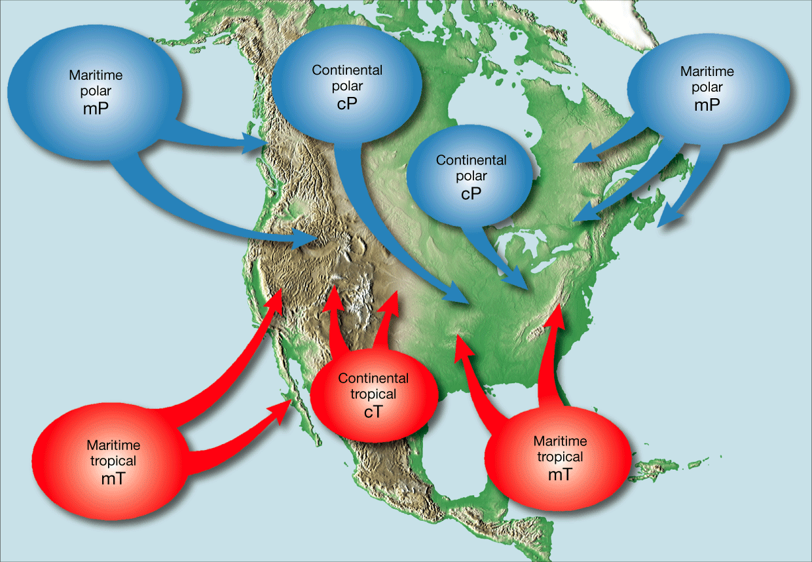
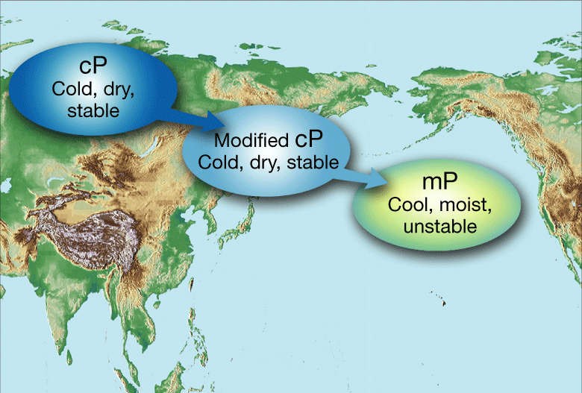

- Much of the weather in North America, especially weather east of the Rocky Mountains is influenced by__________________________________________________________________ _____________________________________
- Continental Polar Air Masses
  - Continental polar air masses are uniformly ______________________ in __________ and _______________________ in ___________________
- Maritime Tropical Air Masses
  - Maritime tropical air masses are ___________________________________________ _______________________________________
Maritime tropical air is the source of __________, if not most, of the ___________________________ received in the eastern two-thirds of the US
- Maritime Polar Air Masses
  - Maritime polar masses begin as _________ air masses in ______________. The __________________ continental polar air changes into relatively ______________ ________________________maritime polar air during its long journey across the North Pacific
  - Maritime Polar air masses also originate in the North Atlantic off the Coast of Eastern Canada
- Continental Tropical Air Masses
  - Only occasionally do cT air masses affect the weather outside their source regions. However, when a cT air mass moves from its source region in the ______________, it can cause extremely ___________________________________ conditions in the _____________________.
  - Movements of cT air masses in the ________ result in _________ weather in the ________________________ region, often called _____________________.

20.2 Fronts:
Formation of Fronts
- When two _____________________________, the form a ___________, which is a boundary that separates two air masses
Types of Fronts
- ____________________________
  - A _____________________ forms when ____________________ moves into an area formerly covered by _________________________.
- ___________________________
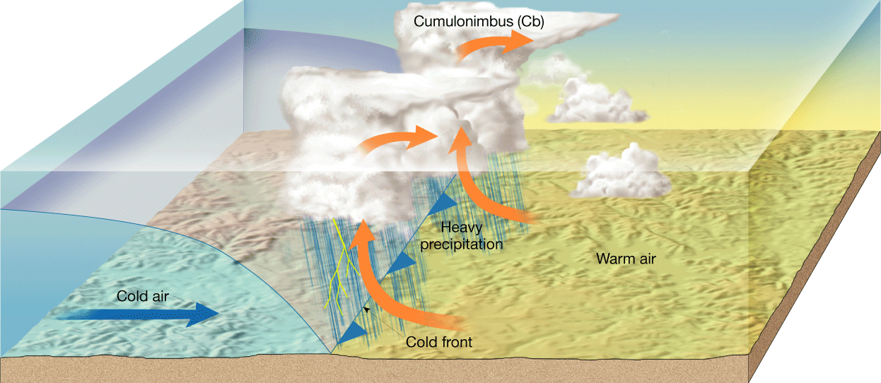
  - A _________________________ forms when _____________________________air moves into a region occupied by _________________________.
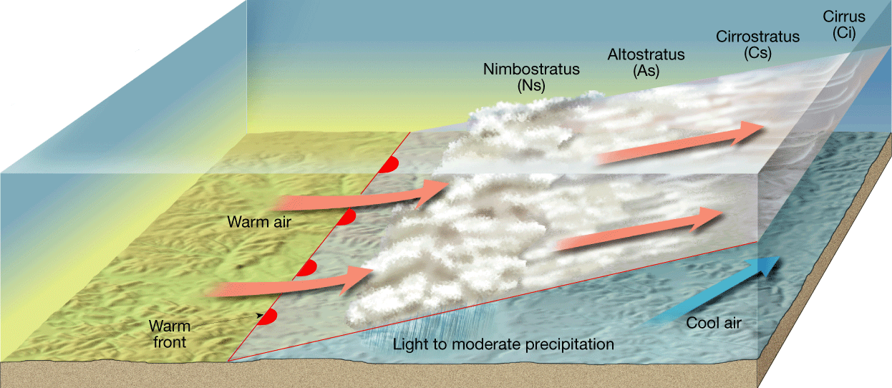

- ___________________________________
  - Occasionally, the _________________________ on either side of a front is neither toward the cold air mass nor toward the warm air mass, but almost ____________ to the line of the front. In such cases, the ___________________________ of the front _____________________________, and a __________________________ forms.
- _______________________________________
  - When an _____________________________ overtakes a ____________________, an _________________________ forms.

Middle-Latitude Cyclones
- Middle-latitude cyclones are _______________________________________________ that generally travel from _________________________ and cause ________________________.
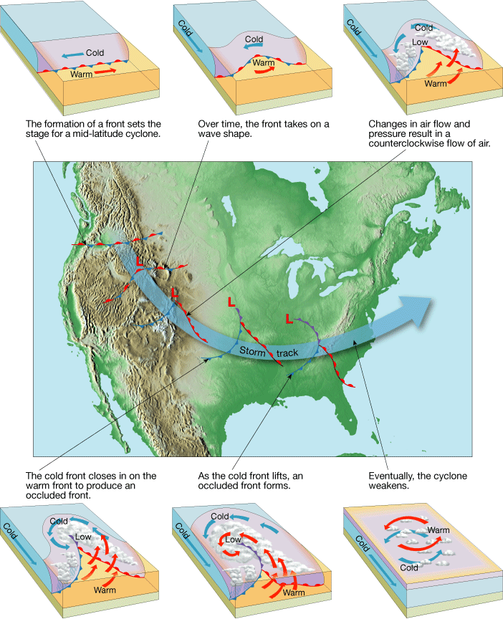
- The Role of Airflow Aloft
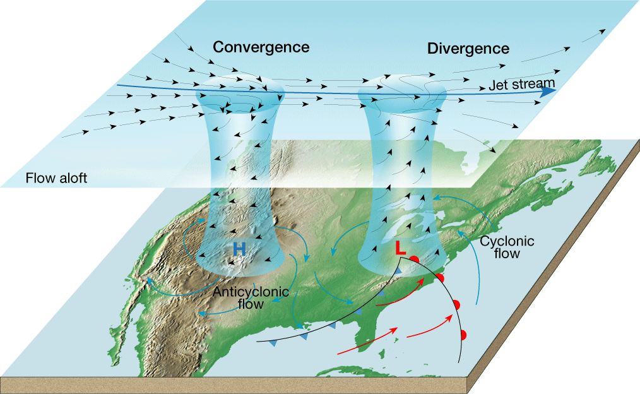
  - More often than not, air _____________________________________fuels a middle-latitude cyclone

20.3-Severe Storms
Thunderstorms
- A _____________________________is a storm that generates ________________________ ___________________. Thunderstorms frequently produce ____________________________ _________________________________________.
- Occurrence of Thunderstorms
  - At any given time, there are an estimated _________thunderstorms in progress on Earth. The greatest number occur in the ___________ where warmth, plentiful moisture, and ______________are common atmospheric conditions.
- Development of Thunderstorms
  - Thunderstorms form when ________________________________________ in an ___________ environment.

Tornadoes
- ____________________ are violent __________________that take the form of a _________ column of air called a ____________. The vortex extends _____________ from a ______________________________ cloud.
- Occurrence of Tornadoes
  - Most tornadoes form in association with _____________________________________
  - A ____________________ is a _____________cylinder of _______________________ that develops in the _____________________________.
- Tornado Intensity
  - Because tornado winds ___________ be measured _______________, a rating on the _______________ scale is determined by assessing the ___________ damage ___________________ by the storm.
- Tornado Safety
  - Tornado _______________ alert people to the _________________ of tornadoes in a specified area for a particular time.
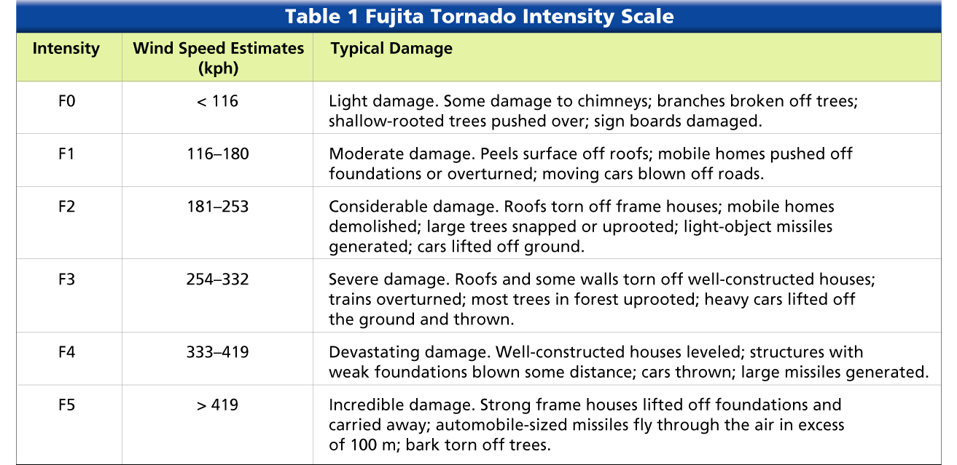
  - A tornado _________________ is issued when a tornado has ___________________ ___________________ in an area or is indicated by ___________________________.

Hurricanes
- Whirling _______________________________ that produce winds of at least ____________ are known in the United States as ________________________
- Occurrence of Hurricanes
  - Most hurricanes form between about 5 and 20 degrees north and south latitude. The ______________________ has the greatest number of storms, averaging ____ per year.
- Development of Hurricanes
  - Hurricanes develop most often in the _________________ when water temperatures are ____________ enough to provide the necessary ___________________________ to the air.
  - The ________is a zone of ____________________________________ averaging about _____________________ in diameter at the _______________of a hurricane.
  - The ____________ is a __________________-shaped area of intense _______________________ development and ______________________ that surrounds the eye of a hurricane.
- Hurricane Intensity
  - The intensity of a hurricane is described using a ______________________________
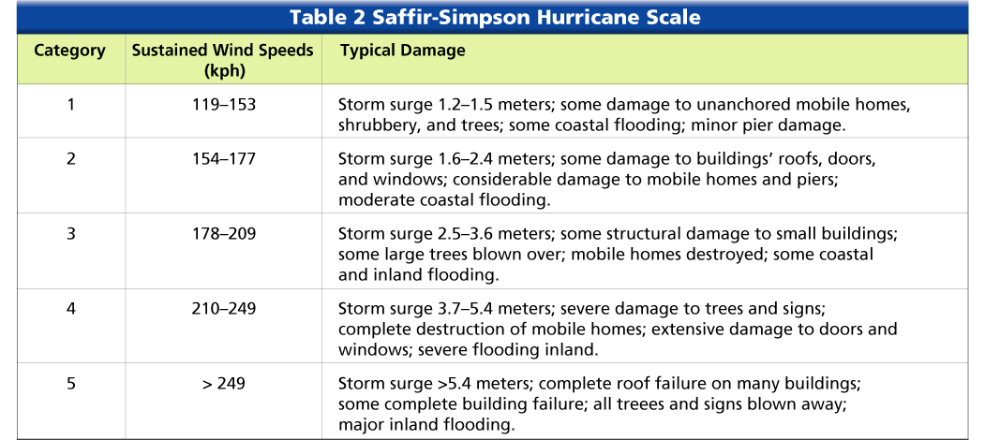
  - A ___________________ is the ___________________________ of the sea along a shore as a result of ___________________________

Chapter 21-Climate
21.1-Factors that Affect Climate
- _________________________
  - As latitude _____________, the intensity of solar energy __________________
  - The ____________________________ is between ______________________________ _______________________________________________________________________. The sun’s rays are most intense and the temperatures are always warm
  - The _______________________________________ are between _________________ _______________________________________________________________________. The sun’s rays strike Earth at a ______________ angle than near the equator.
  - _______________________ are between _____________________________________ _______________________________________________________________________. The sun’s rays strike Earth at a _______________________ angle in the polar zones.

- ___________________________
  - The ____________________ the elevation is, the ____________ the climate

- _______________________________
  - Topographic features such as _____________________ play an important role in the amount of __________________________ that falls over an area
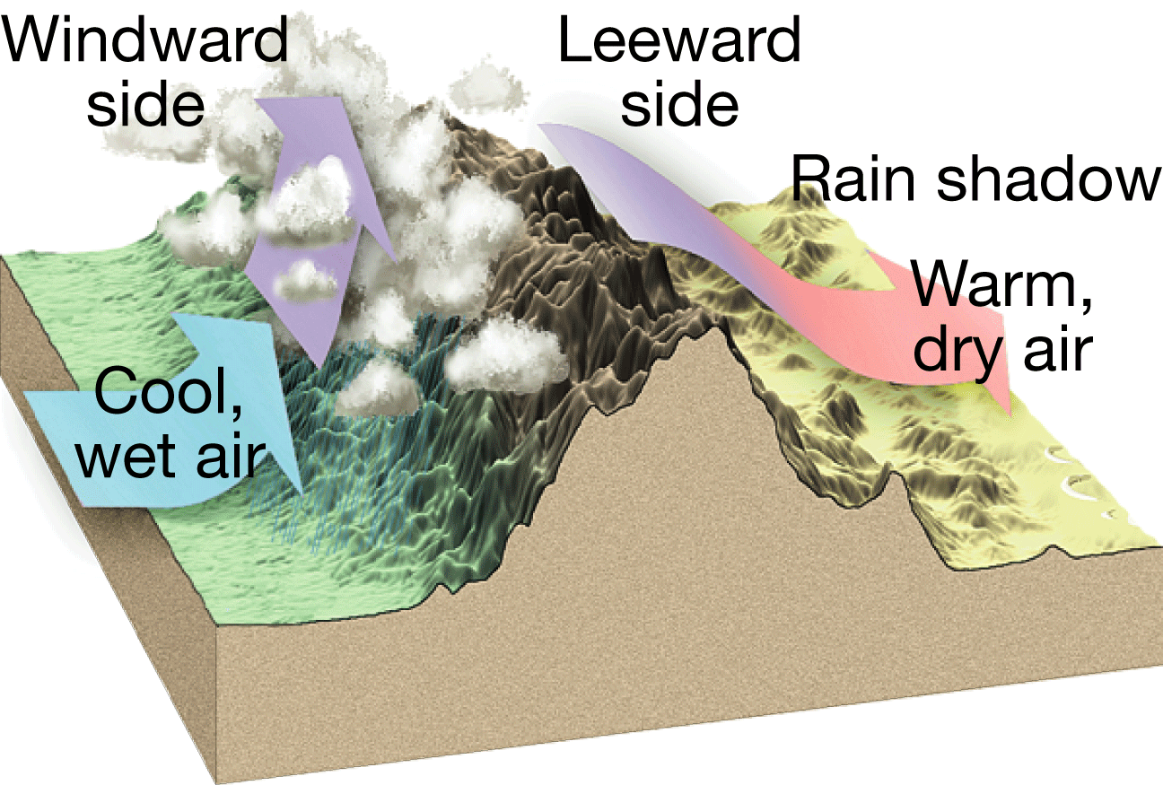

- _____________________________________
  - Large bodies of water such as ___________________________________ have an important effect on the temperature of an area because the temperature of the water body influences the temperature of the _______________________________.

- ______________________________________
  - _____________________ are another factor that influences climate because they ____________________________________________________________around Earth.

- ___________________________
  - Vegetation can affect both the _____________________________________________ patterns in an area

20.3-Climate Changes
Natural Processes that Change Climates
- _____________________________________________
  - The presence of volcanic aerosols (ash, dust, and sulfur-based aerosols) in the air __________________ the amount of _______________________ that is ___________ back into space. This causes Earth’s ___________atmosphere to _____________

- _______________________________________
  - Changes in ocean circulation also can result in ___________________________ climate fluctuations.

- __________________________
  - When the sun is ______________________, it contains dark blemishes called sunspots. The formation of sunspots appears to correspond with ___________ periods in ___________________________________________.

- ________________________________________
  - Geographic changes in Earth’s land and water bodies cause changes in climate.
  - Changes in the _______________________________ and the __________________ __________________ on its axis are other Earth motions that affect global climates.

Human Impact on Climate Changes
- _______________________________________
  - The greenhouse effect is a __________________________________ of both Earth’s _________________________________ and Earth’s ____________________ from ____________________________ being absorbed and emitted by the atmosphere.
- ____________________________
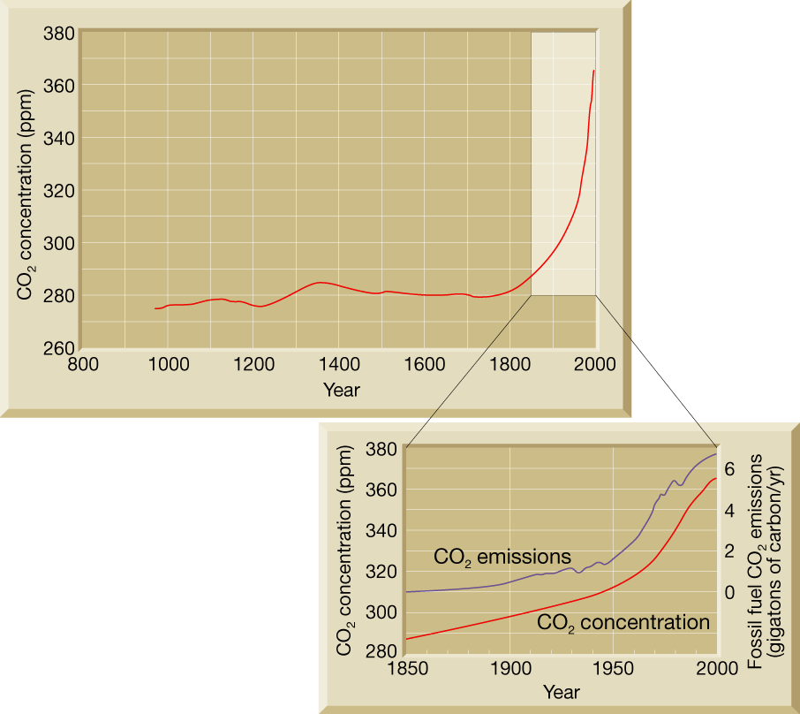
  - As a result of ________________________ levels of _____________________ and other greenhouse gases, _______________________________________________. This increase is called _____________________
