Name______________________________Period_____Date________

Chapter 22-Origin of Modern Astronomy
Guided Notes

22.1-Early Astronomy
Ancient Greeks
- ____________________ science that studies the universe. It deals with the _________________________________________________________________
- The Greeks used _________________________________ to explain natural phenomena
- The Greeks also used some __________________________________
- The Greeks used objects called_______________________ to track the position of the ___________

- _______________(384-322 BC) concluded that earth was __________________ because it always casts a _______________________________ on the earth
- Not widely accepted until much later
- ___________________________(276-194 BC) was the first person to successfully attempt to establish the ______________________________
- He observed the _____________________________________ in 2 Egyptian cities North and South of one another.
- Using the angles calculated, he proposed the earth’s circumference was _______________________, close to modern estimates of _______________________

Models of the Solar System
- __________________________
  - The __________________________________________ of the time (Mercury, Venus, Mars, Jupiter) orbited_________________________
  - Earth was a _________________________________ of the solar system and universe
- _______________________________________
- First proposed by ____________________________ (312-230 BC)
- ____________________________________________________
- This model not excepted until ________________ years later
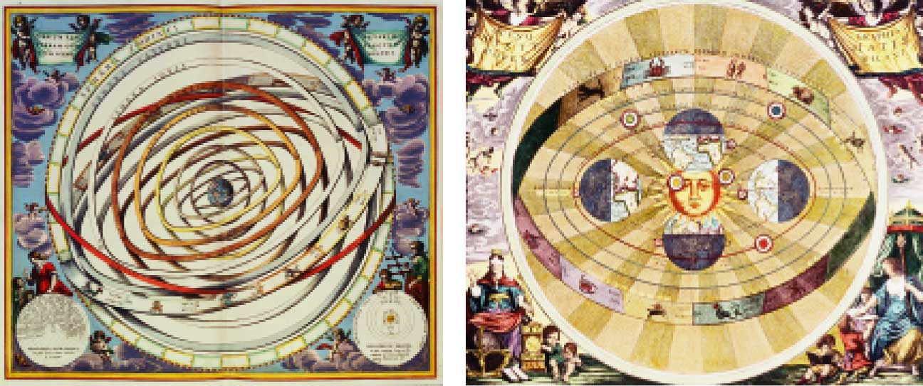

- ___________________________
  - Much of the knowledge of Greek Astronomy comes from Ptolemy.
  - He created a model of the universe that was called the Ptolematic System that accounted for the ____________________________________
  - Though universe as ________________________________
  - He saw the planets move _____________________ across the sky against a ____________ background. Sometimes, the planets would _________________ ___________________ for a time called a _______________________________ and then resume eastward motion

Modern Astronomy
- Now scientists began to discover the universe is governed by ____________________________________
- Major scientists-__________________________________________________________ _______________________________________________________________________

- _______________________ (1473-1543)
  - Concluded earth is a planet that__________________________________
  - Proposed solar system with the _________________________________
  - Used _________________________________________

- ______________________ (1546-1601)
  - Designed and built __________________________________________________ of heavenly bodies
  - Had fairly precise observations of ____________________________

- _________________________ (1571-1630)
  - Worked as Brahe’s assistant
  - Discovered ______________ laws of ____________________

- Orbits of the planets around the sun are____________________________
- Planets revolve around the sun at _______________________________
- There is a ___________________________ relationship between a planet’s _________________________ and its _______________________________
  - Described orbital periods with reference to the ________________
  - Planet’s distance to the sun is measured in ______________________________
  - The AU is the _____________________________________________________. It is about _________________________________
  - If Earth equals________period, Mars equals ______________ periods
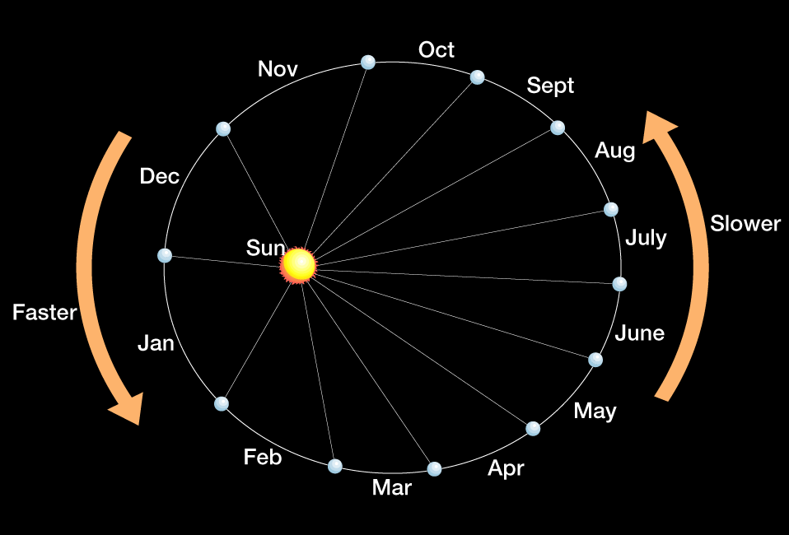

- ______________________(1564-1642)
  - Most important contributions were his descriptions of the ___________________ _____________________________________________
  - He developed his own telescope and made __________ important discoveries:
- ______________________________________________
  - Proved solar system was _______________________
- Planets are __________________________, not just points of light
  - Showed other planets must be _______________
- _____________has ________________ just like the _________
  - It must orbit the ________________________
- The moon’s surface is ________________________________
- The sun has ________________________________________

- __________________________(1624-1727)
  - Theorized the idea of _______________________
  - First to formulate and test the law of ___________________________________
    - Gravitational force ____________________________________
    - The ____________________________ of an object, the ___________________its gravitational force
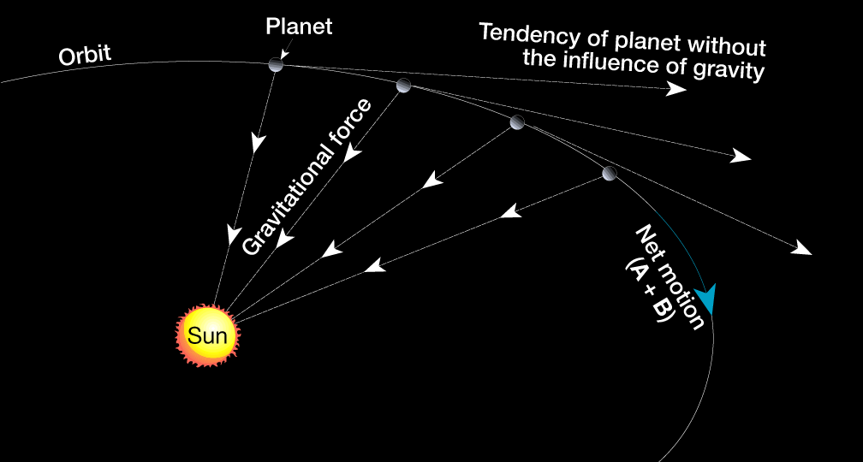
22.2-The Earth-Moon-Sun System
Motions of the Earth
- There are two main motions of Earth. They are ________________________________ ____________________________. ______________________________is a third and ______________________________________________________.

- Rotation: the ________________________________________________________
  - Two measurements for rotation
  - ___________________________________ is the time interval from one ________________ to the __________________, about _________ hours
  - __________________________________ is the time it takes for earth to make __________________________________________ (360 degrees) with respect to a _________________ than the _________-23 hours, 56 minutes, 4 seconds
- Revolution is the _______________ of a body, like earth, along a _________________ ______________ some _________________________________, in space.
  - Earth revolves around the sun at an average speed of _____________________ ______________. It’s average distance to the sun is ______________________
  - _________________ is the time in _________________ when the Earth is ____________________ to the sun
  - _________________ is the time in ____________ when Earth is the _____________________from the sun

Earth’s Axis and Seasons
- The imaginary plane that _________________ Earth’s orbit with the _________________________ is called the __________________________________
  - This plane is at approximately _____________________
- Because the inclination of Earth’s axis to the plane of the ecliptic (23.5°), Earth has its ____________________________
- ____________________________
  - _________________day of year, ________________________ than any other day, Occurs _______________, Official start of _____________________
- ____________________________
  - ___________________ day of year, ______________ sunlight than any other day, Occurs _______________________, Official start of ________________
- ______________________________
  - Occurs in between _______________________________________
  - ________________________ amount of sunlight as darkness
- _________________________
  - Occurs in between _________________________________
  - __________________amount of sunlight as darkness

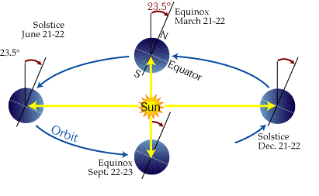
Earth-Moon System
- Earth has _________________________________________
- Moon orbits the earth in about _______________________
- Moon orbits earth in _______________________________
  - About _____________________________________
- At a point called __________________, the moon is _________________ to Earth
- At a point called __________________, the moon is ________________ from Earth

Phases of the Moon
- The phases of the moon are the progression of changes in the ____________________ ____________________________ during the month
- Lunar phases are a result of the _____________________________________________ __________________________________________________
- __________ the moon is ___________________________________________, but because of location of the ___________________, it does ______ always look half lit.
- When the moon is between the ___________________, none of the bright sides face earth so you get a _______________________
- The _______________ month is based on the cycle of the _______________________. It lasts ______________________________
- The _________________month is the ______________________ of the moon’s revolution around earth. It lasts _____________________
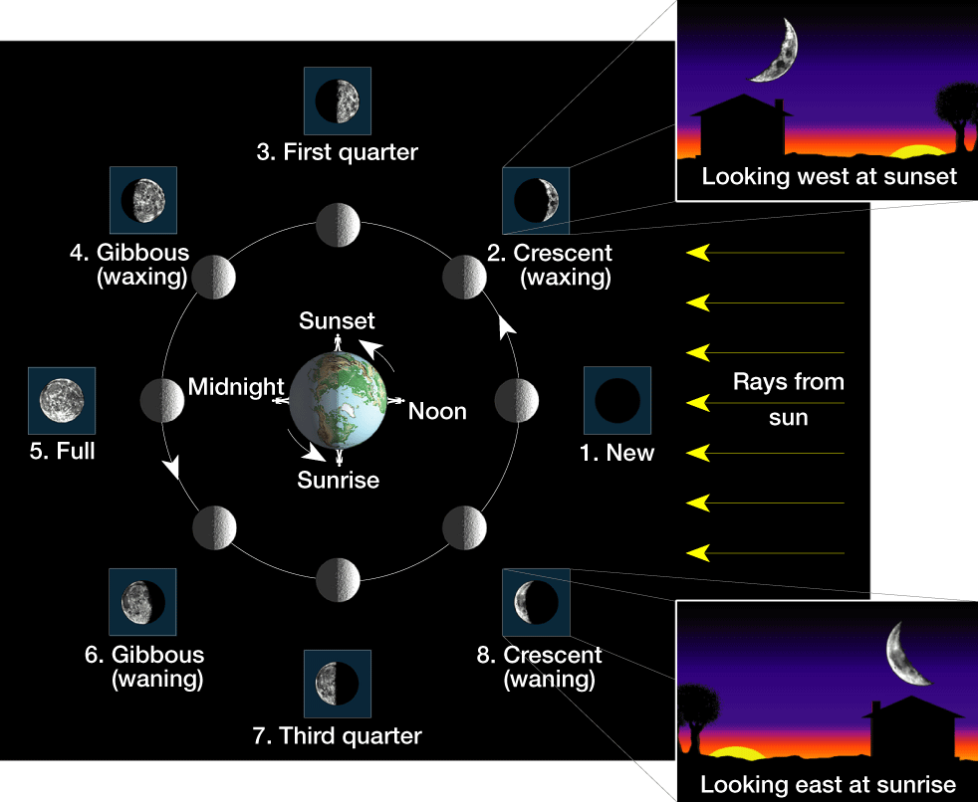
- The Major difference between the synodic and sidereal cycles is due to the __________ __________________________________________________________

Eclipses
- __________________________ occur when the _________ moves in a __________ directly between __________________________, casting a shadow on ___________
- ____________eclipses occur with the _______________________________________
- During a new-moon or full-moon phase, the ______________________ must cross the ____________________________________________ for an eclipse to take place
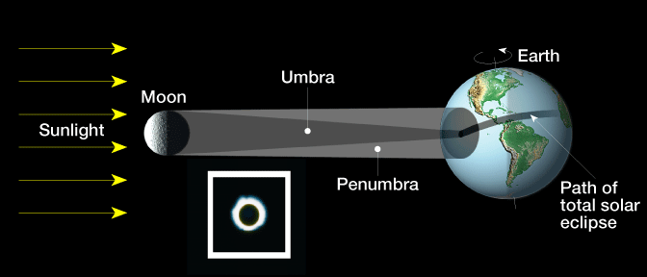

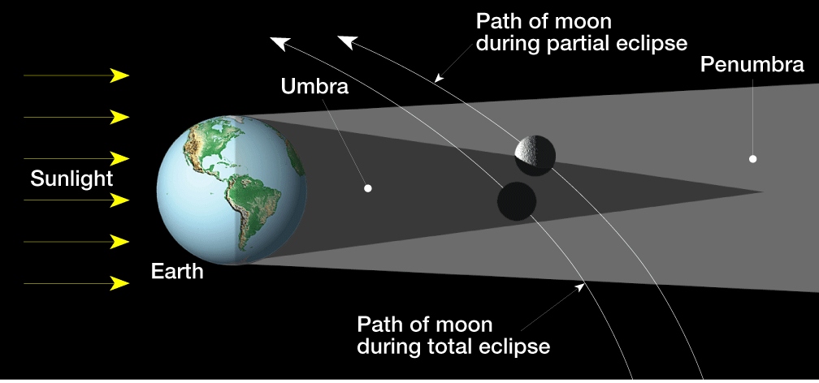

22.3-Earth’s Moon
The Lunar Surface
- Craters
  - A _______________is the ______________________at the ________________ (top) of a volcano or a depression is a __________________________________
  - Most craters on the moon were produced by _____________________________ _____________________
  - _____________ are any of a system of _________________________________, sometimes associated with craters on the moon
- Highlands
  - Most of the lunar surface, is made up of densely __________________________ _________________________________________________________________
- Maria
  - _______________________________________, originated when ____________ punctured the lunar surface, letting ____________________________
  - Lava filled the ________________ and ___________ to solid ___________ rock.
  - A _____________ is a ________________________ associated with lunar maria. It looks similar to a _______________________
- Regolitih
  - The lunar __________________is a ____________________________ on the __________________of the moon, consisting of _____________compacted, fragmented material believed to have been formed by repeated impact of _____________________
The Moon’s Age
- Scientists have concluded that the moon evolved in _________________ phases, the _______________________________________________________________________
- During it’s early history, the moon was _____________________________________as it swept up debris
- These attacks combined with ______________________________________, generated enough ___________________________________________________________and possibly the interior.
- Remnants of the __________crust occupy densely ______________________________
- The highlands have been estimated at _____________________________________

Steps of The formation of the moon
- Earth collided with a _________________________________
  - Happened when ________________________________; a ___________-sized body _________ earth and a large part of earth’s _______________ was blasted into__________
- ___________________________________________
  - The debris began to ______________ together to form the moon. Debris consisted of _____________________.
- _________________________________________
  - After the moon ____________________, starting ______________________ due to Earth’s _________________________________

Topographic features of the Moon
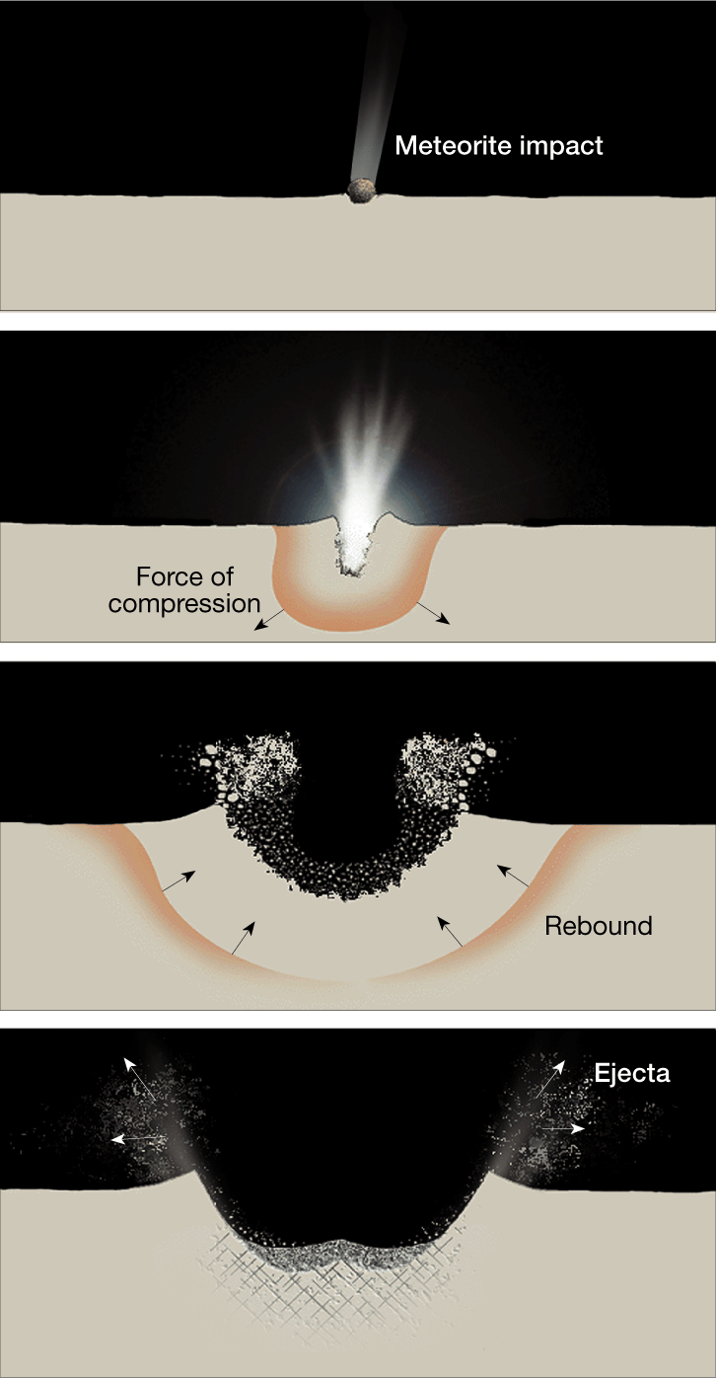
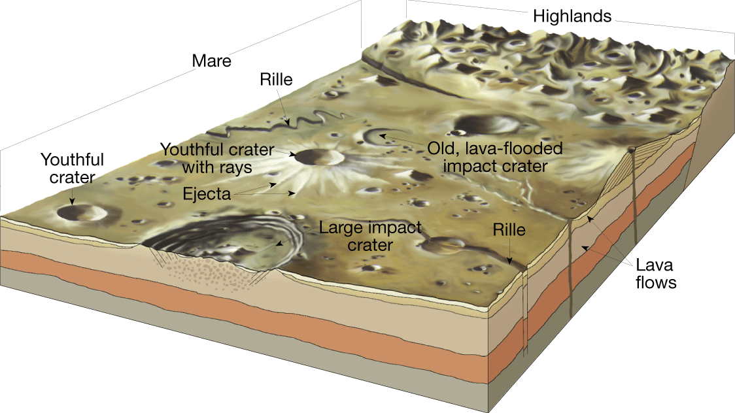
Formation of a Crater:
Surface of the Moon
