Name_______________________________________________Period_______Date________________
Chapter 22 Review
- Which astronomer first estimated the size of earth?

- What was the first astronomical tool used to track the position of the sun called?

- Which ancient Greek FIRST said earth was round?

- Which model of the solar system proposed that earth was in the center with everything revolving around it?

- What is the heliocentric model?

- In the geocentric model, how was earth described?

- What is retrograde motion?

- Which model of the universe did Ptolemy use?

- Which astronomer first concluded that earth was a planet that revolved?

- What do planets orbits look like?

- What are Kepler’s 3 laws of planetary motion?

- What is an AU and what does 1 AU equal?

- What were Galileo’s 5 important discoveries?

- Since Jupiter has satellites, what does this prove about the model of the solar system?

- Does gravitational force decrease or increase with distance?

- What are the three motions of the earth?

- What is meant by mean solar day?

- What is meant by mean sidereal day?

- When is earth closest to the sun?

- What is the angle of the plane of the ecliptic?

- What is it called when there is an equal amount of daylight as darkness in day?

- What is it called with there is more sunlight than any other day of the year?

- What does moon’s orbital path look like?

- What is the point called where the moon is farthest from the earth?

- How much of the moon’s surface is lit at all times?

- What is it called when a moon is “growing”?

- What is it called when the moon is in between the earth and sun, and it looks like there is no moon?

- Name and draw the phases of the moon in order starting with a new moon.

- Predict AND NAME the next moon in the following sequences:
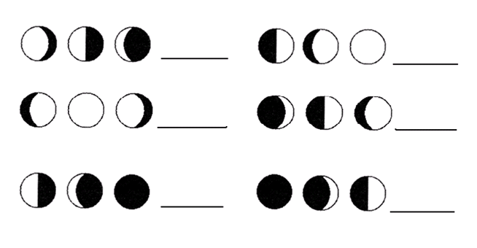
- When will a solar eclipse occur?

- When will a lunar eclipse occur?

- What is a crater?

- What caused most of the craters on the moon?

- What is maria?

- What kind of rock is formed after magma cools into craters?

- What is regolith?

- How old is the moon?

- What are the three steps that formed the moon?

