Name________________________________________________Period______Date_______________

Chapter 23 Guided Notes-Touring Our Solar System

23.1-Origin of the Solar System

Solar System Basics
- The sun is at the ___________of our solar system, with _____planets _____________ around it
- The sun accounts for _____________________ of our solar system
- All planets orbit the sun due to the sun’s _______________________________ in an ______________________ and all travel in the ____________________________
- The _________ the planet is to the sun, the ____________ it revolves around the sun

Overview of the Planets
- Planets fall in to two groups:
  - ____________________________________
- Terrestrial planets are ________________ than Jovian, and are relatively _______________________________________
  - Include ____________________________________________
- Jovian planets are _______________________________________
- Include __________________________________________
- Remember, Pluto _____________________________________________________________ anymore. (we’ll talk later about this)
- ____________________ is the most obvious difference between Terrestrial and Jovian planets
- Terrestrial are ________________________________________________
- Density, chemical makeup, and rate of rotation are other ways in which the two groups of planets differ.
  - Terrestrial ________________________(_________greater than water)
  - Terrestrial ______________________
  - Terrestrial ___________________, Jovian are________________
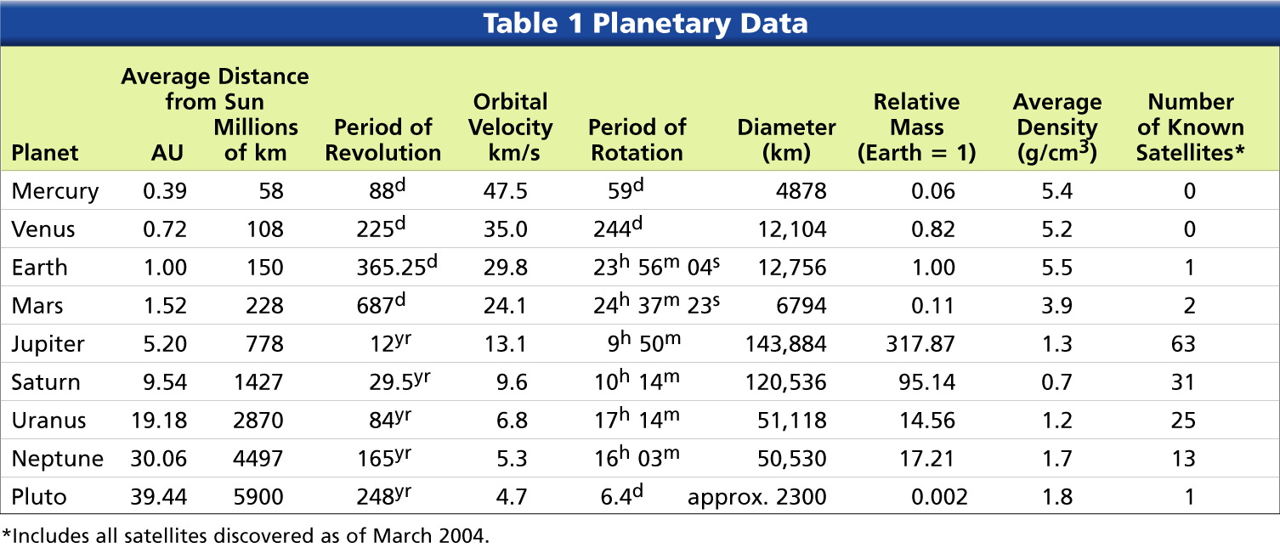
The Interiors of Planets
- Substances that make up the planets are divided into 3 categories: ____________________ _____________________________________________________________
- The gases-_________________________________________________
- The rocks are mainly ___________________________________________________________
- The ices include _____________________________________________________________ and have intermediate melting points
The Atmospheres of Planets
- A planet’s ability to retain an atmosphere depends on its _____________________________
- If hotter and ____________________________________
- If colder and ____________________________________
- _____________ planets have very ______________________________
- _______________ planets have meager and __________________________________ layers
Formation of the Solar System
- ______________________________________________________
- Usually ______________________________________________________________________
- For some reason, these _______ clouds begin to ___________________________________ gravitationally
- As they contract, they spin __________________
- According to the __________________________, the sun and planets formed from a ___________________________________________________________________________
- As the speed of rotation _____________, the center of the disk began to ______________.
- Matter began more concentrated at the ___________where the _______ eventually formed
- The planets began to form through a process called _________________________________ ______________________________________________________________
- With terrestrial planets, temperatures were so _________ that ________________________ _____________ materials could form solid grains
- With Jovian planets, temperatures were so _______that__________ of water and other substances could form.
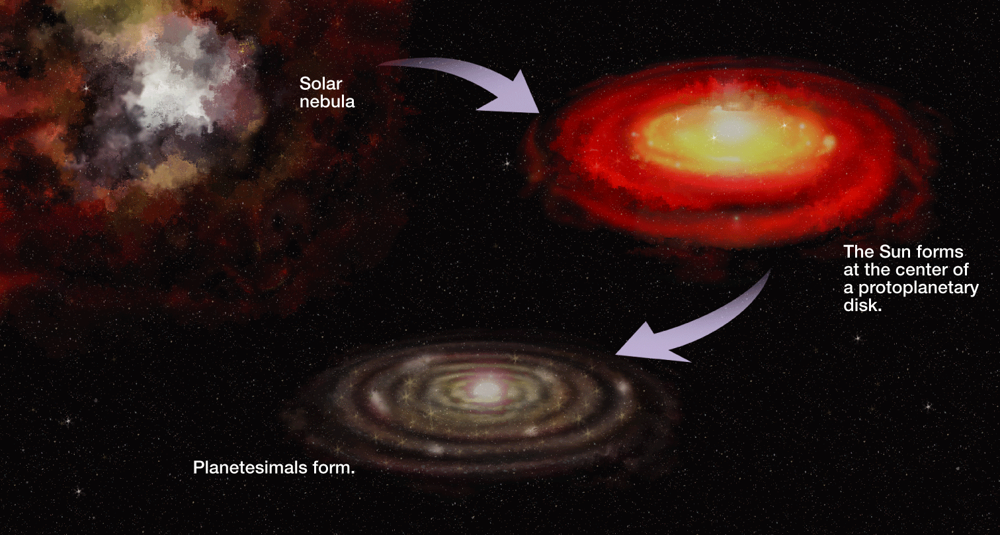

23.2- The Terrestrial Planets
- Include ____________________________________________________
Mercury
- Mercury is the _________________ and _________________ planet; it is hardly larger than _____________________.
- Mercury takes ______________ to rotate on its axis (takes 24 hours on earth)
- Has _______________________________
- Mercury’s surface has cratered _________________, much like the moon, and vast smooth terrains that resemble _____________________.
- Temperatures- Mercury has the greatest _______________________ of any planet.
  - Can range from ___________________________ during the day
- Mercury has _______________________
Venus
- Venus is similar to _____________in size, density, mass, and location in the solar system. Thus, it has been referred to as “Earth’s twin.”
- Revolves around the sun in ___________________ (365 on earth)
- Surface Features
  - Venus is covered in ___________________ that visible light _____________________ ______________________.
  - About _____ of Venus’s surface consists of __________________________________ _____________________________.
  - Only _______________ of venus’s surface consists of ________________________
- Venus’s Atmosphere
  - Can be _____________________
  - Atmosphere is ___________________________________________
  - This leads to a large ______________________________________________________ ________________________________________________________________________
  - Only small amounts of water vapor and nitrogen have been detected
  - Venus has _____________________________
Earth
- ________________planet from the sun
- Rotates on axis every ____________________
- Revolves around sun every ___________________
- Relatively _____________ atmosphere made of mostly ___________________
- Earth has ___________________
Mars: The __________ Planet
Atmosphere
- The Martian atmosphere has only _____________ of the _____________ of Earth’s.
- Although the atmosphere of Mars is very ___________________________________ and may cause the _____________________ observed from Earth.
Surface
- Most Martian surface features are old by Earth standards. The highly cratered ___________ hemisphere is probably ______________________________ years old.
- Some of the “newest” volcanic regions are at least____________________________
- Has the solar system’s biggest ___________, _______________________ (size of Ohio, _______ times taller than Mt. Everest)
- Gets the name Red Planet from the ______________________ on the Surface
- Has _____________________
- Water on Mars
  - Some areas of Mars exhibit _____________________________ similar to those created by streams on Earth.
  - Images from the Mars Global Surveyor indicate that _________________________ has recently migrated to the __________________.

23.3- The Jovian Planets
- Includes ______________________________________________________
- Separated from the Terrestrial Planets by the ______________________________________

Jupiter
- Jupiter ______________ planet from sun
- __________________planet
- Has a mass that is ____________________________________ than the mass of all the other planets and moons combined
- ____________________________________
- Known for _______________________, a big ________________ that is _______times the size of earth
Atmosphere
- Made of mostly ____________________________________________, and also contains small amounts of methane, ammonia, water, and sulfur compounds
- The ______________ you see on Jupiter are huge ______________________
- Gives off ______________ as much heat as it ________________ from sun
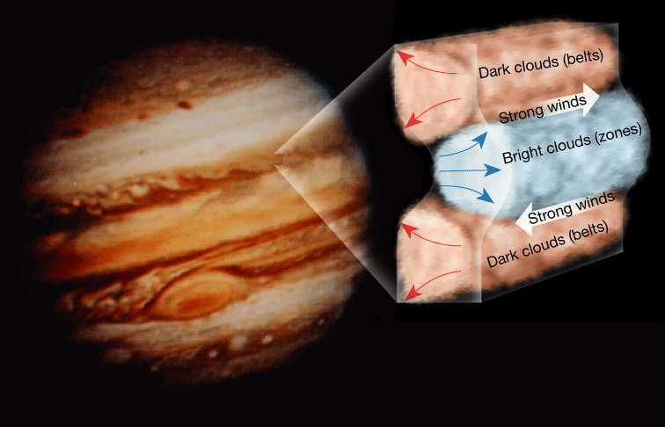

Jupiter’s Moons
- Jupiter has ___________moons, including the _________________________
- _____________________________________________
- __________________-Believed to have _______________________________________ ________________________________
- _______________________________________________________________________
- ___________________________________________________________ in solar system
- Jupiter’s Rings
  - Jupiter’s _________________________ was one of the most unexpected discoveries made by the __________________________

Saturn
- The most prominent feature of Saturn is its ______________________________
- Features of Saturn
  - ______________planet from sun
  - Takes _________________________ to make one ________________________ around the sun
  - Saturn is almost ______________________ from the ___________________________
  - ____________________________

  - Saturn’s atmosphere is very active, with winds roaring up to ____________________
  - __________________________________ similar to Jupiter’s Great Red Spot, but much smaller, occur on the surface
  - Rings of Saturn are very complex
  - Saturn has many moons-________________
- Saturn’s Rings
  - Until the discovery that Jupiter, Uranus and Neptune have ring systems, we thought it was just Saturn
  - Most rings fall into one of two categories based on ______________________
    - Main rings, A & B are ______________________________
    - The _______________ are composed of widely _________________________
- Saturn’s Moons
  - Saturn’s satellite system consists of 31 moons
  - _______________ is the largest moon
    - Titan is __________________
    - Has a thick _____________________ atmosphere with _______________ and photochemical smog
    - It may have ___________________________________ oceans, rivers, and rain

Uranus
- The ____________________________________
- Instead of being generally perpendicular to the plane of its orbit like the other planets, Uranus’s ____________________________ lies nearly_______________ with the plane of its orbit.
- This causes it to look like its ____________________ instead of spinning, which could have been caused from a _______________________
- ________________ planet from sun
- ________________________________
- Atmosphere is mostly ___________________________________
- Atmosphere gases give it a _____________________ color
- Has ________________________________
- Has _________________, small moons

Neptune
- _______________ planet from sun
- Known as the ______________________
- Winds exceed over _____________________________
- Also has a ____________________________________(a giant storm)
- _____________________________________________
- Atmosphere made mostly of ________________________________
- ________________ color from atmospheric gases
- _______________________________
- _______________ known Moons
  - _______________ is largest, about the size of Earth’s Moon
  - Lowest surface temperatures measured in the solar system at -200 degrees Celsius
  - Only ____________________ that exhibits ______________________________

Pluto
- Pluto was decommissioned as planet in ___________________, now classified as ___________________________
- We will get into what it is classified later
- Pluto does not follow the trends of other Jovian Planets
  - ___________________
  - _____________________
  - ______________________________________________
  - ___________________________

23.4-Minor Members of the Solar System

Asteroids
- An asteroid is a ___________________________________ whose diameter can range from a __________________________________________________________________
- Most asteroids lie between the orbits of ______________________________. They have orbital periods of ____________________________
Comets
- ____________ are bodies made of _______________________________ held together by ________________gases. Comets generally revolve about the sun in _____________________________________________.
- _______________
  - ___________________ component of a comet’s _________________
  - A small growing nucleus with a diameter of only a few kilometers can sometimes be detected with a coma. As comets ____________________________, some, but not all, develop a _________________that extends for ______________ of kilometers
- Comet’s tail points _________________ from the sun

_________________ Belt
- Encompasses the region of the solar system past ____________________
- ______________________ is the largest member
- The belt was discovered in______________________
- Known KBO are over ______________ but believed to be over ______________ total
- Orbits are close to the same plane as the planets

___________ Cloud
- Comets with long orbital periods appear to be distributed in all directions from the sun, forming a spherical shell around the solar system
- This is ________________________________________ than the Kuiper Belt

__________________ Comet
- Most famous short period comet
- Orbital period is ____________________
- The next time we will be able to get a good look at it is ______________________

Meteoroids, Meteors, Meteorites
- _____________=_______________________________________________________
- __________=luminous phenomenon observed when a meteoroid enters ________________ _______________________ and burns up, popularly called a _________________________
- ________________= _____________of a _______________that reaches earth’s __________

Most meteoroids originate from any one of the following three sources:
- ___________________________________________________________________________________________________________________________________________________________
- ______________________________________________
- _____________________________________________________________________

