Name________________________________Period_____Date______________
Chapter 25 Guided Notes: Beyond our Solar System

25.1: Properties of Stars
What is a star?
- Huge _________of very hot ______that emit ______________________
- The sun is the ____________________to earth
- The next closest star is _______________________, which is _________ _____________ times farther away from Earth than the __________
- On a clear night you can see about ____________ stars

- Stars are driven by ______________________reactions
- A star is made of mostly __________________________________
- A star is held together by _____________forces from its own _________
- Nuclear fusion takes place in the ______________ of a star
- _________________is released as ______________________________

- ___________________: an apparent ____________________ originally named from mythical creatures. The sky contains ________ constellations
Measuring Distance to Stars
- ______________: the slight _______of the _______________________ of a star due to the ___________motion of Earth
  - The ______________way to measure distance
  - The ______________stars have the _____________parallax angles, while those of _____________stars are too __________ to measure
  - _________parallax angles are still _____________ or smaller than _____________of an arc
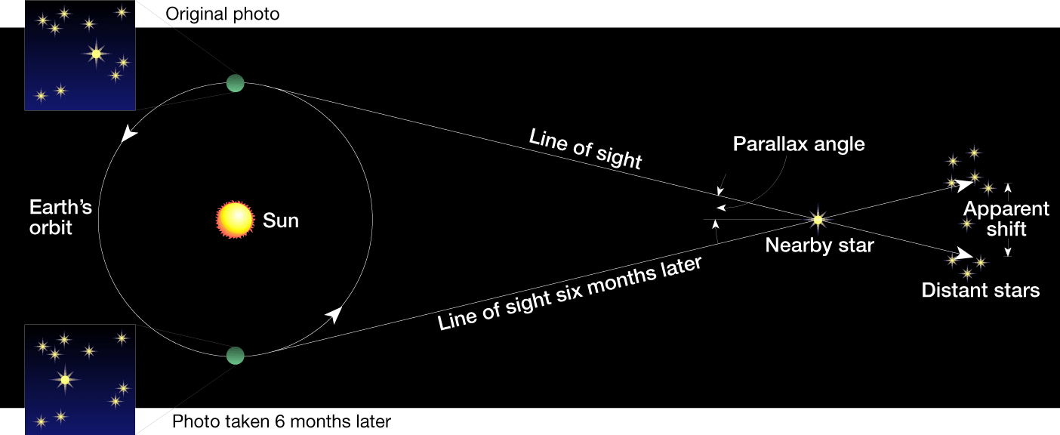
- _____________: the _____________which a ray of light would travel in ______________________
  - 1 light year = _______________________
  - Proxima Centauri is about _________ly away from the sun
Binary Stars and Stellar Mass
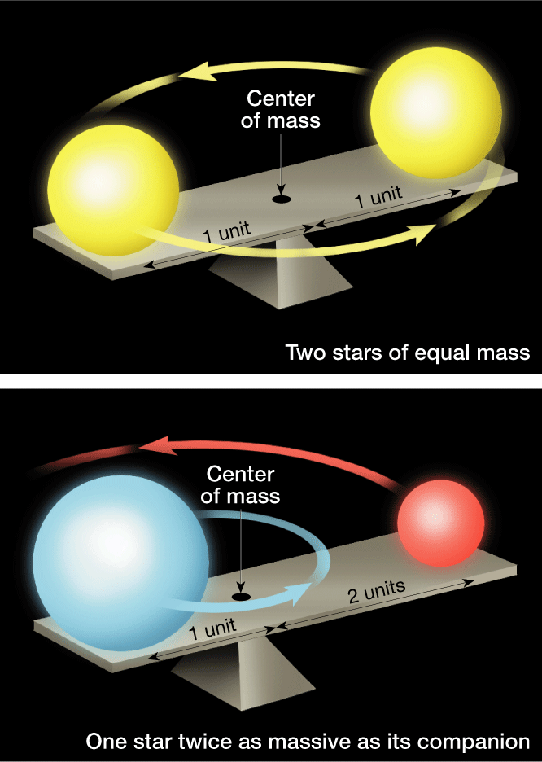
- A ____________________ is one of ____stars revolving around a common _________________________ under their mutual ___________________
- More than __________of the stars in the universe _______________ in pairs or multiples
- Binary stars are used to determine the star property most difficult to calculate: _________________
- For stars of ____________mass, the center of mass lies _____________ __________________between them
- If one star is more mass than its partner, their common center will be ________________________ _________________________. If the size of their ___________are known, the mass can be determined.

Brightness (luminosity)
- _____________________(brightness)
  - A measure of __________________of celestial objects
  - ___________________________values represent _____________ objects, ___________ values represent _________________objects
- _____________________________
  - How bright a star ________________________________
  - Brightness depends on _____________________________________ _______________________________________________________
- ______________________________
  - _________________________________________

Star Color and Temperature
- Color is a clue to a star’s ________________
- Very ________ stars emit light in __________wavelengths, so they appear more ___________
- ____________stars are much ___________, and their wavelengths are ___________________
- Stars are classified by ______________________________
- Remember: __________________________________________________ _______________________________________________
- ___________objects glow with light that is ______intense, and has ________________ wavelengths
- The hottest type of star is a _______________________
- The coldest type of star is a ________________________
- The sun is a ________________________________

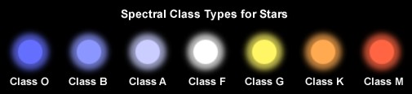

H-R Diagram
- Stands for ___________________________________Diagram
- A _________________ to study the stars
- Shows the relationship between the _______________________________ ______________________________________________
- Y axis:___________________________ X axis:_____________________

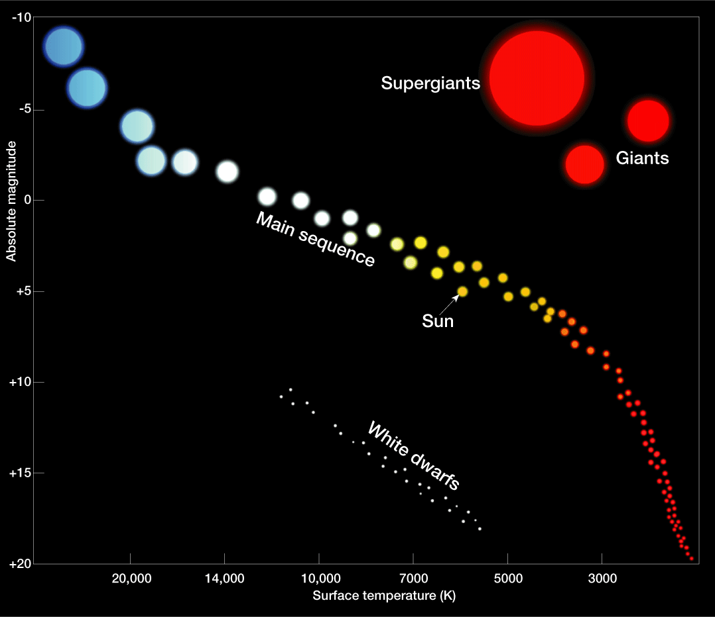

- A ________________________star is a star that falls on the main sequence category on the H-R diagram. This category contains _______of the stars and runs __________________from the _____________________________ ______________________________________
- The __________________stars are about ______times more massive than the __________, while the _________________stars are only about ______ the size of the sun
- The graph shows stars from _________________stars to _______________ stars
- A ____________is a _____________star of ______________________, it occupies the ______________________portion of the H-R Diagram
- A ____________________is a _________________________red giant star
- The ___________________(though not all white in __________) are much ____________ than main sequence stars of the same ________________ Some are probably no bigger than ____________. They occur in the ___________________________part of the H-R Diagram
- ____________________
  - A ______________variable star is a star whose _______________ _____________periodically because it _______________________; it is a pusating type of star
  - A ______________is a star that explosively ________________ in ________________________
    - Scientists think that novas occur in _____________systems consisting of a expanding _____________and a nearby ______________________
- ______________________
  - A ___________ is a cloud of ___________________ in space
  - There are _____major types of nebulae
  - ________________-if close to a _______star
    - _______________ nebula-mostly _______________
    - ___________________nebula-reflects light of nearby stars
  - _____________________-if ______________________to a bright star to be lit up

Section 2: Stellar Evolution
Star Birth
- Stars __________their lives as __________________
  - In the Milky Way Galaxy, nebulae consist of ___________________ _________________________________
- _______________may cause the nebula to ________________
- _______________ in the gas cloud will begin to ________________into a _______________region called a _____________________
- A protostar is a __________________ star ______________________ to engage in _________________________
- When the _______ of a protostar has reached about 10 million K, ____________ is so great that nuclear fusion begins, and a star is _____

Main sequence stage
- Once nuclear fusion ________, the star is now it is __________________ stage where it spends about _____________ of its life
- Life span depends on _____________
  - Very _____________stars burn their fuel much __________, and only last a few _________________________
  - ____________stars will live on for _______________of years because they burn their fuel much __________________
- Eventually, the star’s fuel will begin to ____________________

- As nuclear fusion slows, the _____________fuel source is depleted, and a star ______________________
- With the exception of ______-mass _____stars, a star can _______ its death by fusing ____________elements and become a giant
- ________________mass stars become ________________
- ________________stars become ____________________
Red Giant/Supergiant Stage
- ________________burning migrates ___________. The star’s ______ envelope _____________(and becomes a giant)
- Its surface __________ and becomes ___________
- The __________________ as _____________ is converted to ________. Eventually, all nuclear fuel is used and _______________ squeezes the star
  - Average star=______________
  - Massive star=__________________
Burnout and Death of Stars
- ______stars, regardless of ________, eventually run out of fuel and collapse due to _____________
Death of Low Mass Stars
- Stars _____________________mass of the sun _________evolve to the _____________ stage, but remain in the stable ____________________ stage until they consume _____________________fuel and collapse into a ________________________
- Low mass stars don’t get ____________ to fuse _________ so only fuel source is ___________________
Death of Average/Medium Mass Stars
- Stars with masses _____________________ evolve essentially the same way as ____________________
- During their collapse from ___________________________________, medium mass stars are thought to cast off their bloated ________layers, creating an ___________round cloud of _______ called a ____________ _____________
Death of Massive Stars
- Stars that are over ________the mass of the sun have relatively _______ life space, which end in a _________________ explosion event
- A ____________ is an __________________ that _______________ in __________________ many thousands of times
  - Supernova are ____________, none have been observed in the galaxy
- The massive star’s ______________ condenses and may produce a ______ ____________object that is either a _____________________________

Burnout and Death
- H-R Diagrams and Stellar evolution
  - H-R Diagrams have been helpful in formulating and testing models of stellar evolution
  - They are also useful for illustrating _________that take place in an __________________________during its life spac
Stellar Remnants
- White Dwarf: a ________that has exhausted _________________ of its nuclear fuel and has ____________ to a very _________________, believed to be near its __________ stage of evolution
- The sun begins as a ____________ spends much of its life as _________ _______________star, and then becomes a _________________, a _______________, a _____________, and finally a _________________
- ______________: a _________extremely ________________ composed entirely of ________________
  - Neutron stars are thought to be the remnants of _______________ events
- _________________: A ___________ star that has collapsed to such a __________________ that its _______________________ the escape of _______________________________
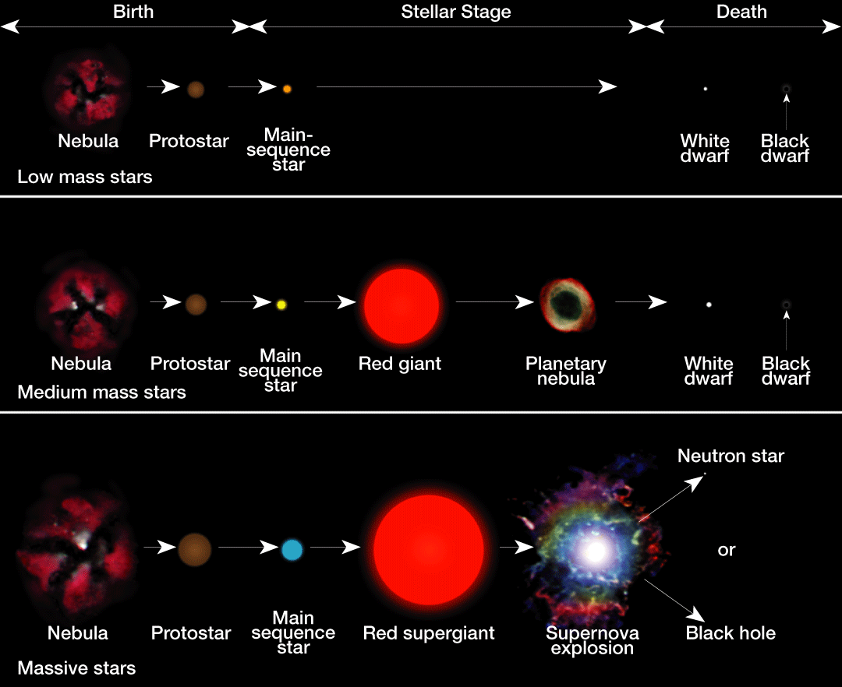
  - Scientists think that as matter is pulled into a black hole, it should become very _____ and emit a flood of ________ before being pulled in

Section 3: The Universe
Types of Galaxies
- A ____________is a __________________________________________ _________________________
- There are _____types: ________________________________________
- Classified based on ____________________
__________Galaxies
- About ______ of all galaxies are spiral galaxies
- They have ______________________ ____________________________ _____________________________________________
- Usually disked _________________________, with a somewhat ________ concentration of stars near their ______________
- A __________ spiral galaxy has its stars arranged in the shape of a bar which rotates as a rigid system and attached to the bar are ___________ ________________________
  - The Milky Way may be a Barred Spiral Galaxy
- Have ______________________________ in between stars
- Clouds of interstellar matter provide the materials to allow ____________ _____________________

The Milky Way Galaxy
- Size of the Milky Way Galaxy
  - Hard to study because _______________________ blocks are vision
  - A ________ spiral galaxy whose disk is about __________________ thick at the nucleus.
- Structure of the Milky Way
  - Scientists have used __________ telescopes to determine the structure of our galaxy
  - Has at least __________________________
  - The sun is in _______________ about __________________ away from the ____________ of the galaxy
  - Our solar system orbits the galactic nucleus once every __________ __________________

_____________Galaxies
- _____ of all galaxies are elliptical
- Range in shape from ______________________
- Most are _________, though the largest galaxies are ______________
- ____________________
- _________________________________

_________________Galaxies
- Only _______of the known galaxies have irregular shape
- Irregular galaxies contain ____________________
Galaxy Clusters
- A _____________________ is a ________________________________ _________________________
- We are in the ________________________ which contains at least ____ galaxies (___________________________________________________)
Superclusters
- Galaxy clusters make groups called __________________________
- These may be the _________________structures in the universe

Origin of the Universe
- Remember, a light year is the distance light travels in __________
- When we say the sun’s light is 8 minutes away, we are saying we see it as it was 8 minutes ago, and never as it really is
- The same is true for stars, planets, galaxies or clusters of galaxies
- Most of the universe is __________________________

The Expanding Universe
- ___________shifts
  - Red shift, or a Doppler shift toward the red end of the spectrum, occurs because wavelengths are _____________, which shows that Earth and the source are moving ___________________________
- __________________ Law
  - A law that states that the ___________________________ from the Milky Way at a speed that is proportional to its ____________
  - The red shift of distant galaxies indicate that the universe is ___________________________

Big Bang Theory
- States that at one time, the entire universe was confined to a dense, hot, ____________________. Then about ____________________, a violent explosion occurred, hurling this material in _____________________
- _________________________ were created at that ______________. After several hundred thousand years, the universe became ______ enough for atoms to form. Gases in the universe continued to cool and condense. They eventually formed the stars that make up the galaxies we now observe moving away from us
Supporting Evidence for Big Bang
- _____________________________
- Scientists have discovered a type of energy called ___________________ _______________. Scientists think that this radiation was produced during the big bang.
Predicting the Future of the Universe
- The future is uncertain, but there are 3 possible outcomes
  - The universe will keep _________________________
  - The expansion of the universe will ___________________________, and the universe will approach a __________ in size
  - The universe will __________________ and start to fall back in on itself _____________________
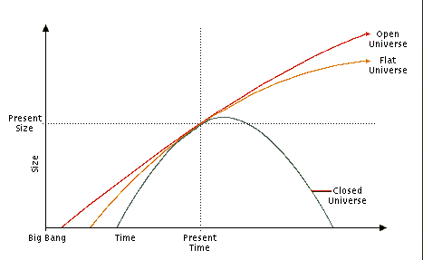
Fate of Universe Depends on _______________
- If _________________mass, the gravitation force will be too ______ to stop the expansion and the universe will _________________________
- If there is just the ______________ of mass, the expansion will continually ___________, but will never ____________
- If there is _______________mass, gravity will eventually overcome the expansion and the universe will start to __________________
  - Could be known as the _________________

