Name__________________________________________Period_____Date__________

Chapter 25.1-Characteristics of Stars

- What is the nearest star to earth, besides the sun, and how far away is it?

- What type of reaction keeps stars “alive” or burning?

- How is a star held together?

- How many constellations are there in our sky?

- What is meant by the term parallax?

- Do close stars or distant stars have smaller parallax angles?

- What is a light year?

- If I have a binary star that is the same mass as another star where it shares a common center of mass, where will the center of mass be? (you can draw a picture?

- If I have a binary star that is less massive than its partner star, where will the center of mass be? (you can draw a picture)

- Do smaller or larger magnitude values represent brighter objects?
- What is the difference between apparent and absolute magnitude?

- List the classifications of stars from hottest to coldest-include color and class.

- Why do hot stars appear more blue?

- What class of stars does the sun belong to?

- What are Hertzsprung-Russell Diagrams used for?

Use the diagram below to answer questions 16-23
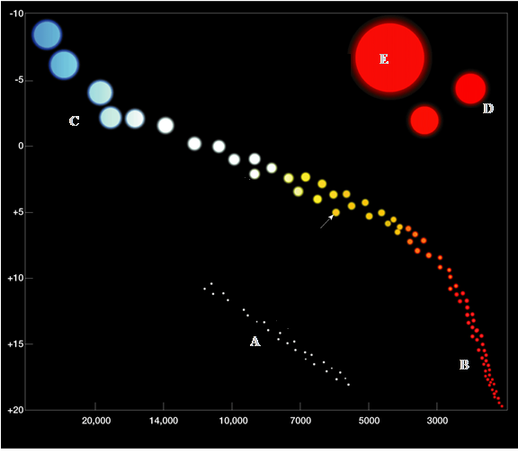
- What variable is represented on the x-axis?

- What variable is represented on the y-axis?

- How do we classify the group of stars clustered at point A?

- How do we classify the group of stars that runs from point B to point C?

- What is the difference between point D & point E?

- Which star is the largest on the chart?

- Which star is the smallest on the chart?

- Where is the brightest star located?

- What is a nebula?

- What is a cepheid star?

- What is a nova?

- How do scientists think that novas form?

- Describe the two types of nebulas.

- What is an emission nebula?

- What is a reflection nebula?

