Name___________________________________________Period_____Date______________

Physical Science Chapter 2 Guided Notes
Matter

- What is Matter
- Matter: Anything that has __________________ and takes up _____________
- Kinetic Molecular Theory
- Particles of matter are ____________________________________
- The _______________________(speed) of these particles _______________ as _______________________ increases
- Pure substances
- __________________: composed of ________________ atoms
  - An atom is the ______________ unit of an element that maintains the ____________ of the element
  - Ex:____________________________________
- _____________________: composed of ________________________________ in a ____________ ratio
  - Properties ______________ from those of individual elements
    - Ex:_______________________
  - Every compound is ______________ from the elements it contains
  - _______________ can join together to make _____________________
- Chemical Formulas
  - Shows how many ___________ of each _________ are in a unit of a substance
  - The ________________ (little numbers to the right) tell you how many atoms of each are present
  - Ex: C₆H₁₂O₆ has ____ Carbon atoms, ____hydrogen atoms, and _____ oxygen atoms
- Law of _____________________________
  - A given ___________________ always contains the _______________________ ratio of ____________________
- Law of _______________________________
  - Elements can ___________________ in _______________________ to form ______________________ compounds
- For example: Two different compounds below, each has a definite composition.
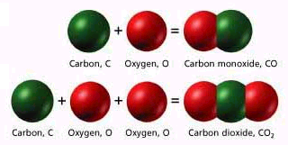

- Mixtures
- _______________ combination of ______________________________________
- Two different types: ________________________________________________
- Homogeneous:
  - very ______________ particles
  - particles _________________ settle
  - Ex: ______________________________________________
- Heterogeneous:
  - Substances are _________________________ distributed or uniform
  - Particles ___________ settle
  - Ex:__________________________________
- Matter Flow Chart
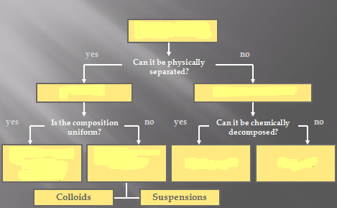
- Examples:

  - Graphite _____________________
  - Pepper _______________________
  - Sugar ________________________
  - Paint_________________________
  - Soda ________________________

- Liquids can either be ________________________________________
- Miscible
  - _______________________
  - Only looks like ________ liquid when combined
  - Ex. ____________________________________
- Immiscible
  - ______________________
  - Liquids ____________ mix and they form _________________
  - Ex. ____________________________________________________

- Properties and Changes in Matter
- Density
- A measure of _________ per unit of ________________, remains ________________ for _____________________________________
- How much ________________ is contained in a certain _____________________
- The ____________ the object’s density, the ____________ its mass per volume
- This is what decides if something __________________________________
- SI Unit: kg/m³
- Common units in problems: g/mL & g/cm³
- Problem Solving steps:

    - Analyze
    - Plan
    - Compute
    - Evaluate

- Problem #1 Example: An object has a volume of 825 cm³ and a density of 13.6 g/cm³. Find its mass.

Given:
V=
D=
M=
Work:
M=
M=
M=

- Problem #2 Example: A liquid has a density of 0.87 g/mL. What volume is occupied by 25 g of the liquid?

Given:
V=
D=
M=
Work:
M=
M=
M=

  - Physical Vs. Chemical Properties
- _________________ Property : can be observed or measured ____________ changing the _____________ of the substance
- _____________________Property: describes the ability of a substance to go through _______________ in identity
- Examples

Melting Point______________________
Flammable________________________
Density__________________________
Magnetic_________________________
Tarnishes in air____________________
Reactivity________________________

- More examples of Physical Properties
Melting point | Boiling point | Freezing point | Density
Buoyancy | Color | Texture | Changes in physical state  (solid, liquid, gas)
- More examples of Chemical Properties
Reactivity | Fermentation | Flammability | Oxidation
pH | Toxicity | electronegativity

- Physical Vs. Chemical Changes
- Physical Change:
  - Changes the form of a substance _________________ changing its identity
  - Properties __________________________________
- Chemical Change:
  - _____________________________________ of a substance
  - __________________ have different properties
- Signs of a Chemical change
  - ________________________________________
  - ________________________________________
  - _____________________________________________________________
  - ________________________________________________
- Examples:

Rusting iron______________________
Dissolving in water_________________
Burning a log______________________
Melting ice_______________________
Grinding spices____________________

- Quick Summary
  - _______________ changes are changes in the ________________ properties of a substance that do ____________________ the identity of a substance
  - Physical changes are often easily __________________________
  - ________________ changes form ______ substances that have ________ properties.
  - They can only be reversed through ________________________________
  - They often cause changes in color, smell, or produce sound, light, odor, or heat

