**Name_________________________________Period______Date_________**

**Physical Science Chapter 3 Guided Notes**

**States of Matter**

*Kinetic Molecular Theory*

* All matter is made up of _________ and ______________ that act like particles
* Particles of matter are ______________ in _____________
* The kinetic energy (_____________) of these particles ______________ as temperature ________________

*Four States of Matter*

* ____________
  + 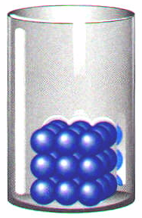___________ kinetic energy- particles ___________ but ________ move around
  + _____________________________
  + ______________________:repeating geometric pattern
  + ______________________: no pattern (e.g. glass or wax)
* 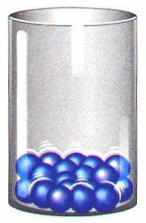______________
  + _____________ kinetic energy than solids, particles can move around but are still _________________________
  + ______________________________
  + ______________________________
* 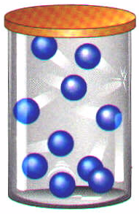__________________
  + __________ kinetic energy-particles can __________ and move _______________ container
  + _________________________________________________
* _____________________
  + ______________________ kinetic energy-particles ___________ with enough _______________ to break into charged particles (+ and –)
  + ________-like, ___________________________________________
  + Conduct __________________________________
  + Ex: stars, fluorescent light bulbs, TV tubs

*Thermal Expansion*

* Most matter ____________ when _____________ and _____________ when ________________
* Total ____________ energy = total _______________ energy
* ___________ temperature causes ______________ kinetic energy
  + Particles collide with more __________ and ______________________
* Thermal energy also depends on __________ of particles in substance

*Phase Changes*

* ___________________: _______________ to _____________
* ____________________: _______________ to _______________
* ______________________(boiling): ___________to _________ at the boiling point
* ____________________: __________ to ____________ ___________ the boiling point
* ________________: _________ to ____________
* _______________________: ___________ to _______

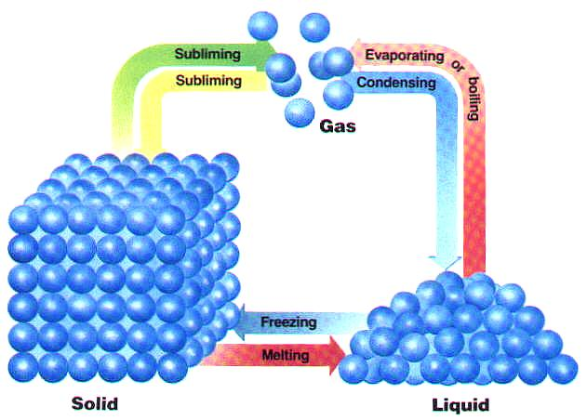

*Conservation of Mass and Energy*

* When water boils, the number of molecules ______________ even as the liquid loses volume. The mass of the __________ is the same of the mass of the ______________________________
* Mass __________________________________________________, it can be _______________________

*Fluids*

* _______________= states of matter than have the ability to ________ (ones ______________________)
* _______________________________ are fluids

*Fluids and Pressure*

* Fluids exert pressure ______________ in _________ directions
* Pressure is the amount of _______________ per unit _____________
  + Pressure= Force ÷ Area
  + SI Unit= Pascal

*____________________________*

* Force of a fluid that _______________ on an _____________
* Makes the object seem _________________
* Why most of your toys didn’t sink in the bathtub
* Buoyancy: the ability of a fluid to exert an _______________ on an object ___________________________ in it

*___________________ Principle*

* There are 2 ways object can float:

1. If the ______________ force of an object is _________ to the ________ of the fluid displaced by the object
2. If the ______________ of the object is _________ than the density of the liquid

* Density of water is ______________; Will gasoline (density=0.7 g/mL) float or sink in water? _____________________
* Archimedes found that the buoyant force _________ the weight of the fluid displaced by an object
* In other words, the weight of the __________ has been _________________________________________________

*Why do Ships float?*

* If the weight of the __________displaced is ________ than the weight of the __________, the object will ____________
* Otherwise, the object will _________
* Archimedes’ Principle explains why steel ships float. Steel is more dense than water, so why do ships float?

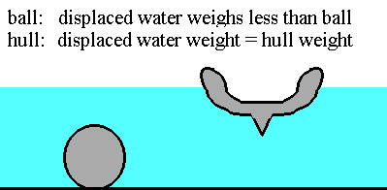

Example: An object weighs 20N. It displaces a volume that weighs 15N. What is the buoyant force on the object? Will it float or will it sink?

Buoyant force=weight of water displaced

Buoyant force=_________________

Object will ____________ because its weight is ______________than the ____________________ acting on it

*Pascal’s Principle*

* The _____________ applied to a fluid is ______________________________ the fluid
* Example: when you squeeze one end of the toothpaste, toothpaste emerges from the other end.
* _____________: _______________ of a fluid to __________
  + Water vs. syrup
* What happens to viscosity if you increase temperature?
* Water has a _______ viscosity, it can flow _______________
* Syrup has ________ viscosity; it flows ________________
* __________________ affects the viscosity of a fluid:
  + __________________ items flow faster
  + ________________items flow slower

*_________________ principle*

* As the ________________(speed) of a fluid ________________, the pressure exerted by the fluid _____________
* Example: airplanes, birds, Frisbees

*Gases*

* Properties of Gases
  + _________________________________
  + Gas particles move ___________ in _________ directions
  + Gas molecules are in _____________ motion and frequently _________ with one another and their ________________
  + Gases have a very _____________ because particles are so _____ apart
  + Gases are ___________________
  + Gases ___________out and easily _________ with one another
  + Gases are mostly ________________________
* Gases exert ________________ on their containers
* Gases will try to ________________when ever possible

*Gas Laws*

* For temperature values with gas laws, we have to use ________ instead of degrees Celsius

0°C=_____________K

* Example: Find the temperature in units of Kelvin if it is at 25°C

*_____________Law*

* Relates ________________________
* For a fixed amount of gas at constant _______________, volume __________ as pressure _____________
* As volume ___________, pressure ___________
* Inversely related



*________________Law*

* Relates _______________________________
* For a fixed amount of gas at constant ________________, volume ____________ as temperature _______________
* As volume ___________, temperature ________________
* Directly related



*____________________________ Law*

* Relates ____________________________________
* For a fixed amount of gas at constant ______________, pressure ____________ as temperature ____________
* As temperature ____________, pressure _____________



* Example #1: A gas occupies 100 mL at 150 kPa. Find its volume at 200 kPa
  + Given:

V1=

P1=

V2=

P2=

* + Work:
* Example #2: A gas occupies 475 cm3 at 36°C. Find its volume at 94°C. Remember to change to Kelvin
  + Given:

V1=

T1=

V2=

T2=

* + Work:
* Example #3: A gas pressure is 765 torr at 23°C. At what temperature willt he pressure be 560 torr?
  + Given:

P1=

T1=

P2=

T2=

* + Work: