Name____________________________________________Period_______Date____________
Chapter 4 Guided Notes: Earth’s Resources

Section 4.1: Energy and Mineral Resources
- _____________________ resources can be replenished over fairly short spans of times, such as _______________________________________
- ______________________resources take ___________of years to form and accumulate
- ___________________ are ________________ that may be used as fuel including ____________________________________
Coal
- Formed when _____________________ transform _______material over millions of years
- Four stages of development: __________________________________________ _____________________________________
- Used to generate ______________________ and production of _____________
- Mined three different ways__________________, _____________________, __________________________________
- Advantages of Coal:
  - _______________________, in US can provide about _______ years
  - _________, ________________, ______________, ________________
- Disadvantages of Coal:
  - ______________
    - ______from the _______ when burning coal
    - Releases ________________________
  - __________________, about _____% efficient from coal to electricity
Natural Gas and Petroleum
- Formed from remains of _____________________ that were buried in _______________--
- Formation begins when large quantities of __________ become buried in ________________; over _____________ of years, chemical reactions slowly transform some of the organic remains into the __________________ form
- ___________: geologic structure that allows large amounts of _________to accumulated
  - All have two things in common
    - ________________________: allows oil and gas to collect in _______quantities
    - _______________: near impenetrable so keeps oil and gas from escaping to _________________
    - ____________ in an uparched series of _______________________
- Advantages of Petroleum
  - ____________, ___________________, ______________________
- Disadvantages of Petroleum
  - ________emissions, recovery process not ____________, drilling endangers_____________________, ____________
- Advantages of Natural Gas
  - Burns cleaner that ________________, ________________, _____% less_______ than other fossil fuels
- Disadvantages of Natural Gas
  - Inability to recover all in-place gas from producible_________, lack of ______________
Tar Sands and Oil Shale
- _______derived from tar sand and oil shales could become good substitutes for dwindling petroleum supplies
- ____________: mixtures of _______________ combined with ______ and varying amounts of back, thick tar called ___________
  - Can be pumped out ___________
  - Requires lots of ____________
  - Can lead to ________________ in ___________________ponds
  - _______________
- _______________: rock that contains ________mixture of hydrocarbons called ______________
  - ___________ of world’s supply in ___________________ in _________________________________________________
Formation of Mineral Deposits
- Some of the most important mineral deposits form through ____________ processes and from ________________solutions
  - _______ is a useful _________mineral that can be mined at a profit
  - _____________________________________________ just a few deposits produced by igneous processes
  - Hydrothermal solutions
    - ___________
    - Hydrothermal deposits form from hot, ______________fluids that are left during the _____ stages of movement and cooling of ______
    - Examples: ________deposit in ______Dakota; _________________ ________ deposits in _________, __________ deposits in Michigan

- _________Deposits
  - Formed when __________heavy minerals settle _______from moving _______ while less _______ particles remain suspended and continue to move
  - Usually involve minerals that are heavy but also ____________________ ___________________________
  - Common Sites: _______________________________________________ ____________________
  - Best known example of placer deposit: ____________

Section 4.2: Alternate Energy Sources
- Solar Energy
  - Two advantages:
    - Solar energy’s fuel ( )is ________________
    - Solar energy is _____________________
  - Disadvantages:
    - Solar energy is not ________
    - _____________________________
    - ______________________________
  - How some work:
    - Active solar ______________
      - Roof mounted devices, collect _______ from sun that can be _______________ to areas where it is needed by circulating ______________ through piping
      - Also used to heat water
    - ______________cells
      - Convert sunlight’s energy into _____________
- Nuclear Energy
  - In nuclear __________, the ____________ of heavy atoms like ______________ are bombarded with ______________
  - The uranium nuclei _______ into smaller nuclei and emit __________________________________________
  - Advantages:
    - _____ emissions, fuel can be _____________, ______________, ___________________
  - Disadvantages:
    - Potential of _________________, problem with where to put _____, ________________can cause damage and leaks at plants, _____________________, _______________________

- Wind Energy
  - In the next _________ years, wind power could meet between ____________% of the country’s demand for electricity
  - _________________________ alternate energy source
  - Advantages
    - _______________, not many emissions (still need _________ that is produced from __________)
  - Disadvantages
    - ________________, turbines may be _________, ________________ availability
- Hydroelectric Power
  - Power generated by ____________________
  - The water held in a _____________behind a dam is a form of stored energy that can be released through the dam to produce __________________
    - The ______water flow that results, drives ____________and _________________________
    - Negative Effects: ________________________________________ ______________________________________________________
    - We’ve built all the dams we can! _____% of US rivers are dammed
- Geothermal Energy
  - Harnessed by tapping natural underground reservoirs of _________________________
  - Hot water is used directly for ______________and to turn turbines that generate ___________________________
  - ________________gets _____% of energy from geothermal
  - No harmful products, little maintenance after construction of plants
  - _________ be built everywhere
- Tidal power
  - Harnessed by constructing a dam across the ____________of a bay or an estuary in ____________areas
  - The strong in and out flow of tidal water drives __________________________________________________

Section 4.3: Water, Air, and Land Resources
The Water Planet
- Each day people use fresh water for drinking, cooking, bathing, and growing food
- Water covers ________% of Earth’s surface
- <______% of water is usable __________water
- Freshwater Pollution
  - _____________source pollution comes from a _________ and __________ location, such as factory pipes
  - ________________source pollution is pollution that does _____have a specific point of ___________
  - __________ is the water that flows ______ the land rather than seeping into the ________, often carrying ___________________________ pollution
- Water pollution can lead to:

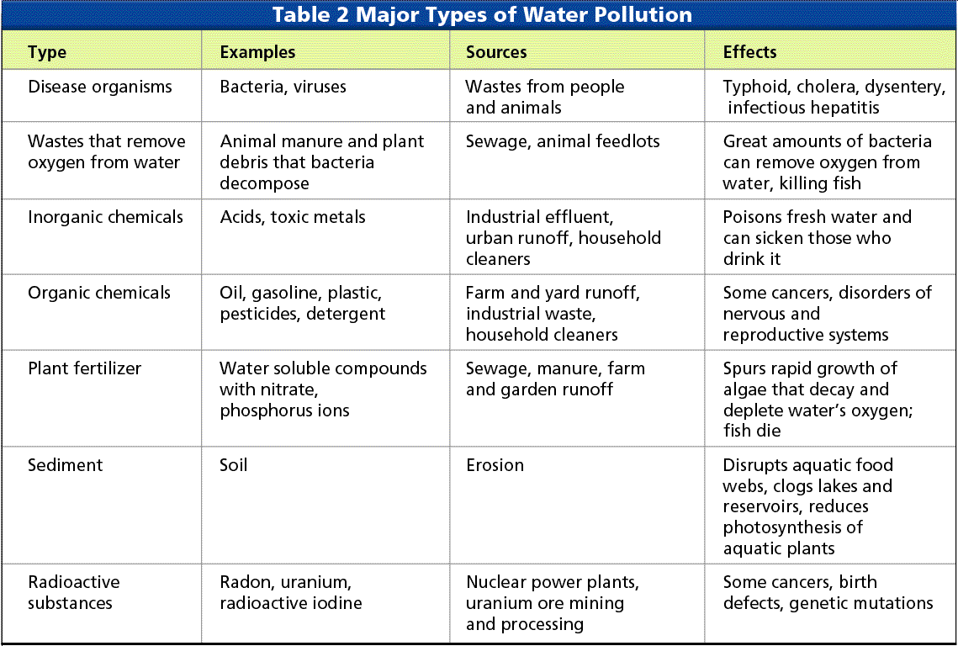

Earth’s blanket of Air
- The chemical composition of the _________________helps maintain life on Earth
- Pollution in the Air
  - The increase of _______________ in the atmosphere has altered the _______ cycle and contributed to __________________-the unnatural warming of the ___________ atmosphere
  - Through a series of chemical reactions, these pollutants in the air are converted to ________ that are a major cause of ____________________
- Burning of fossil fuels also produces ________
- Global Warming could result in big changes in Earth’s environment
  - These changes could include:

- ________________________(CFCs) once used in air conditioners and plastic foam production destroy ________ in the stratosphere layer of the atmosphere
  - Could result in increased health problems like cataracts and skin cancer because more of the suns UV radiation would reach Earth’s __________
Land Resources
- Earth’s land provides ____________, as well as ___________________ resources
- Damage to land resources
  - _________ produce many mineral resources, but mines are destroying __________________________________________
  - Mines also cause ____________ and pollution that contaminates soil and water and destroys _________________

Section 4.4: Protecting Resources
- ________________________ is the careful use of resources
- Pollution prevention means stopping pollution from entering the environment
- Starting in the __________, the federal government passed several laws to ____________________________ pollution and protect resources
  - In ______, the _______________________(CWA) required industries to reduce or eliminate __________________pollution into surface waters
  - The ___________________________of 1974 helped protect drinking resources
- In the 1970’s, Congress passed the ___________________, the nation’s most ___________ air pollution act
  - Established six “criteria” for pollutants known to cause health problems:
    - ______________________________________________________________________________________________________________

- Caring for Land Resources
  - Protecting land resources involves preventing pollution and managing land resources wisely
    - ____________________- is partly ____________________material that can be used as ______________________
    - ___________________ is the collecting and processing of _____ items so that they can be made into ______ products
  - Recycling Facts:
    - ______________________tons of municipal waste per year
    - Average American produces _______lbs of trash per day
    - US Recycles about _______ of all waste
    - ______% of paper products recycled
    - _______% energy saved by recycling an aluminum can compared with manufacturing a new one

