**Name______________________________________Period_______Date____________**

**Chapter 4 Guided Notes (Continued)**

**The Periodic Table**

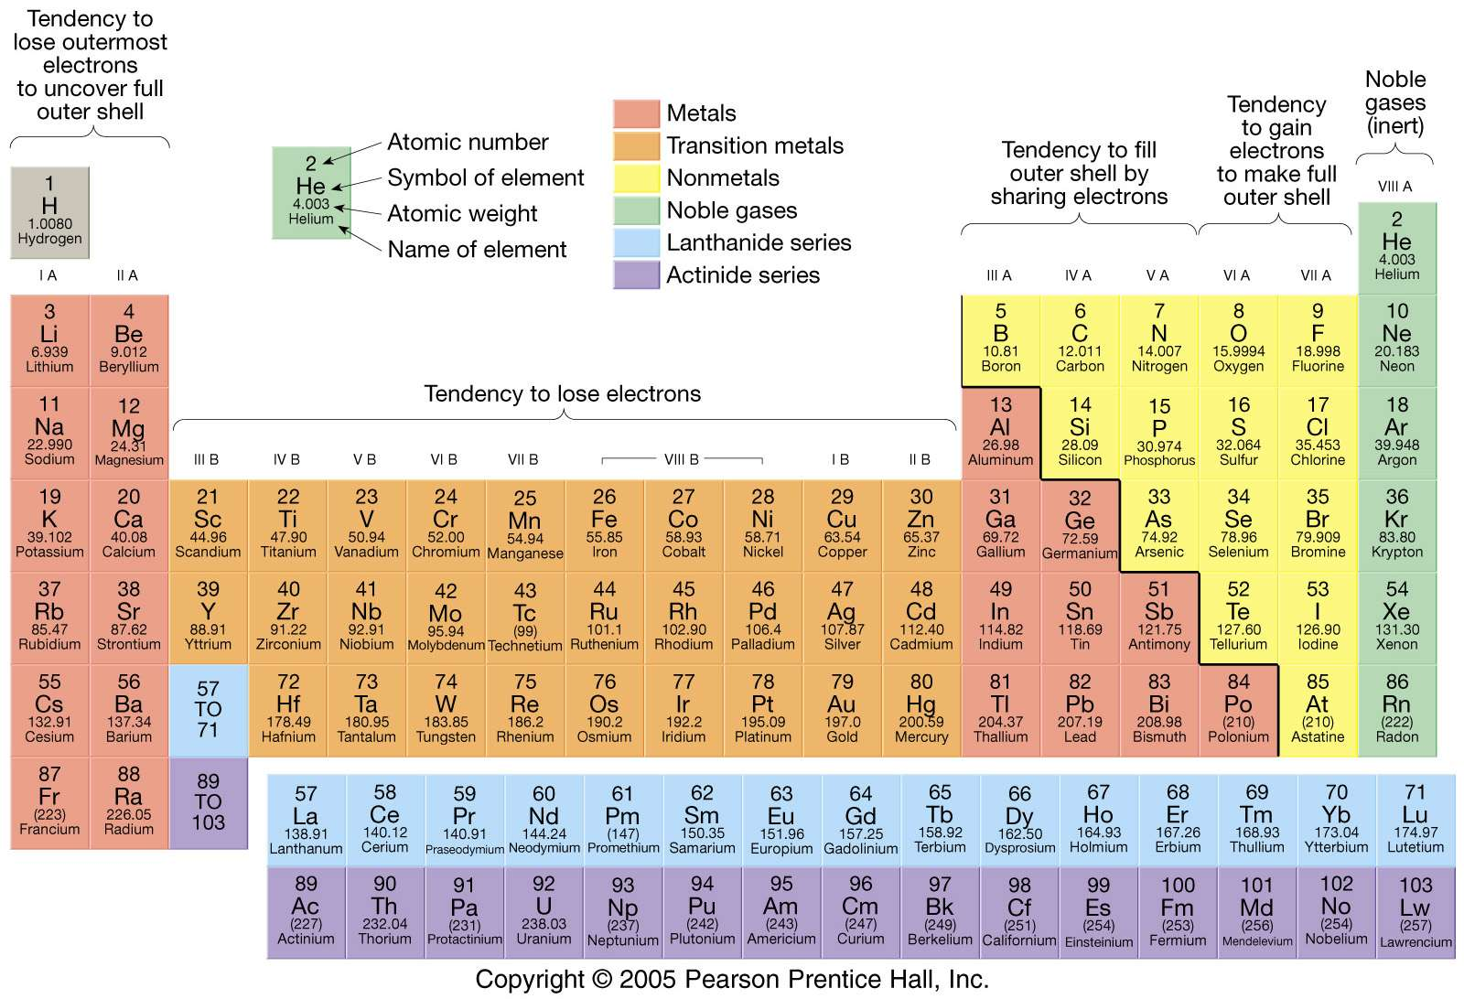

**The Periodic Table**

* Purpose: allows us to have an ________________ way of viewing _____________
* Knowing the _____________ of the periodic table gives us insight to elements’ ________________________________________________________
* Who?
  + Dmitri ___________________, a Russian chemist. Created the periodic table where elements were arranged by ___________________________________
  + Predicted that elements that were not yet ___________________
  + Henry G.J. _______________________, English scientist. Fixed problems with old period table when he arranged elements by increasing _____________________
    - Periodic law states that when elements are arranged in this way, _________________________ in their properties will occur in a _____________________ pattern
* Columns and rows
  + A __________= a _________________________________ on the periodic table
  + A __________=a ___________________________________on the periodic table
* Groups
  + Vertical ______________ are called groups
  + Each group contains elements have similar characteristics
  + They also have the same number of _______________________________
* Periods
  + Horizontal ____________________ are called periods
  + Each period contains elements which have the same number of ____________________ containing ________________________

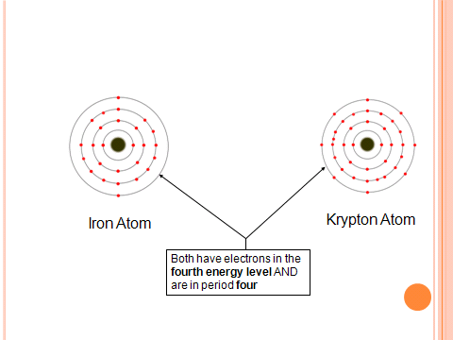

* Regions of the periodic table
  + _____________________
  + ________________________
  + _______________________
* Metals
  + There are ____________ metals on the period table
  + They are the ________________________________ of element on the table
  + Are usually ______________, with the exception of Hg, ___________________
  + Are ___________ and good ________________________ of heat
  + Metals are broken into 5 categories:
    - ____________________________
    - _______________________________
    - _________________________________
    - ___________________________________
    - __________________________________
  + Alkali Metals:
    - Are in Group ____________
    - Very _________________
    - Only have __________ valance electron
    - Occur as __________________ in nature
  + Alkali Earth Metals:
    - Are in group ______________
    - Somewhat reactive
    - Have _________ valence electrons
    - Occur as ___________________ in nature
  + Transition Elements
    - In groups __________________
    - Occur as _____________________ in nature
    - Most can be _____________ and shaped into flat sheets or wires (___________________)
    - Most are good conductors of ____________________________
      * Ex: wires
  + Actinides
    - In period __________, consisting of elements of ________________
    - Are _______________________________
    - Most are _________________________(synthetic)
    - Produced to help scientists, even diagnose cancer
* Nonmetals
  + Mostly on the ______________ side of the periodic table
    - Exception:______________________
  + Are _________ shiny and ___________ good conductors of _____________
  + ____________________________________ exist within the nonmetals
  + __________________________________________
  + Noble Gases
    - Group _____________
    - Very _________, thus not __________________
    - Has ___________ valence electrons
    - ________________at room temperature
    - Will ____________ bond with other elements
  + Halogens
    - Group _________________
    - Fairly __________________
    - Have ____________ valence electrons
    - Most are ________________
* Semiconductors (________________________________)
  + The metals that border the line between metals and nonmetals
  + Only 6-____________________________________________________________ __________________________________________________________________
  + They are able to conduct _____________________________________ under certain conditions
  + ______________________ is most familiar semiconductor, makes up ________ of the Earth’s crust; component of _______________

***Periodic Table Trends***

* _____________________________________
  + Increases to the _______________________________
  + Draw Arrows below:



* + Which atom has a larger radius
    - Be or Ba: _________________
    - Ca or Br: _________________
* **Valence Electrons**
  + Group # (column)= __________________________(Except ____)
    - Families have similar properties and reactivities
  + Period # (row)= ____________________________________
  + Fill in # valence electrons and row number



**The Mole**

* An SI Unit
* A counting unit, like a dozen
* The amount of substance that contains as many particles as there are atoms in _______ of Carbon-12
* The number of particles (____________) in a mole=_____________________________
* The mole can also be said to be the amount of substance that contains ___________________________________________ of particles
* _______________________ is the mass of one _____________ of a substance
  + Written in ___________________
  + Molar mass is the same as the ________________________________ and is used as a conversion factor



* Example #1: What is the mass in grams of 3.50 moles of Copper?
* Example #2: A chemist produces 11.9 g of Al, How many moles of Al are produced?
* Example #3: How many moles of Ag are in 3.01 x 1023 atoms of Ag?
* Example #4: What is the mass in grams of 1.20 x 108 atoms of Cu?