**Name____________________________________________Period_____Date______________**

**Physical Science-BONDING NOTES!**

**Guided Notes**

**SECTION 1-Molecules and Compounds**

* A ____________________ is a substance made of ___________________________________ that are chemically combined by __________________________
* __________________are made of different substance that are just placed together, each substance in the mixture ______________________________________________

What is a chemical Bond?

* An ________________ between the ________________________________ ____ of different ___________________ that binds them together
* Bonds form in order to
  + ________________________________________
  + ________________________________________

Chemical Formulas

* A compound always has the ______________________________________
* Chemical formulas show:
  + _________________________________________
  + ________________________________________
  + Ex. H2O _______________________________________________________

Chemical Structure

* This tells you how the ________________________________________________
* Described by ________________________________________________________
* ________________________: the _______________ between two _____________ of bonded _______________________
* ________________________: tells you how __________________ the atoms are away from each other in relation to the ____________________ atom
  + Bond angles try to be as _______________ as possible to _______________________

Models of Compounds

* ____________________________: shows the relative ___________ occupied by molecules
* ___________________________: gives you idea of the ____________(bond angles) of a compound
* Some compounds exist as a large network of ______________________________
* Some compounds exist as a large network of bonded ________________________________ _________________________
* Some compounds are made of many _______________________________________

**SECTION 2: Bonding**

Vocabulary:

* Chemical Formula
* Ionic = ____________________________________ ex. __________
* Covalent = __________________________________ ex. _____________
* Compounds
* 2 elements = ______________________________ ex ___________________
* More than 2 elements = _____________________ ex ___________________
* Ions
* 1 atom = _______________________ ion ex. _________________
* 2 or more atoms = ____________________________ ex. _____________

**Ionic Bonds**

* Are formed by the _______________________________ of electrons
* What constitutes an ion?
  + ___________________________________________
  + ___________________________________________
* ____________________________attract
  + _________________________________________
  + _________________________________________
* Bonding will always take place in the _________________________________ between _____________________________________________

Properties of ionic bonds

* _________________________________________
* _________________________________________
* __________________________________________
* __________________________________________
* __________________________________________

What makes an ionic bond?

* Must include a _____________________________________________________
  + ______________________________
  + _____________________________
* Anion ________________________________________ from cation
  + _________________ is ALWAYS willing to give it away, to a ___________ energy level
  + _________________________ is looking to fill the ____________________________
  + For this region __________________________ love group ________________________ ______________________________________
    - Creates a ________________________

**Covalent Bonds**

* Compounds that are made of _____________________________________
* Bonds that are formed by _____________________________________________
* Electrons are shared from the _____________________, still want it ___________
* But electrons are not always shared __________________
  + When two chlorine atoms bond, they are ______________________ to the positive nucleus of each atom=___________________________________covalent bond
  + When not shared equally= __________________________covalent bond

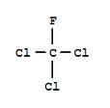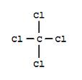

Properties of Covalent bonds

* ________________________________
* Can be found as ________________________________________
* Do not conduct __________________________
* _______________________________________
* _______________________________________
* All the _______________________________ are covalently bonded
* Can share more than _____________ of electrons
  + _________________________shares _________ pair of electrons
  + ________________________shares ________pair of electrons
  + ________________________shares __________ pair of electrons



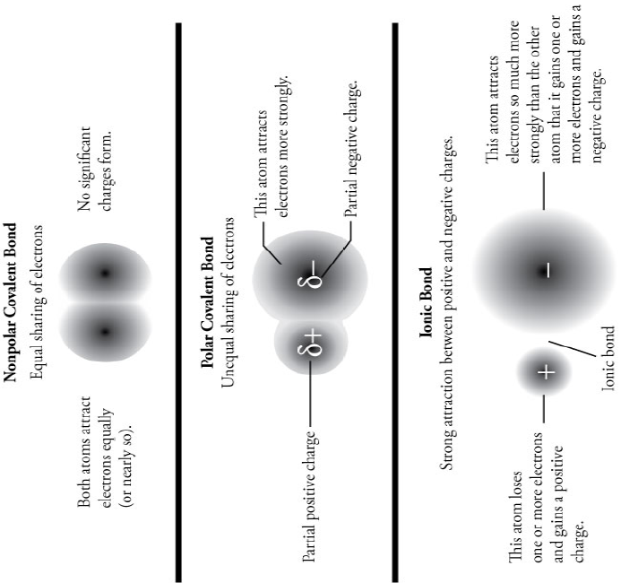

**Metallic Bonds**

* **____________________________**
* Attraction between one atom’s _______________ and a neighboring atom’s _________________
* ______________________, causes most outermost energy level to ____________________
* Electrons are free to move from ___________________________________
  + This is why they are good conductors of _________________________________

**Hydrogen Bonds**

* Explains why an oxygen molecule of one water molecule is attracted to hydrogen atom of a neighboring water molecule
* Water molecules attract each other, but these bonds _____________________________ as the bonds holding oxygen and hydrogen molecules together ___________________________

**SECTION 3: LEWIS DOT STRUCTURES FOR BONDS**

Steps: NASL Method

1. Figure out what __________________________________________( I will give you this part)
2. Calculate N : number of electrons ____________________ for all atoms to abide by the __________________________________________________________
3. Calculate A: number of electrons ______________________ by adding up all _______________ _________________________________________________________________________
4. Calculate S: ___________________________number of electrons = ________________
5. Calculate L: _________________________________ = _____________________________
6. Check to make sure you have used the right number of electrons as you said you needed in the A step

Examples:

What if it’s charge?

1. When calculating the _________ include _________ in electron count
   1. ___________________________________________
   2. ___________________________________________
2. Calculate everything else the same.
3. When finished, draw ___________________ around picture with _______________________

Examples:

**SECTION 4: Empirical and Molecular Formulas**

* _____________________Formula= _____________ ______________ number ratio of atoms in a compound
  + Ex: C2H6 reduces to __________________________
* Calculating Empirical formula:
  1. Find mass or ____________ of each element
  2. Find ____________ of each element
  3. Divide moles by the smallest # moles to find _______________
  4. When necessary, multiply subscripts by 2,3,4 to get whole #s
* Ex. Find the empirical formula for a sample of 25.9% N and 74.1% O.
  + Need to make the subscripts __________ numbers so multiply by ___________
  + Empirical formula = _________________________
* Molecular Formulas
  + _________ formula, the ___________ of atoms in a compound
  + Different compounds can have the _____________ empirical formula



* Steps in finding Molecular Formula
  + Find _______________________
  + Find the empirical formula _____________________
  + Divide the __________________________________________________
  + Multiply each subscript by the answer from step 3



* Example: The empirical formula for ethylene is CH2. Find the molecular formula if the molecular mass in 28.1 g/mole.
  + Empirical Mass=
  + Divide MF mass by EF mass:
  + Multiply answer by EF subscripts: