Name________________________________________Period______Date_____________

Chapter 6-Guided Notes
Chemical Reactions!
Signs of a Chemical Reaction
- ________________________________________________
- _______________________________________________
- _______________________________________________
- ________________________________________________

Law of Conservation of Mass
- ____________ is neither ______________________________ in a chemical reaction
  - __________________________________
  - Atoms can only ______________________________
  - Draw the picture on the slide below:

Chemical Equations

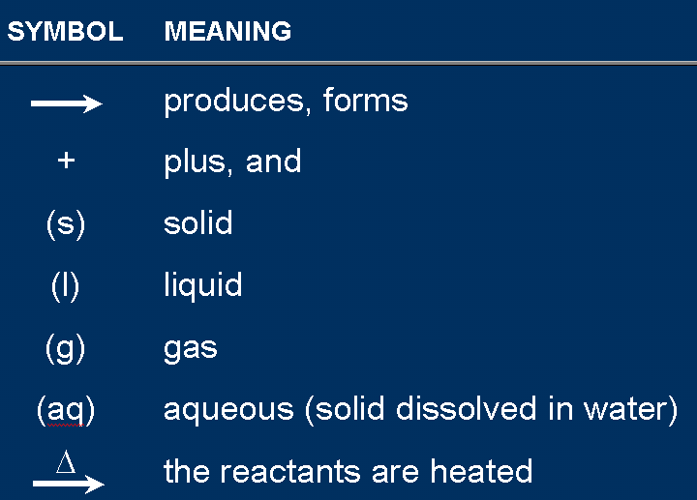

Energy and Reactions
- ______________ must be ____________ to _____________ bonds
- Energy is ___________________when bonds are ________________
- This energy can be in the form of ____________ as well as other things like _________________________________________________
- ______________energy: the energy ________________when a chemical compound ______________ to produce a ________________________________
- _____________________________________________________________________

Endothermic vs Exothermic
- ___________________-a chemical reaction that _____________________________
  - _________energy is needed to ____________ the bonds in the ____________ than is _________________ by forming bonds in the ___________________
  - Examples:_______________________________________________________ _______________________________________________________________ _______________________________________________________________
- ___________________-a chemical reaction that _____________________________
  - ____________is given off in the reaction as a _____________; heat is ___________________ to the surroundings
  - ____________ energy is _____________ by forming products than is needed to _____________ the bonds of the ___________________
  - Examples: _____________________________________________________ ______________________________________________________________

- Reaction Profiles:
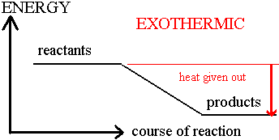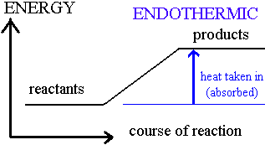

Types of Chemical Reactions

- _________________________
- _________________________
- _________________________
- _________________________
- _________________________
- _________________________

Types:________________________________________
Example:

General formula:

- A &B can be ___________________________________
- A & B _________________________________________
- Another example:

Types:__________________________________
Example:

General formula:

- Kind of like the _______________________________________
- Start with only ______________ and break down into ________________ parts
- If ________________(two things making it up), it breaks down into ______________
- Others are harder to tell and you DON’T need to worry about these!!!

Types:_______________________________________
Example:

General Formula:

- _________ element ___________________________ in a compound
  - _____________________________
  - _____________________________
- A ___________________ element will take the place of a ______________________ one (ACTIVITY SERIES-DO NOT NEED TO KNOW THIS!)
- When have a alkali metal with water, write like this:

- This will make it look like other single replacement reactions and will help you out! Just remember diatomics (H will have to be H₂)
Types:_____________________________________________
Example:

General formula:

- Ions in two compounds _______________________________
- ____________ of one compound combines with ____________ of the other
- Occurs when a ______________________________________ forms
- Precipitate-______________________ that comes out of solution during this type of reaction

Types:____________________________________

- The ____________of any substance in _________ to produce ___________
- Substance A is usually an ______________________ (made of C & H)
- Must have ______________ for _________ combustion (we will just assume everything is complete combustion)
Example:

When A is organic:

General:

Writing and Balancing Chemical Reactions
Steps
- ________________________________________
- ________________________________________
- ________________________________________
  - ________________________________________________
- _____________________________________________________________________
- ______________________________________________________

Helpful Tips!
- Balance ___________ element at a time
- Update _______ atoms counts after adding a ______________________
- If an element appears more than once per side, balance it ______________
- Balance polyatomic ions as _______________________
  - ____________________________________________

Balancing Example: Aluminum and Copper (II) chloride react to form copper and aluminum chloride.

Writing Equations:

Describing Equations:
- Individual atom =________________________
- Covalent substance = ______________________
- Ionic substance =_________________________

3CO₂ ____________________________________
2Mg _____________________________________
4 MgO ___________________________________

Describing Equations:
Zn(s) + 2HCl (aq) ZnCl₂(aq) + H₂(g)

Law of Definite Proportions:
- A compound _____________ contains the ______________________ in the same proportions, regardless of how the compound is made or how much of the compound is formed

Mole Ratios
- The ____________ amount of moles of substance required to produce a given amount of _______________ in a chemical reaction
- Look at this chemical equation:

- The mole ration from the BALANCED REACTION is ________ of H₂O : ______ moles H₂ : ______________ O₂

- Example: Determine the mass of hydrogen gas (H₂) and oxygen gas (O₂) produced by 4 moles of water in the following chemical reaction

H₂O H₂ + O₂

Rates of Change

Factors affection reaction rate
- ___________________-how ________ the reaction goes from __________________
- Factors affecting reaction rate:
  - ___________________________
  - ___________________________
  - ___________________________
  - ___________________________
  - ________________________________________
  - ________________________________
Temperature
- Most reactions go ___________ at a ____________ temperature
- This is because of the ____________________________
  - Higher temperature means molecules going ________, more likely to _______
Surface Area
- A _________________________________________ reactions
- Solids that have a ____________ surface area react more ____________ because more particles come in contact with the other ______________________
Concentration
- Most reactions go ______________ at a _____________ concentration
Pressure
- Reactions go ____________ at _______________ pressure
- Gases are _______________ at higher pressures because it has been ______________ into a ___________ volume and have _____________ collisions

Size & Shape
- Massive, _______________________________________
- Because of ___________________________
  - Bigger molecues move ________________, __________________

Catalyst
- A substance that changes the ___________ of a chemical reaction without being _______________
- Not ________________________________
- Does not play a role in the _____________________
- Catalysts-______________________________________
- ____________________________________________________
- __________________________________________________________

