Name_______________________________________________Period_____Date__________

Chemical Reaction Review

- List some signs that would indicate a chemical reaction has occurred.

- What must be added to break chemical bonds?

- What are the chemicals on the LEFT side of an equation called?

- What are the chemicals on the RIGHT side of an equation called?

- What does the law of conservation of mass say about how much energy I start with in the reactants and how much energy I end up with in the products?

- If I start with 10 hydrogen atoms on the react side of a chemical equation, how many must I have on the product side?

- What is the difference between an endothermic and exothermic reaction?

- Label the reaction profiles below as endothermic or exothermic.

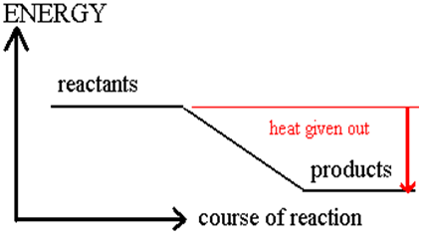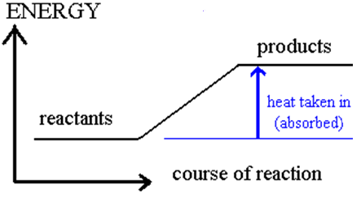

- How many reactants will I have in a synthesis reaction? # products?

- How many reactants will I have in a decomposition reaction?

- What occurs during a single replacement reaction?

- What happens during a double replacement reaction?

- What will be one reactant in all combustion reaction? What are the two products?

- What is a reaction rate?

- What are ways to increase reaction rate?

- What are ways to decrease reaction rate?

- What is a catalyst? Does is participate in the reaction as a product, reactant, or neither?

- What does the Law of Definite Proportions say?

Balancing Reaction Practice & Type of Reaction Practice:

- ____N₂ + ____H₂ ______NH₃ Type:

- ____P₂O₅ _____P + _____O₂ Type:

- ____Na + ____H(OH) ___Na(OH) + ____H₂ Type:

- ____C₆H₁₂O₆ + ____O₂ ____CO₂ + ____H₂O Type:

- ____K + ____MgBr ____KBr + ____Mg Type:

- ___FeCl₃ + ____Na(OH) ___Fe(OH)₃ + ____NaCl Type:

- ___MgCl₂ + ____Li₂(CO₃) ____Mg(CO₃) + ____LiCl Type:

- ___C₆H₁₂ + ___O₂ ____CO₂ + ____H₂O Type:

- ____Ca(CO₃) ___CaO + ___CO₂ Type:

- ____C₂H₂ + ____H₂ _____C₂H₆ Type:

Product Prediction Practice: ( YOU DO NOT HAVE TO BALANCE THESE)

- NaI + CaCl₂ ___________________ Type: Double Replacement

- Ag + CuSO₄ ______________________ Type: Single Replacement

- MgO₂ ____________________________ Type: Decomposition

- Ca + N₂ __________________________ Type: Synthesis

- C₄H₈ + O₂ _________________________ Type: Combustion

Writing chemical equations from word problems.
- One molecule of propane (C₃H₈) reacts with 5 molecules of O₂ to form 3 molecules of O₂ and 4 molecules of H₂O.

- Two units of AlBr₃ and 3 units of MgO react to form 2 units of Al(OH)₂ and 3 units of MgBr₂.

