Unit 13- Deserts and Wind
Objectives and Vocabulary
Objectives:
- Describe how running water affects deserts
- Explain the role of mechanical and chemical weathering in the desert
- Explain why flash floods occur in the desert
- Locate the Colorado Plateau, Basin and Range, and Sierra Nevada regions on a map
- Define alluvial fan and playa lake
- Describe and locate on a diagram desert features in the Southwestern United States located in the Colorado Plateau region including plateaus, mesas, butte, monocline, hogback, and cuesta
- Describe and locate on a diagram desert features in the Southwestern United States located in the Basin and Range region including playa lake, faults, alluvial fans, bajada, and pediment.
- Describe two ways that wind can cause erosion
- Explain the process of deflation
- Identify and differentiate types of landforms that are deposited by winds
- Describe different types of sand dunes and identify types of sand dunes using a diagram
- Identify the sand dune that can reach the greatest height.
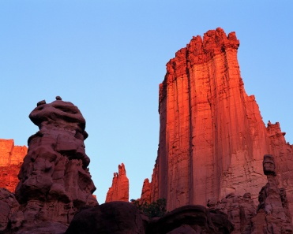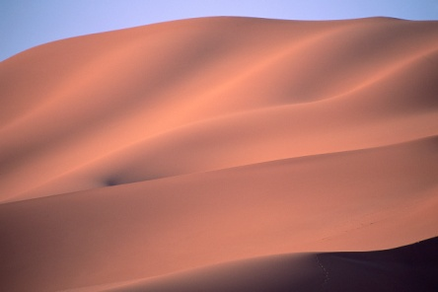

Vocabulary:
 | Alluvial fan | Playa lake | Mesa | Butte
Monocline | Hogback | Cuesta | Fault | Bajada
Pediment | Deflation | Desert pavement | Loess | Sand dune
Barchan dune | Transverse dune | Barchanoid dunes | Longitudinal dunes | Parabolic dunes
Star dunes

