COMMON IONS & THEIR CHARGES
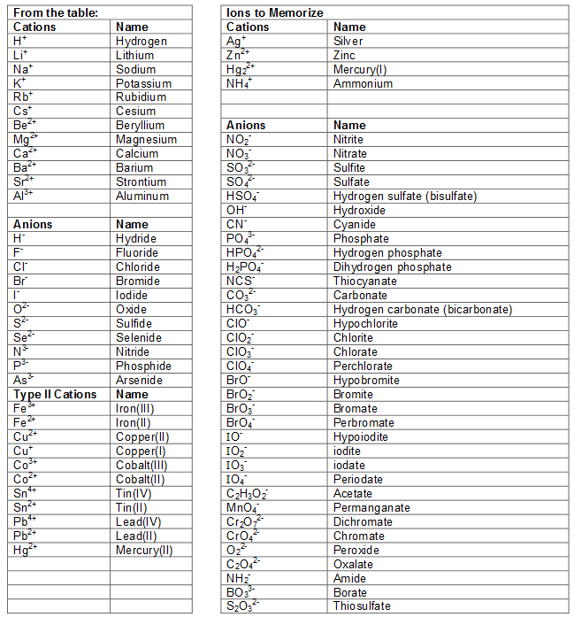

TIPS ON LEARNING IONS

