Name___________________________Period_____Date_________

Density of Solids Lab

Background:

Mass is a measurement of the amount of matter in a sample, while volume is a measurement of the space occupied by a sample of matter. In this experiment, you will measure the mass and volume of two different samples of two different metals. You will then use the combined data from your class to determine whether there is any consistent relationship between the mass and volume of a given substance.

Measurements of mass are made on an electronic balance. Volume measurements are made in different ways, depending on the physical state of the sample being measured. The volume of a liquid is commonly measured measured in a graduated cylinder. A graduated cylinder containing a quantity of liquid is shown below.
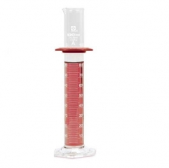
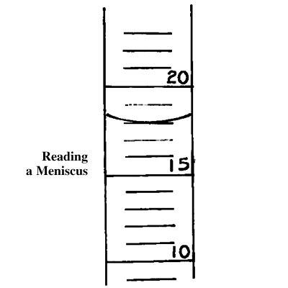
In graduated cylinders, the liquid curves upward where it hits the cylinder walls. This curved surface is called a meniscus. We always take the volume reading at the BOTTOM of the meniscus. You must make the reading at eye level (looking straight at it).

You would read the graduated cylinder to the right as the meniscus is at 16 mL.

Purpose:
- To determine the mass and volume of several samples of matter

- Calculate the density of a solid object from its mass and volume

Materials:

- Graduated cylinder
- Ruler
- Electronic balance
- Metal Samples
- Calculator
- Paper Towels

Procedures:

- Obtain samples of two different unknown metals. Be sure that the samples are clean and dry, and that you can distinguish between them. Weigh each sample on the balance to the nearest 0.1 gram (write 25.2 g instead of 25 g). Record the mass of each sample in Data Table 1 and in Data Table 2.

- Find the volume of each sample in the following way. Fill the graduated cylinder about half full with tap water. (remember the water comes out very fast so turn it on BEFORE you put the graduated cylinder under the stream of water). Record the initial volume of water in the cylinder in Data Table 1. Title the cylinder and slide one of the metal samples carefully into the water so that it doesn’t break the cylinder and so the water doesn’t splash out. If the metal sample is not completely submerged, you must remove the sample and start again using a larger initial volume of water. It is important the sample be dry before it is in the water. Otherwise, you will have error in your experiment. Record the final volume of water containing the submerged metal sample in Data Table 1. To find the volume of metal sample. Subtract the initial volume from the volume + metal . Record this value into Data Table 1 and Data Table 2. Volume of metal = (volume of metal + water) – (volume of just water)

- Repeat Step 2, using the other metal sample. Dry both samples and return them to where you obtained them.

Data Table 1: Individual Data

 | Metal A | Metal B
Mass (g)

Volume of water (mL)

Volume of water + metal (mL)
Volume of metal (mL)

Density of metal
(mass÷volume)(g/mL)

Data Analaysis:

- Once your individual calculations are complete, got to the DocCam and write in your results on Data Table 2.

- Complete your Data Table 2 by recording the mass and volume data collected by the other students in your class.

- Using the class data, plot a graph related mass and volume. Plot mass on the vertical (y) axis and volume on the horizontal (x) axis. Choose a scale that will generate a graph that fits comfortably on three-quarters of the graph paper.

Data Table 2: Class Data

Lab Group | Metal A |  | Metal B
 | Mass | Volume | Mass | Volume
1
2
3
4
5
6
7
8
9
10
11
12

- Use a ruler to draw the best straight line fit through each group of plotted points. You should have two lines, one for each metal. Note that not all of the points in a group will lie on the best straight line for that group of points. However, approximately as many points above the line, as lie below the line
- Determine the slope of each line. If a line goes through the point (0,0) its slope is y/x. The general equation for a line is y=mx+b where m is the value for the slope and b is the value for the y intercept. In the graph you have plotted, y/x is equal to mass/volume, which is the formula for density. Thus, the slopes of the line of the lines you have drawn represent the densities of metals you have examined. Find the density of each of the metals studied from the slope of the line drawn for that metal. Record those densities and your method of calculation in Data Table 3.

Data Table 3: Density Calculations for Class Data

Metal A | Metal B
Conclusions:

- What does this experiment demonstrate about the density of a substance? What does it demonstrate about the densities of different substances?

- Calculate the percent error in the densities you calculated for your two samples. Ms. Price will provide you with an accepted value for the density of each sample.

% error=accepted value-experimental value x 100
Accepted value

- Calculate the percent error in the densities you obtained from the slopes of the lines in your graph.

- Which of the ways you used to calculated density was better (more reliable and accurate). Explain your reasoning

- Do you think that density can be used to identify a substance? Explain your answer. Attempt to identify the materials used in this experiment by referring to table of density.

