Elements to Memorize Assignment

Quiz Date: ___________
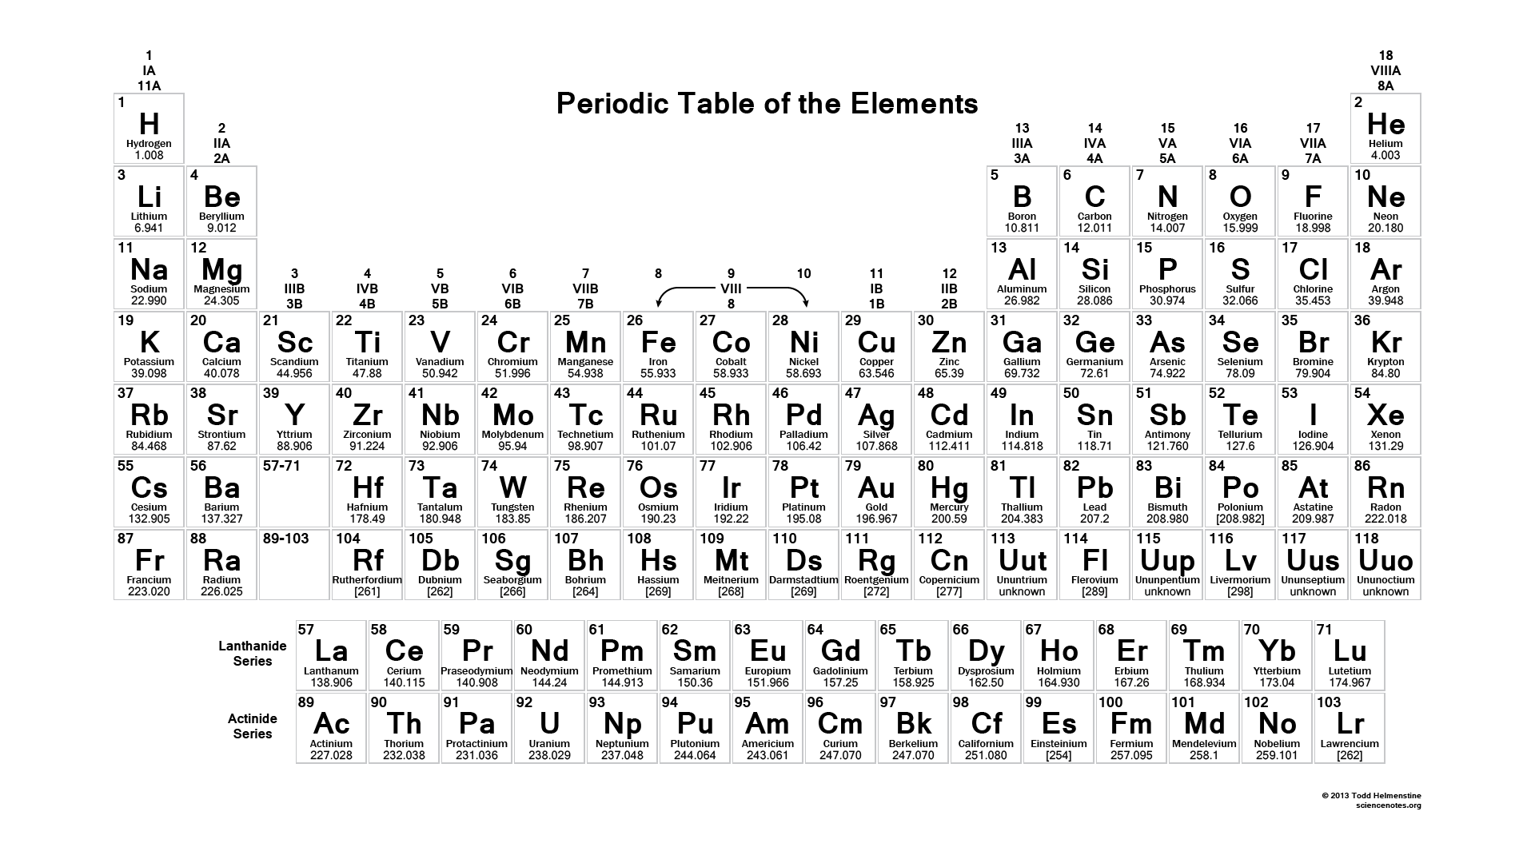
Memorize the first 54 elements (name & symbol) + Au, Hg, Pb, W, U, Ba

