Name_____________________________________________Period_______Date___________
Geology Lab #7-Alternate Energy Sources

At this station, you will be looking at some data using a website provided by FindSolar.com at this hyperlink: http://www.findsolar.com/index.php?page=rightforme
- On the right hand side it says Solar Power Calculator:
  - Enter you zip code (Bloomfield is 87413, Farmington is 87402)
  - Click in the circle that says residential
  - Click in the box to make the electricity offset to 100%
  - Choose your utility company from the drop down list.
  - Enter your family’s average electric bill OR estimate your family’s kWh usage per month (My bill last month was for 593 kWh)
  - Click Go
- Under System Specifications
  - What is the estimated cost to install solar panels?_______________________
  - What is the post incentive cost to install solar panels?____________________
- Under Incentives:
  - What is the federal incentive tax credit for using solar panels? ______________
- Under Savings:
  - What is the average monthly savings by installing solar panels? ______________
  - What is your savings over 25 years? ______________________
  - How long does it take you to break even with your investment on solar panels? _______________________________
- Carbon Emissions:
  - The electricity you use causes the release of how many pounds of CO₂ per year? ______________
  - How far would you have to drive to equal the amount in letter a? _____________
  - How many trees do you need to plant a year to offset the yearly emissions? _____________
Questions:
- What are the advantages of Solar Energy?

- What are the disadvantages of Solar Energy?

At this station, you will be looking at wind energy and factors that effect its efficiency (how well it works). The information is provided by National Geographic and can be found at the this link: http://environment.nationalgeographic.com/environment/global-warming/wind-power-interactive/
- Once on the website, click how it works
- Inside a Wind Turbine:
  - Introduction: Most turbines have ____ large blades that are aerodynamically designed to turn as easily as possible when ______ blows on t hem. These turning blades spin a ________, which connects to a __________ that produces electricity
  - Blades: As the wind blows over the turbine’s blade, they create _______, much like an airplane’s wing, and being to __________
  - Low Speed Shaft: The _________rotor blades turn this shaft some ____to _____ times every minute
  - Gear Box: The gears in this box connect the low speed shaft with a ______ speed shaft that drives the ______________. The gears also boost the rotation speed of the high speed shaft to __________ to ________ rotations per minute
  - High Speed shaft: This rapidly spinning shaft drives the generator to produce ________________
  - Generator: The generator’s electrical output is connected to the larger ________________
- Now Click on Generating Power:
  - Four Main Variables to determine how much electricity a turbine can produce: _____________________________________________________________________
  - Wind Velocity: Turbines usually do not operate if the wind speeds are below ___miles per hour. Between ____ and ____ miles per hour, a wind turbine generates electricity at peak power. Most turbines shut down at about ____ miles per hour because they can be damaged by higher winds
  - Blade Radius: The ___________ the area of the wind blades, the greater the power produced. ________ the blade, or rotor, diameter can result in ____ times more power
  - Tower Height: Tall turbines are usually more efficient. Tall turbines are able to reach ___________ winds found at altitude and are less subject to turbulence
  - Air Density: _______-altitude location have lower air pressures and “lighter” air, so they are ______ productive wind turbine locations. The dense heavy air near ______________ drives rotor relatively more effectively
- Trying it Out
  - How much power is produced with a tower height of 315 ft, a blade radius of 150 ft, wind speed at 21 mph, and an altitude of 5000 ft? _______kW Homes supplied?____
  - How much power is produced with the same conditions as in a, except change the wind speed to 10 mph? ________kW 25 mph?________kW 49 mph? _________kW
  - How many homes supplied with power with the same conditions as in a, except change blade radius to 30 ft? _______ 100 ft? __________ 130 ft? ____________
  - How many homes supplied with power with same conditions as in a, except change tower height to 270 ft? ________200 ft?__________ 130 ft? __________________
  - How many homes supplied if keeping the same conditions as a, except change altitude to 0 ft? _______ 12,000 ft? _________

At this station you will be looking at data from nuclear power plants located in the United States.

- How many nuclear power plants have been constructed since the 1970? ______ 1980s?______1990s? _________

- How many nuclear power plants started commercial operation since the beginning of 1990?

- How many nuclear power plants are located in New Mexico? _______ Arizona? _______ California? _______ Texas? _______

- How much net MWh² were generated in 2009 total by all nuclear power reactors? _______________MWh²
- What is the name of the power plant generated the most energy in 2009? _________________________
- Which state has the greatest forward-cost uranium reserves as of 2008? ______________

- Name six states that have the most forward-cost uranium reserves?

- Name 3 of the 11 states that are included in the “other” state for forward-cost uranium reserves.

- What are some of the advantages of nuclear power?

- What are some of the disadvantages of nuclear power?

Use the data provided at the tables to answer the questions below about Coal
- As of 2008, how many people in the US total are employed by coal mines?
- As of 2008, how many people in New Mexico are employed by coal surface coal minse? ________ how many people in New Mexico are employed by underground coal mines? ________
- As of 2008, how many coal mine operation are there in America? _____________
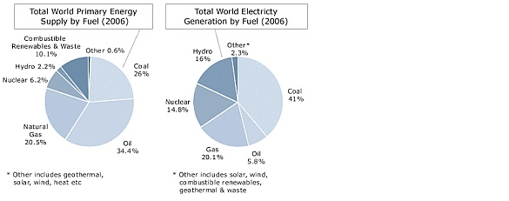
- Using the above graphs, answer the following questions
  - As of 2006, the world received most of the energy from _______ at ______%
  - As of 2006, what fuel provided the most generation of electricity to the world? What percentage is this?
  - What percentage of natural gas contributed to the total world primary energy supply in 2006?

- Complete the following Venn Diagram: Compare Fossil Fuels and Renewable energy in the center, and then contrast them in the appropriate circle.

The graph below shows US energy consumption from 2009. Use it to answer questions 1-4
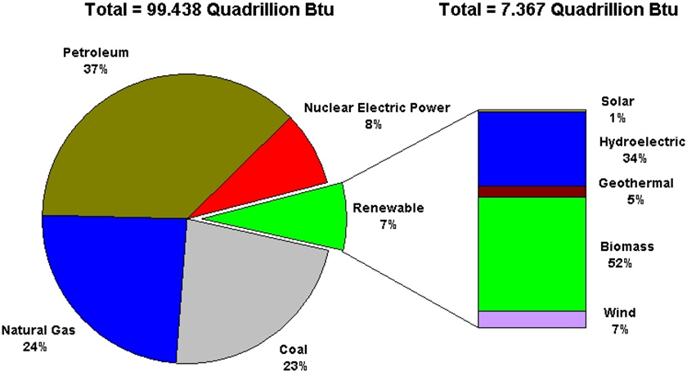
- The chart above shows that what percentage of energy came from renewable energy in 2009?

- What percentage of all the renewable energy was produced by solar energy? ______ wind?______ geothermal? ________ hydroelectric? _________

- Where did most of the energy used in 2009 come from?

- Is nuclear electric power a renewable energy source?
Use the graph to the left to answer questions 5-7
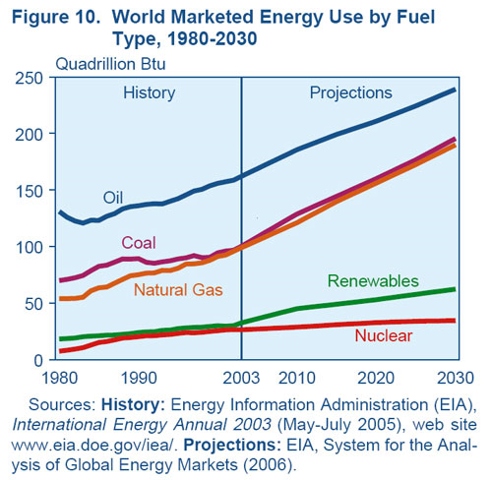
- True or False: coal energy use is predicted to increase over the next 20 years?

- True or False: Natural gas and oil use is predicted to increase over the next 20 years?

- True or False: Renewable energy use is predicted to increase over the next 20 years?

Use the graph on the table to answer questions 8-10
- What fuel provided the most energy in 1910?

- When did nuclear fuels start to provide energy for the US?

- When did oil start provide energy for the US?

Questions:
In a perfect world, what energy source would you choose to help power things you use?

Would your answer change if asked the above question today in not a perfect world? Why or Why not? If you would change, what would you change to?

Write what you think is the three most important things you learned today about types of energy fuels.

