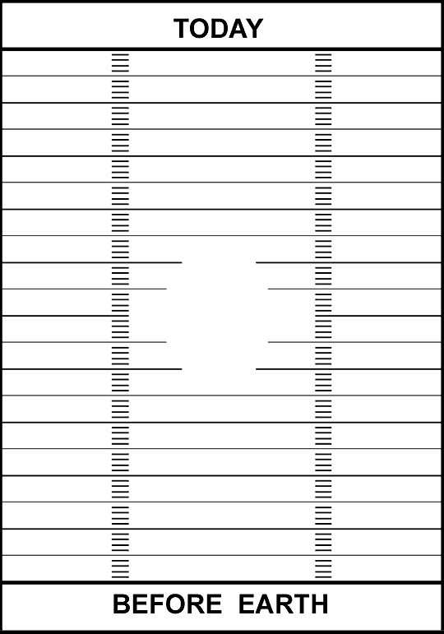

Name______________________________________Period_____Date__________

Geologic Time Activity Worksheet
Instructions
Go to http://pubs.usgs.gov/gip/fossils/numeric.html and use the geologic time scale to find the missing dates and fill in the blanks under the Approximate Age category. Next, calculate the corresponding distance on a football field that each event represents and fill in the blanks under the Distance category. For this activity, 1 yard = 50 million years. Mark the events on the Geologic Time Football Field. One end zone is labeled "TODAY" and the other is "BEFORE EARTH." As you place your events on the football field, pay close attention to which end is which. Place events at the nearest yard.
Geologic Event | Approximate Age | Distance (yds)
Rocky Mountains are formed | 80 million years
First known fish | 510 million years
Paleozoic Era begins
Earliest humans | 2 million years
Formation of the Earth | 4.6 billion years
First known mammal | 200 million years
Proterozoic Eon begins
First single-celled organism | 1.2 billion years
Columbus discovers America | 506 years
Oldest rock | 3.8 billion years
Extinction of the dinosaurs | 65 million years
First known plant | 498 million years
First known reptile | 325 million years
First multi-celled organism | 700 million years
First known amphibian | 375 million years
First known bird | 160 million years

Investigation
1. What event is exactly in the middle of the football field?
______________________________________________________________________________
2. Find where your birth date would be on the football field. Why is it almost impossible to show a human's life on this scale? Would it be easier if we changed the number of years that 1 yard represents?
______________________________________________________________________________
______________________________________________________________________________
______________________________________________________________________________
3. In what periods did fish, mammals, reptiles, amphibians, and plants appear on Earth?
______________________________________________________________________________
______________________________________________________________________________
4. Look at the geologic time scale. Why do you think the Phanerozoic Eon has many more divisions and dates associated with it than the Archean Eon?
______________________________________________________________________________
______________________________________________________________________________
______________________________________________________________________________
5. How many years does the first 10 yards represent? What events are within the first 10 yards of the football field from the TODAY end zone?
______________________________________________________________________________
______________________________________________________________________________
______________________________________________________________________________

