Name_______________________________________Period_________Date____________________

Graphing Notes

- ___________________________
- Shows distribution of ___________________________________________________
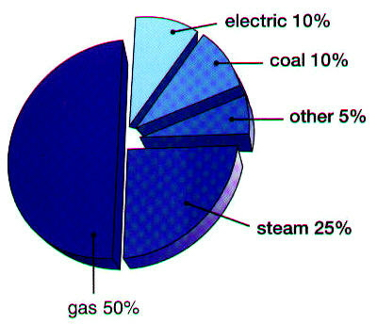
- How to determine pie slice
- Find the _______________
  - Ex. 5/15 = ___________________
- ____________ that number by _____________
  - Ex. ______________=
- Round that to the nearest degree
  - Ex ___________ _________
- Using Protractor to build graph
- Draw a __________ line from the _________ to the ________ of you circle
- Line up your protractor on the straight line
- Find the angle you want
- Draw a new line.
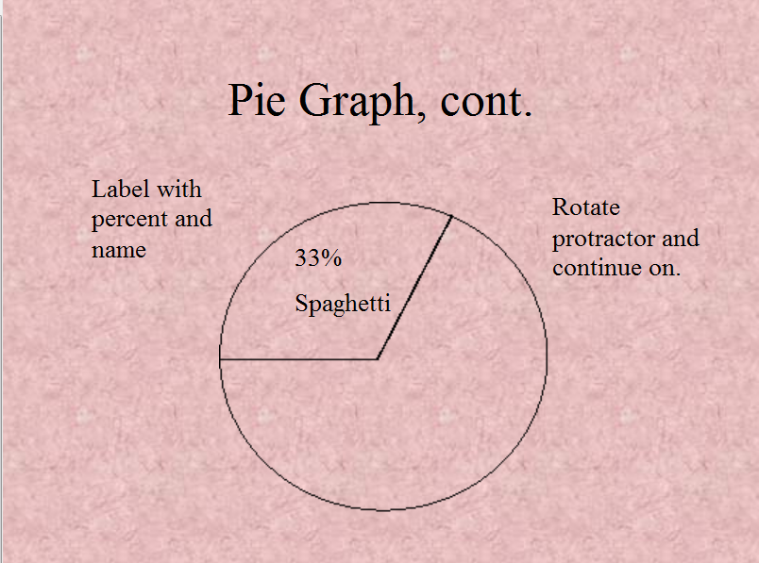
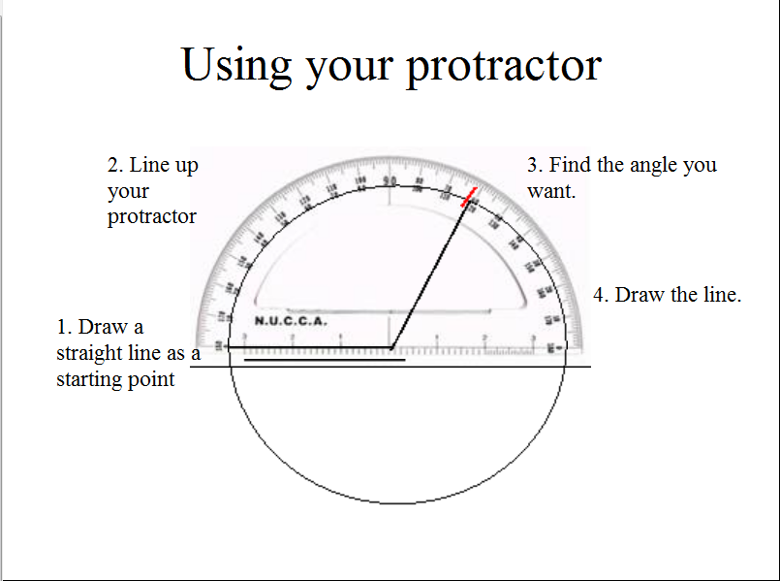
- Rotate your protractor to the new line, repeat new pie slice

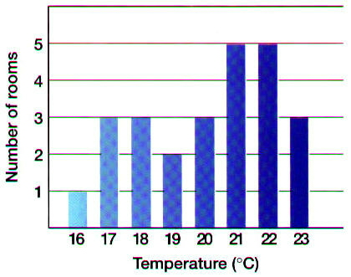
- ___________________________
- Shows information collected by_____________

- ___________________________

- Shows the relationship between _______________________________
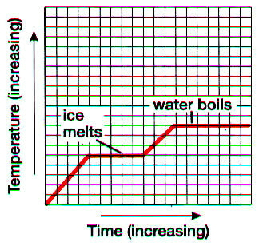
- X axis= ___________________________
- Y axis= ___________________________
- Independent variable
  - Goes on ______ axis
  - _______________________________________
______________________________________
  - Does _______________________________
on the other variable
  - Manipulated/ Changed
- Dependent variable
  - Goes on ______ axis
  - _______________________________________________________
  - Does ________________________
on the other variable

  - It’s what you actually __________________ in the lab

