Name___________________________________Period_____Date_____________

Physical Science Graphing Assignment

In addition to drawing graphs, it is also important that you be able to interpret data that is represented in graph form. The following problems are provided to help you develop the ability to read information shown on a graph.

- Identify the graph that matches each of the following stories:
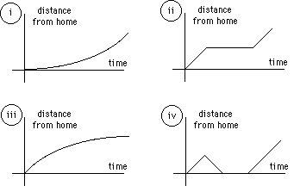
  - I had just left home when I realized I had forgotten my books so I went back to pick them up.
Graph:________
  - Things went fine until I had a flat tire
Graph:________
  - I started out calmly but sped up when I realized I was going to be late.
Graph:________

- The graph at the right represents the typical day of a teenager. Answer these questions:
  - What percent of the day is spent watching TV? _______
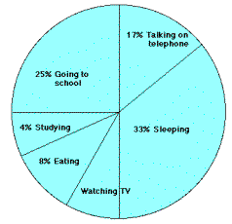
  - How many (NOT what percent) hours are spent sleeping? ______
  - What activity takes up a quarter of the day? ______
  - What activity takes up the least amount of time _________________
  - What two activities make up 50% of the day? _________________________________________________________
  - What two activities take up 25% of the day? _________________________________________________________

- Answer these questions about the graph below
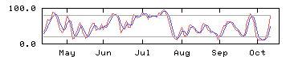
  - How many sets of data are represented (how many lines)? ___________
  - On approximately what calendar date does the graph begin? __________
  - In what month does the graph reach its highest point? _____________

- Answer these questions about the graph on the right:
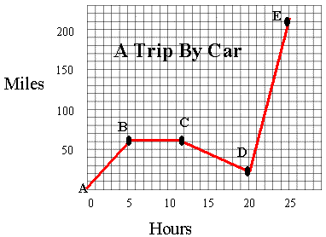
  - How many total miles did the car travel? ________
  - What was the average speed of the car for the trip? (HINT: take the total miles traveled from part a and dived by the total number of hours) _______
  - How many miles were traveled during the first two hours of the trip? _______
  - Which line segment represents when the car was going the fastest (HINT: look for steepest slope)? ________

- Answer the questions about the graph at the right:
  - What is the dependent variable? ______________________
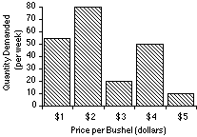
  - Does the price per bushel always increase with demand? ________
  - What is the demand when the price is $5 per bushel? ________

