Name__________________________________________Period______Date______________

Geology Guided Notes Unit 2

Basic Chemistry & Minerals

Text Reference:

Ch 2: Pg 33-57

**BASIC CHEMISTRY**

* _________________:the substance of which any physical object is composed
* States of Matter:
  + Controlling factors:
* The make-up of ____________ matter on earth:
* _______________: fundamental building block
  + __________________________ that cannot be broken down
* Periodic Table
  + ____________________________
  + ___________________________________; elements of a group have similar properties
  + ________________________________________________

Atomic Structure

The Atom

* _________________: stuff that builds _________________________
* _____________________particle that unique defines an element
* Made up of _____________________________________________________________ ___________________________________________

Subatomic Particles

* _________________________________________charge
* _____________________________________charge
* ___________________________________________________________ of the subatomic particles
* _________________________________define the _____________ of an atom
* Layers of electrons that orbit the nucleus are called ________________ or energy level shells
* Atomic Mass=____________________________________________

Atoms of the _________ element:

* Have the same number of _______________ (i.e. the same ___________________________)
* Can have different number of _________________(referred to as ______________________)
* Can have different number of ______________________
* _____________: an atom that has ________________ or _____________ an electron

Isotopes

* Atoms of the ____________________ with different ____________________________



* Atomic #:
* Mass #
* # protons:
* # electrons
* # neutrons

Ions

* Ion: atom that has gained or lost an electron
* _______________: a _________ of electrons, resulting in a __________________ charge
* _______________: a _________ of electrons, resulting in a __________________ charge
* Ex:

Compounds

* A _________________________ consists of ______________ that ______________ in a specific ratio
* Ex:
* The smallest quantity of a compound is called a __________________________
* Molecules are held together by _____________________________________

Chemical Bonds:

* An _____________ force between the ____________________________________________ of different atoms that binds them together
* Formation of a compound by ____________________________________________________
* Manner in which electrons are distributed
* In bonded atoms, electrons may be _______________________________________________
* Bonds form in order to:
  + ________________________________________
  + ________________________________________

Ionic Bonds

* __________ bonds are formed by the ___________________ of electrons
* _____________________________________
* What constitutes an ion?
  + Positive or negative charge
  + Cation or anion
* ___________________ attract
  + Cations will attract _________________
  + Anions will attract__________________
* Bonding ALWAYS takes place in the valence shell between _________________________
* Must include a ________________________________
  + Metal=_____________________
  + Anon=______________________
  + Anion “takes” electron(s) from cation

Covalent Bonds

* Compounds that are made of molecules
* Bonds that are formed by __________________________________________
* Electrons are shared from the ______________ shel, still want it full
* Generally the __________________________Bonds
* _______________________________________(diamond, Pure C)

Metallic Bonds

* __________________________________
* Generally _____________, less common than other bonds
* Electrons ______________________________________________________________
* Electrons are free to move from atom to atom; this is why they are good ____________________________________________
* Ex: _____________________________________________________

Van der Waals

* _______________________________________bonded atoms held together by ___________ ______________________________________________
* ____________________________bonds
* Ex: graphite, mica

Bond Strength

* **Van der Waals** 🡪 **metallic** 🡪 **ionic** 🡪  **covalent**

**MINERALS**

**Mineral Characteristics**

What is a Mineral?

1. __________________________________
2. __________________________________
3. __________________________________
4. __________________________________
5. __________________________________

* Naturally Formed:
  + No substance created _____________________ is a mineral
    - Examples: ____________________________________(NONE ARE MINERALS)
* Inorganic:
  + Anything formed by a ____________ organism and containing organic materials is NOT a mineral
    - Examples:________________________________________________________
* Solid
  + ________________________________are not minerals
    - Examples:________________________________________________________
* Characteristic Crystalline Structure
  + Must have an _________________arrangement of ______________________
  + Displays ___________________ geometric patterns in 3-D
  + _____________________ a mineral (no internally crystalline structure)
* Definite Chemical Composition
  + Must have a consistent _____________________________________
  + Examples: _______________________________________________(ALL MINERALS)
  + Basalt, like other rocks, contains variable ratios of different minerals

Mineral Terminology

* __________________________: _____________________________________ but don’t fit the definition of a mineral. Example:_________________________
* ___________________________: ___________ minerals with the _______________________ __________________ but different _________________________
  + Example:_____________________________________________

Mineral Formation

* Many minerals grow by ________________________________: atoms are arranged in a specific, ________________________ geometric pattern:
  + _____________________________________________________
  + ______________________________________________________

Some minerals result from the alteration of other minerals during:

* + __________________________
  + __________________________

Mineral Diversity

* Of the almost 4000 minerals, only about _________ are common
* These common minerals make up most of the rocks found in the ______________________
* Over _______ of Earth’s crust is made up of a family of minerals known as ______________
* Only ______ elements make up the bulk of the Earth’s crust
* ______________________________ constitute _____________ of earth’s crust and nearly 84% of the atoms available to form compounds
* When oxygen and silicon combine they are called _________________________________

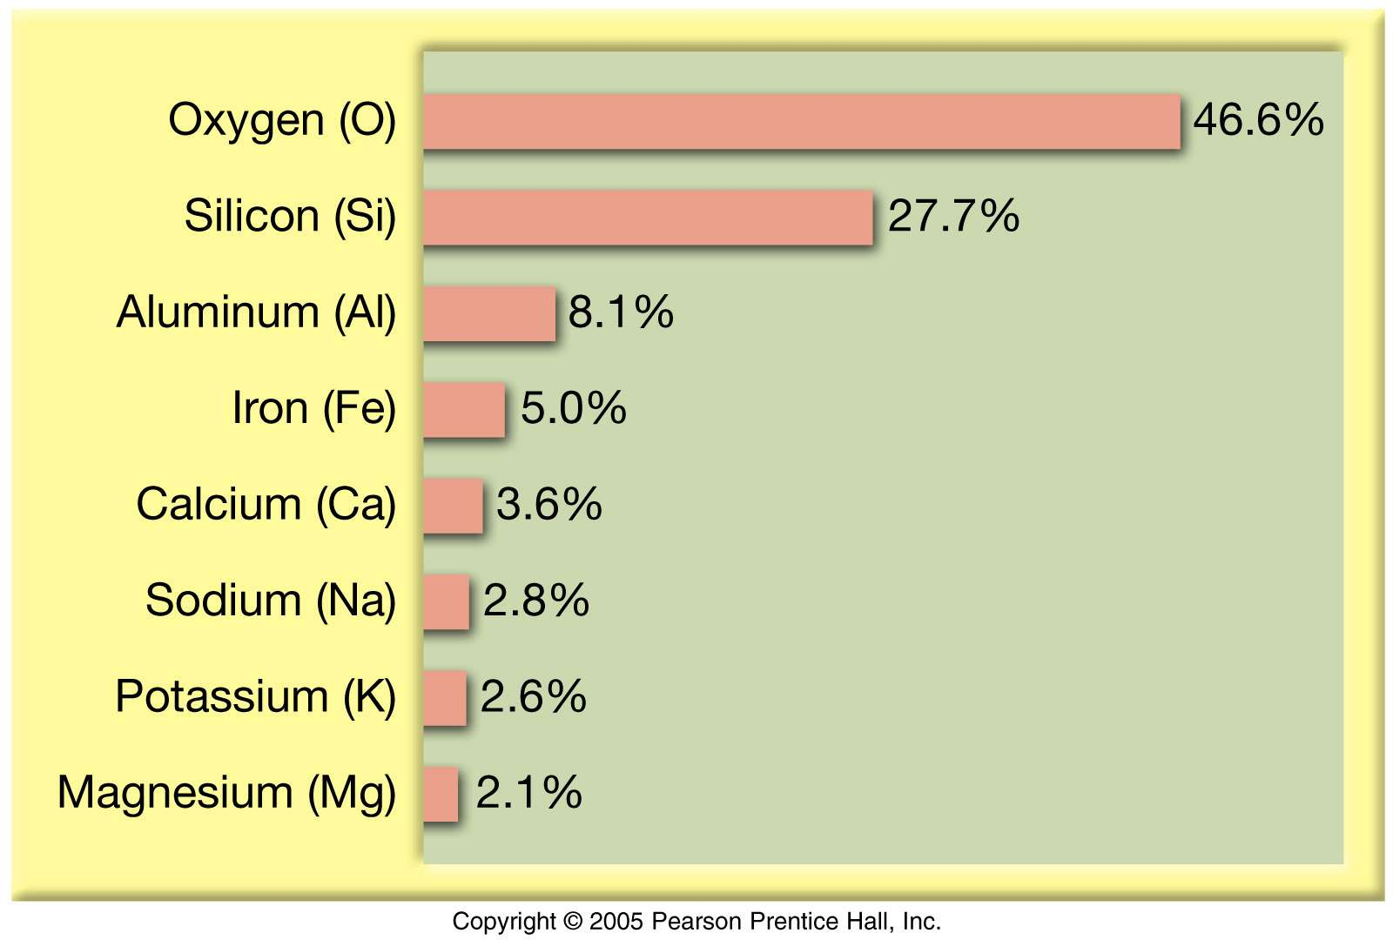

**Mineral Groups**

* Silicates (most abundant)
* Non-Silicates
  + Oxides
  + Carbonates
  + Sulfides
  + Sulfates
  + Halides
  + Native elements (single elements)

*Silicates*

Characteristis

* A combination of oxygen and silica is a ______________________
* ___________________ is pure ____________________
* Most silicates have one or more additional elements
* Orthoclase feldspar: _________________________
* Olivine:____________________________________

Structure

* ___________________________
  + Fundamental building block
  + ___________________ ions surrounding a much smaller _____________ ion
* How tetrahedral maybe ______________
  + ______________________________
  + ______________________________
  + ______________________________
  + ______________________________
  + ______________________________
* _________________ Group: _____________ silicates (__________) Ferromagnesian
  + Structure: ______________________________
  + ______________________________________
* _________________ Group: ___________________________________ silicates (__________)
  + Structure: ______________________________
  + _______________________________________________________________
* _________________ Group: ________________________________ silicates (_____________)
  + Structure: ______________________________
  + ________________________________________________________________________
* ____________________ Group: _____________ silicates (__________) Non-Ferromagnesian
  + Structure: _____________________________________________
  + ______________________________________________________
* _________________ Group: _____________ silicates (__________________)
  + _________________________________ mineral group
  + Structure: ______________________________
  + ________________________________________________________________
* _________________ Group: _____________ silicates (____________________)
  + Structure: ______________________________
  + ______________________________________
  + ____________resistant to ____________________________



*Carbonates*

* Contain ______________ charge _____________________________________
* Calcite or calcium carbonate: ____________________________
* _______________ is the main constituent of the sedimentary rock ____________________
* _________________(CaMg(CO3)2) is formed by the alteration of ___________, replacing it in ancient rocks with ________

*Oxides*

* An element (usually a ________________) combined with ___________________
* Iron Oxides:
  + _____________________:Fe2O3
  + _____________________:Fe3O4
  + Important sources of iron ore for ______________ manufacture

*Sulfides and Sulfates*

* _______________: have a ________ combined with a __________________(_____________)
  + _________________: (CaSO4•H2O)
* _____________: have a ____________ combined with a ______________(_______________)
  + ______________(PbS), ________________________(FeS)

Other Mineral Groups

* _______________: contain _____________ elements (chlorine, fluorine, bromine, iodine)
  + Ex. ________________(NaCl) and ________________________(CaF2)
* ________________________: exist in _________________________________ form.
  + Example:___________________________________________________

**Mineral Properties**

* Rarely is a mineral identified by a single property!!!!!!!! All properties need to be considered when identifying minerals!!!!!

Color

* _________________ observed and the __________ useful
* Exceptions to the color rule:
  + ______________________: always __________
  + ______________________: always __________
* Many minerals have a _________________________
* Many minerals can turn colors due to ___________________, or they can change colors in various circumstances
  + Ex. Pure quartz is __________________________, impurities can make the mineral ___________________________________________

Luster

* ___________ refers to the way a mineral ___________________________________________
* Two types of luster: ____________________(shiny) and ______________________________
* Words to describe non-metallic luster
  + ______________________(ex________________________)
  + ______________________(ex________________________)
  + ______________________
  + ______________________
  + ______________________

Streak

* _____________ of a mineral is the ___________________________________ when rubbed on an unglazed white tile
* The streak is often _________________________________ as the mineral
* A mineral’s color may vary but the streak ____________________________

Crystal Shapes

* Crystal Shape can be a useful property to identify minerals if the minerals have had the _____________________________ to form ___________________ most mineral grains that are in found in ________________________________________________________________
* _____________________ expression of a mineral’s internal atomic structure
* ______________________________ called _____________________________________
* Angles __________________________ are ___________________ for any particular mineral

Cleavage

* The ______________ of a mineral is its tendency to __________________________________ ______________________________.
* Cleavage can even be observed on tiny mineral grains making it a very useful property
* DO NOT CONFUSE CLEAVAGE PLANES AND CRYSTAL FACES!!
* Different types of cleavage

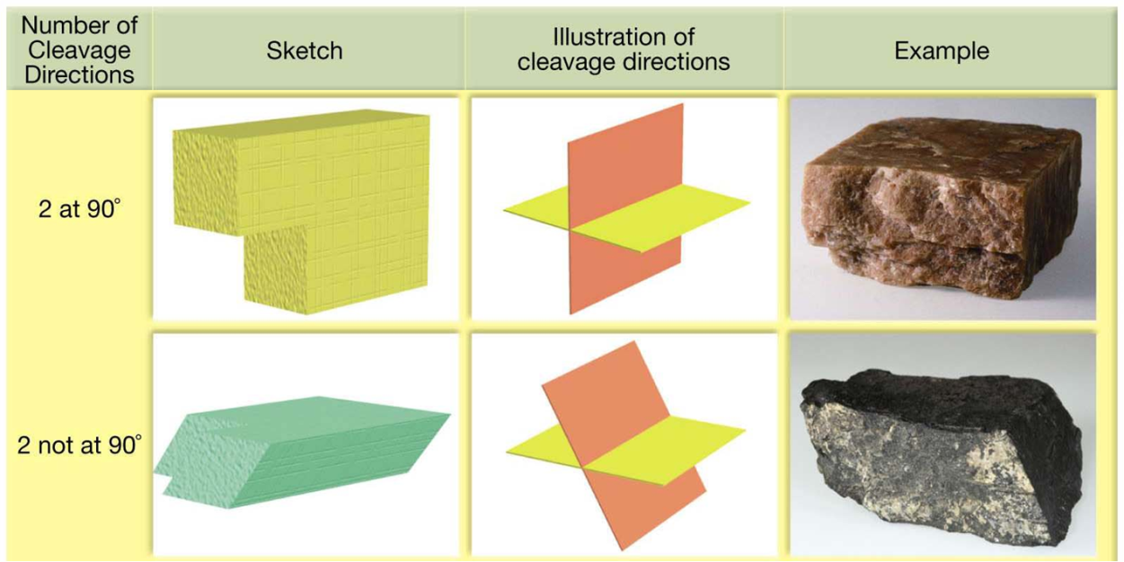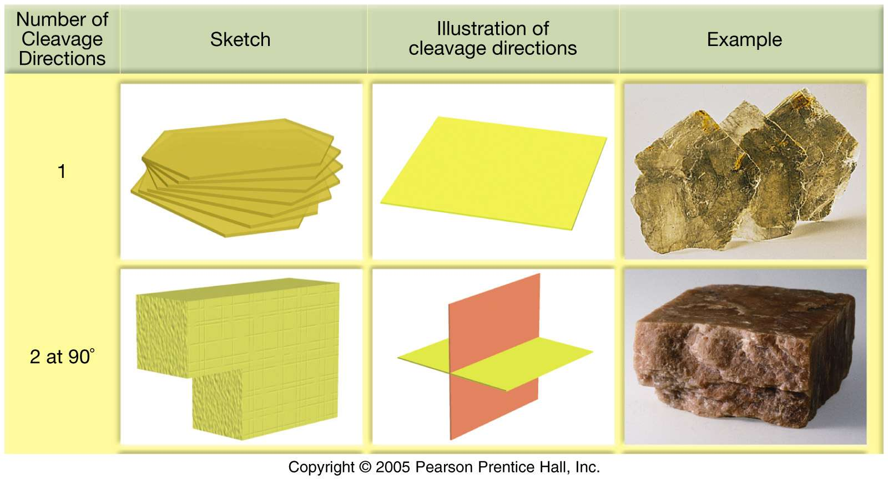

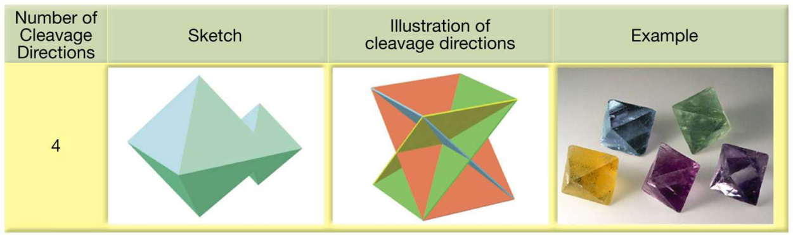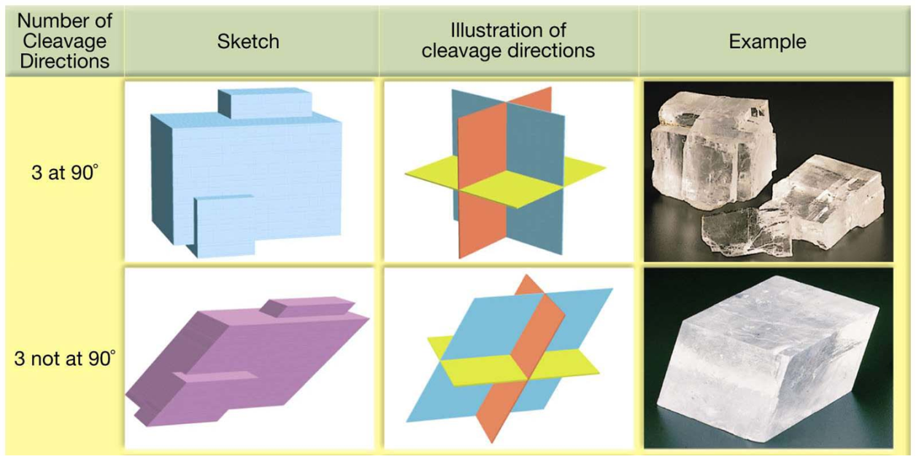

No Cleavage: then Fracture

* ________________minerals show cleavage
* Those that ____________________ along cleavage surfaces are said to have ____________
* Minerals that have some _________________________________ show __________________________
* Minerals, like _____________, that have _______________________________ show fracture

Hardness

* The ______________ of a mineral is its __________________ to being __________________
* _________________ is the ___________________ of all minerals, ________ is the _____________________
* Fredrich _____________ devised a hardness scale
  + In this scale, ten well known minerals are given numbers 1-10
* Moh’s Scale:

|  |  |  |
| --- | --- | --- |
| Hardness | Mineral | Description |
| 1 |  |  |
| 2 |  |  |
| 3 |  |  |
| 4 |  |  |
| 5 |  |  |
| 6 |  |  |
| 7 |  |  |
| 8 |  |  |
| 9 |  |  |
| 10 |  |  |

Other Properties

* __________________________ tells you how many times as ___________ as water the mineral is. Pure gold can have a specific gravity as high as ______________
* ACID TEST: If a drop of weak _____________________________ is dropped on calcite, the acid ________________________ as ______________________________is released
* _______________________________: Minerals that can be ___________________________ _____________________________
  + Ex: ____________________________
* ___________________________: in some minerals that contain ____________ are magnetic
* __________________________: the state of _______________ while under ______________ ___________ light.
* Radioactivity: ex. Uranite
* Taste: _____________________ can be identified this way. NOT RECOMMENDED PRACTICE!

**Chemistry and Mineral Properties**

Hardness

* The ______________ the bond the _______________ the mineral
* _______________ bonds are usually the hardest minerals, __________________ usually the softest
* ____________ structures harder than __________________
* Minerals with __________________ in their structure are generally ____________________
* The larger the _______________________, the ___________ the bond, and the _____________ the mineral

Density

* The ________________ the mineral, the _________________________ it usually is

Color

* The most common cause of color in minerals is interaction with _____ outer-shell electrons
* Minerals of hard cations (_________________________________) have no color and are ________________________
* Minerals of soft cations (________________________________________) commonly have colors unique to the cation. (________________________________________________)

**Uses of Minerals**

* ________________________Pounds!!

Lets take a look at some of the uses of these minerals!

Common Uses:

* Aluminum:______________________________________________________
* Beryllium:_______________________________________________________
* Copper:_________________________________________________________
* Feldspar:________________________________________________________
* Iron:____________________________________________________________
* Calcite:__________________________________________________________

Birthstones:

* January:________________
* February:_______________
* March:__________________
* April:___________________
* May:____________________
* June:___________________
* July:____________________
* August:_________________
* September:_______________
* October:__________________
* November:_________________
* December:_________________

Fireworks:

* Americans use ________________________(60,000 pounds) of fireworks per year. Let’s look at the minerals that make up the colors of fireworks:
  + Red:________________________________________
  + Orange:_____________________________________
  + Yellow:_____________________________________
  + Gold sparks:_________________________________
  + Bright Flashes:________________________________
  + Green:_______________________________________
  + Lavender:____________________________________
  + Silver/White:__________________________________
  + Silver/White flashes:___________________________