Name_________________________________________Period_______Date_____________

Types of Reactions

Identify the reactions below as synthesis, decomposition, single replacement, double replacement, or combustion.

REACTION | TYPE?
Na₃PO₄ + 3 KOH 3 NaOH + K₃PO₄
MgCl₂ + Li₂CO₃ MgCO₃ + 2 LiCl
C₆H₁₂ + 9 O₂ 6 CO₂ + 6 H₂O
Pb + FeSO₄ PbSO₄ + Fe
CaCO₃ CaO + CO₂
P₄ + 3 O₂ 2 P₂O₃
2 RbNO₃ + BeF₂ Be(NO₃)₂ + 2 RbF
2 AgNO₃ + Cu Cu(NO₃)₂ + 2 Ag
C₃H₆O + 4 O₂ 3 CO₂ + 3 H₂O ``
2 C₅H₅ + Fe Fe(C₅H₅)₂
SeCl₆ + O₂ SeO₂ + 3Cl₂
2 MgI₂ + Mn(SO₃)₂ 2 MgSO₃ + MnI₄
O₃ O. + O₂
2 NO₂ 2 O₂ + N₂
3 Cs + AlCl₃ 3 CsCl + Al

Identify the types of reactions below based on the following diagrams. (Your options are synthesis, decomposition, single replacement, double replacement)

- ____________________________________________

- _____________________________________

- 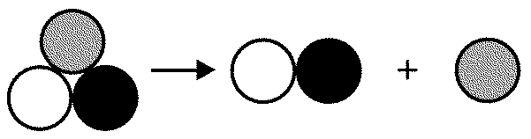 ___________________________________________

- ________________________________

State whether each of the following equations represents a synthesis (s) , decomposition(d), single replacement (sr), double replacement (dr), or combustion reaction (c).

_____________ 1. CO₂ → C + O₂

_____________ 2. NaCl + AgNO₃ → NaNO₃ + AgCl

_____________ 3. S + Cl₂ → SCl₂

_____________ 4. BaCl₂ + 2NaOH -→ 2NaCl + Ba(OH)₂

_____________ 5. 2C₂H₂ + 5O₂ → 4CO₂ + 2 H₂O

_____________ 6. Zn + CuSO₄ → ZnSO₄ + Cu

_____________ 7. CH₄ → C + 2H₂

_____________ 8. Pb(NO₃)₂ + Mg → Pb + Mg(NO₃)₂

_____________ 9. Mg + 2 HCl → MgCl₂ + H₂

____________ 10. H₂SO₄ → H₂ + S + 2O₂

_____________ 11. 2O₂ + N₂ → N₂O₄

_____________ 12. 3CaBr₂ + 2Na₃P → Ca₃P₂ + 6NaBr

_____________ 13. 2KI + Br₂ → 2KBr + I₂

_____________ 14. C₆H₁₂O₆ → 6C + 6H₂O

_____________ 15. 2NaF → 2Na + F₂

_____________ 16. Si + O₂ → SiO₂

