USA (Contiguous) Latitude and Longitude Activity
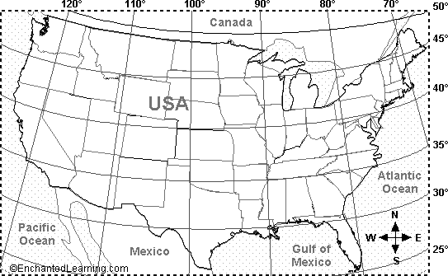

1. Do lines of latitude run east-west or north-south? | _____________________
2. Name three states that extend below latitude 30 degrees N (in the contiguous US), and label them on the map. | _____________________
 | _____________________
 | _____________________
3. Name one US state that is mostly east of longitude 70 degrees W, and label it on the map. | _____________________
4. Name three US states (shown on this map) that extend west of longitude 120 degrees W, and label them on the map. | _____________________
 | _____________________
 | _____________________
5. Is the location 45 degrees N latitude, 82 degrees W longitude on land or under water? On the map, mark it with a red X. | _____________________
6. Name the state that is located entirely between 40-45 degrees N latitude and between 90-100 degrees W longitude, and label it on the map. | _____________________

Label the Latitude and Longitude
Using the terms below (or the glossary), label latitudes and longitudes on the world map.
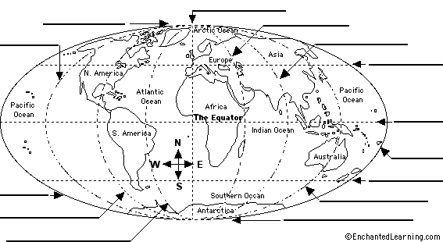

90º N  45º N  0º Latitude  45º S  90º S | 180º W  135º W  90º W  45º W  0º Longitude | 45º E  90º E  135º E  180º E

Map Reading Activity: Topography
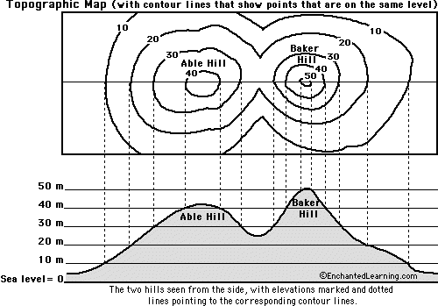

1. Color the elevations on the topographic map as follows. Red: 50m and higher, Orange: 40-50m, Yellow: 30-40m, Light green: 20-30m, Dark green: 10-20m, Purple: 0-10m.

2. Approximately how tall is Able Hill? | ___________________________

3. Approximately how tall is Baker Hill? | ___________________________

4. Which mountain is taller, and by about how much? | ___________________________

5. How many meters of elevation are there between contour lines on the topographic map? | ___________________________

6. Which mountain has steeper slopes? | ___________________________

7. Are the contour lines closer together on Able Hill or Baker Hill? | ___________________________

Map Reading Activity: Topography #2
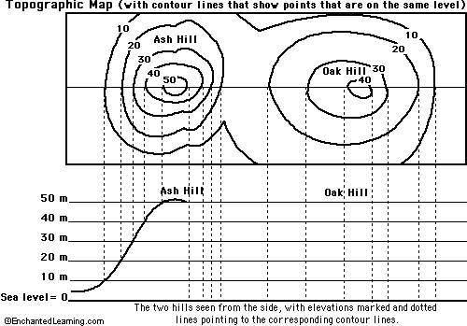

1. Color the elevations on the topographic map as follows. Red: 50m and higher, Orange: 40-50m, Yellow: 30-40m, Light green: 20-30m, Dark green: 10-20m, Purple: 0-10m.

2. Finish the mountain diagram below the topographic map, completing Oak Hill and drawing Ash Hill with proper elevations.

3. Approximately how tall is Ash Hill? | ___________________________

4. Approximately how tall is Oak Hill? | ___________________________

5. Which mountain is taller? | ___________________________

6. How many meters of elevation are there between contour lines on the topographic map? | ___________________________

7. Are the contour lines closer together on Ash Hill or Oak Hill? | ___________________________

8. Which mountain has steeper slopes? | ___________________________

