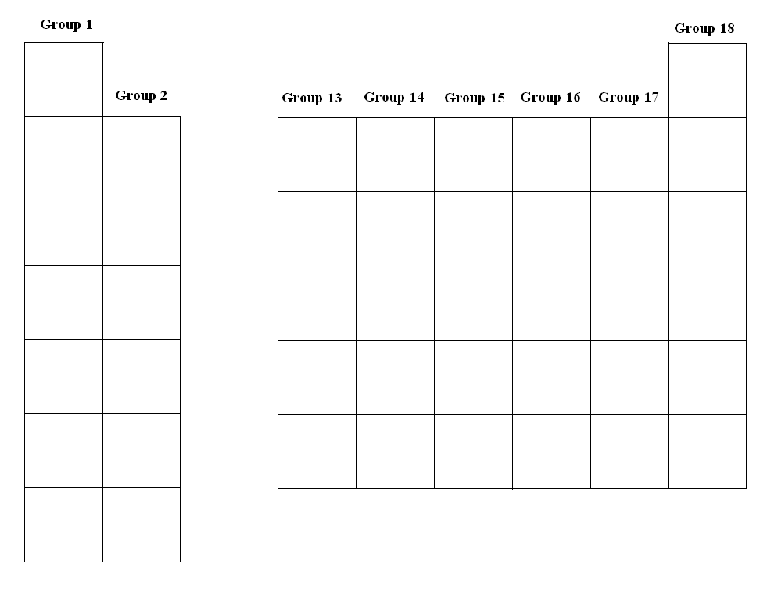
Answer the questions below:
- How many valence electrons does Group 13 have?

- How many valence electrons does Group 18 have?

- Which two elements can only have up to two valence electrons in their outer shell?

- How many valence electrons does each element want to have in their outer shell according to the octet rule?

Draw the Lewis Structures for the following (this will be like the ones on the quiz)

Hydrogen:

Helium:

Sulfur:

Fluorine:

Aluminum:

Beryllium:

Gallium:

Phosphorous:

Xenon:

Silicon:

Potassium:

Iodine:

Argon:

Calcium:

Nitrogen:

