**Name________________________________________Period____Date____________**

**Chapter 15 Part II**

**Light Waves Guided Notes**

*Light*

1. *What is it?*

* Light Energy
  + As atoms ______________________, _________________ jump out to a _______________ level
  + Electrons _______________________ when falling down to the ___________________________________ level
* Light can be modeled as a wave or as a ___________________________________
* ___________________
  + ___________________________bundles of radiation
  + ___________________________________by electrons
  + Energy ________________ with wave ________________________
* Speed of Sound
  + Depends on ___________________________________________________
  + Speed in a vacuum
    - _______________________________________
    - ________________________________________
  + _______________________________________________________________
  + Light travels __________________________than sound.

1. *Electromagnetic waves & Electromagnetic Radiation*

* ___________ waves are known as _________________________________ waves
* Consist of changing ________________________________fields in space
* Electromagnetic Radiation
  + ______________________ waves produced by the motion of electrically charged particles
  + Does _____________ require a __________________
* The electromagnetic spectrum

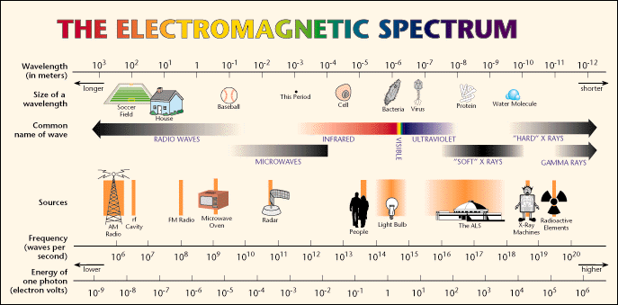

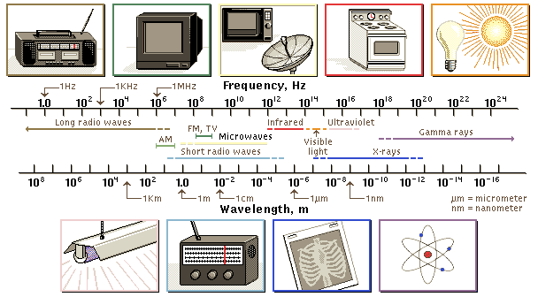

**Short λ**

**High *f***

**High energy**

**Long λ**

**Low *f***

**Low energy**

* The speed of light depends on the ________________________
  + In a vacuum, light always travels at _____________________________
  + Travels faster in ________________________________________________
  + _________________________ traveling signal in the universe
* The brightness of light depends on ________________________
  + Intensity=the rate at which ______________________ through a given area of space
  + As it spreads out, intensity ___________________________

*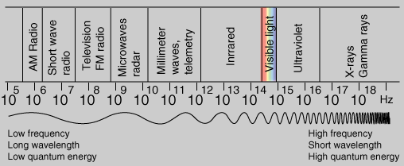Types of Electromagnetic Radiation*

* ____________________________: ______________ energy EM radiation
  + _______________________________________________________________
  + Uses: _________________________________________________________
  + FM:_____________________________________
  + AM:_____________________________________
* ______________________________: penetrate food and ________________ water and fat molecules to produce _____________________________
* ________________________________(____)
  + Slightly _____________ energy than _________________________
  + Can _________________ the thermal energy of objects
  + Uses: ______________________________________________________________
  + _____________________: image made by detecting IR radiation
* _______________________________
  + _____________ part of the spectrum we can see
  + 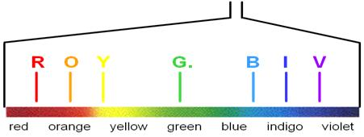ROY G. BIV: colors in order of __________________ energy
  + Red=__________________________________
  + Violent=_______________________________

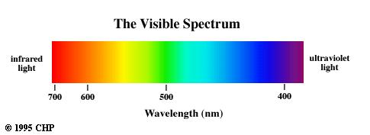

* 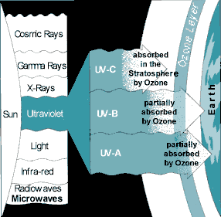_________________________________(_______)
  + Slightly ___________ energy than visible light
  + Types of UV radiation
    - ______________: tanning, wrinkles
    - _______________: sunburn, cancer
    - ________________: most harmful, sterilization
  + If we deplete the ozone, too much UV exposure
* _________________________
  + _________________ energy than UV
  + Can penetrate ____________________ but not _________________
* _________________________________
  + _____________energy EM Radiation; emitted by _______________________
  + Used to kill ____________________________________

1. *Wave Properties of Light*

*Light: Particles or Waves?*

* _______________________________________ explains most properties
* ___________________________ of light
  + ___________________________________________________________________ of light produce ____________________________________

*Reflection*

* When a wave strikes an object and bounces off
* Law of Reflection: the angle of ___________________________=the angle of _______________________________

**

*Reflection & Mirrors*

* _______________________: ____________________ because it cannot be projected
  + Image only _________________________________________
* ______________________: __________________________________________________ _________________________________________________________________________
* _______________________________: _________________________________________ _________________________________________________________________________
* ___________________:______________________________________________________ _________________________________________________________________________

Types of Mirrors

* ________________________________-___________________________________
  + _______________________________:
  + _________________________________________________________________
* ___________________________Mirror
  + ____________________________________
  + ______________________________________
  + Use: ______________________________________________________________
* Convex ____________________
  + ___________________________________________________________________
  + Lens that converges _____________________________ light rays
  + Forms _________________ images and _____________________ images depending on the _____________________ of the object
* _________________________________
  + ______________________________________________________________________________________________________________
  + Diverges (____________________________) light rays
  + All images are _________________________________________

How you see:

* Near Sighted: ____________________________________________________________ __________________________________________________________________________
* Far sighted:______________________________________________________________ __________________________________________________________________________
* Vision-eye is a _________________________

*Refraction*

* Bending of waves when passing from one medium to another
* Caused by a change in speed
  + ___________(__________________) 🡪 light bends ________ the normal
  + ___________(__________________) 🡪 light bends _______ from the normal
* Refraction depends on
  + Speed of light in the __________________________
  + Wavelength of the light: _______________wavelengths(blue) bend ______

*Diffraction*

* Bending of waves around a barrier
* ______________ wavelengths (red) bend more-__________________ of refraction

*Interference*

* Constructive 🡪 _________________________ light
* Destructive 🡪 ______________________ light

1. *Light and Color*

* *____________________*: _______________________________________________ light
  + Color you see is color it _____________________
* *_________________________:* allows light to pass through ____________________
  + Color you see is color that is __________________________, all others are _____________________________
* *_______________*__________: allows _________ light to pass through
* ________________ Light: contains ______________________________
* In which light, an object….
  + ____________________ the color you see
  + _____________________ all other colors
  + Black light ______________________________________________
* The Retina:
  + Lens _____________________ light to converge on the retina. Nerves transmit the image.
* The _________________ contains
  + ____________: dim light, black & white
  + _____________: color
    - _________: absorb ___________________________
    - ____________: absorb ____________________________
    - ___________: absorb ____________________________
* Color blindness
  + ____________ or ____________ sets of cones does not function properly
* Mixing Colors
  + Primary light colors
    - _______________________________________
    - Additive colors
    - Combine to form ________________________________



* + __________________: ______________________ material that absorbs __________ light colors except the ____________ color

**

* + _______________: colored material that __________________________ different colors
  + Primary Pigment Colors
    - ______________________________________________
    - Subtractive colors
    - Combine to form ______________________________
      * 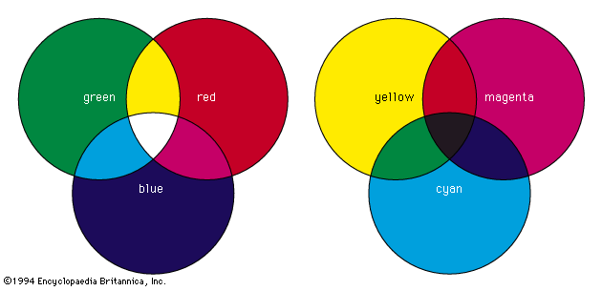Ex. Ink cartridges

When mixing pigments, the color of the mixture is the color of light that ________ pigments reflect

RGB Mixing:

* ___________________________
* ___________________________
* ___________________________
* ___________________________
* ____________________________
* Cyan reflects: and absorbs:

CMYK Mixing:

* ___________________________
* ___________________________
* ___________________________
* ___________________________
* ____________________________
* Blue reflects: and absorbs: