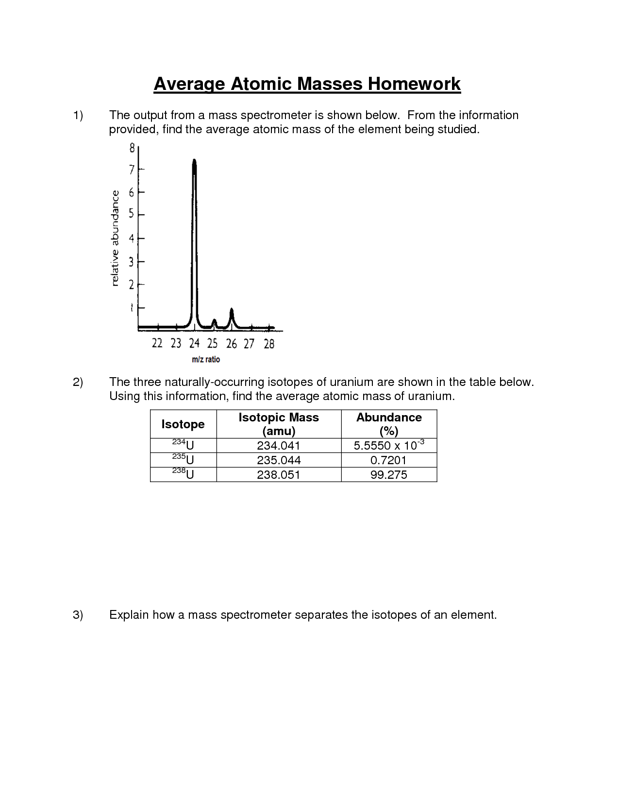**Name_________________________________________Period_____Date____________**

**Mass Spectrometry&**

