Name____________________________________________________________ Period__________

Matter Vocabulary Meme Assignment
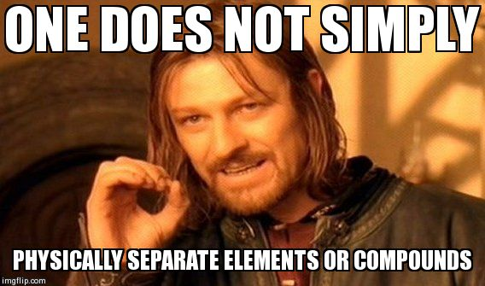
https://imgflip.com/i/9m5f2

What’s a meme?
- A concept or catchphrase that spreads and changes from person to person

What’s your goal:
- Make a meme that reviews at least 2 vocabulary words that could easily be confused
- Be as creative as possible!

How to make a meme:
- Go to https://imgflip.com/memegenerator (or any other meme site) and use stock photos or upload a photo to make a meme.
- Add your text, hit generate meme
- This will give you options to share via social media and will give you an image link
How to submit meme:
- Share your meme via twitter with TWO #s using the #chemwithellis & #mattermeme
  - Your tweet should also include a description of the vocabulary you are reviewing. I would you to add a picture to your tweet rather than just providing the link in the tweet.
  - If your twitter ID does not clearly ID your first and last name, please include your first & last name in your tweet.

- Email me the link of your meme at julia_ellis@bsin.k12.nm.us
  - Your email should also include a description of the vocabulary you are reviewing.
  - In the subject line: Include First Name Last Name’s Meme (ex. I would do Julia Ellis’ Meme)

Rules:
- This is a school assignment, so only use appropriate pictures and language in your tweets. If you are unsure if what you’re doing is appropriate, it probably isn’t…but you can always ask me before posting.
- Be creative! Be funny! If you are unsure where to start, look at other images in the meme gallery and figure out why they are funny or how they get the point across. (but remember to be original)
- If a lab safety meme has already been posted on our twitter feed, you may not copy it, or you will receive zero points for the assignment.

Why are we doing this?
- Seeing a good meme will make you laugh, but creating a meme will really help you remember the science since you created in yourself.

Grading Rubric (20 pts)
 | 0 | 2 | 4
Vocabulary Rule Covered in Meme | Not Covered | Missing parts of rubric to receive a 4 | 2 Vocabulary terms covered in meme with appropriate text and meme picture
Evidence of Understanding the Meme used | No evidence of understanding meme | Missing parts of rubric to receive a 4 | Text of memes matched tone & content of meme picture
Originality | Not original | Missing parts of rubric to receive a 4 | Meme was funny, creative, or thought-provoking
Description of Lab Safety Rule | Did not explain lab safety rule presented | Missing parts of rubric to receive a 4 | Full description of Vocabulary in tweet
Posted Meme to Twitter or Emailed Meme | Did not post meme through Twitter or Email | Missing parts of rubric to receive a 4 | Posted to Twitter using both correct hashtags (class & mattermeme). Tweet includes a picture not just a link to a picture OR emailed meme with correct subject

Those without internet access on phone, on computer, at home, or no opportunity to go to the library for 5 minutes.
You may hand draw your meme, and turn in on the due date, but you will not receive the 4 possible points in the “posted” category on the rubric.

