Using the PhET hydrogen atom simulation to test ideas from classical and quantum physics

Scientists make observations of the world around them. Based on those observations, they often develop models of the phenomena they observe. In this activity, you will:
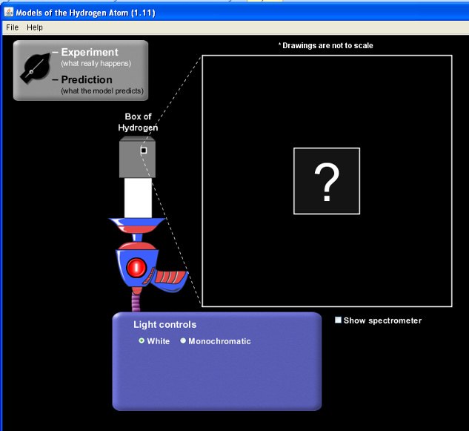
- develop characteristics of a model for the hydrogen atom.
- test different models, comparing them to your model and your observations.
- Go to http://phet.colorado.edu/en/simulation/hydrogen-atom. Click “Run Now”.
- Make sure the dial is set on “Experiment” and the Light Control set on “White”.
  - The gun is used to shoot light photons (energy bundles). Each circle from the gun represents a photon corresponding to that color (with fuzzy purple representing UV).
  - The box with a question mark represents a hydrogen atom.
  - Predict what will happen to the photons as they pass through the hydrogen atom. Be sure you address what will happen to the different colors. Give a justification for your prediction.

- Push the red “O” button on the gun and write down your observations of what happens as the photons pass through the box. Be specific, covering everything you observe. Do your observations match your prediction?

- What conclusions can you make about the structure of the hydrogen atom? Your conclusion should address as many of your observations as possible.

- Once you have made your conclusion, you will use them to formulate a model of the hydrogen atom. Based on what you observed, what characteristics must the hydrogen atom? Justify each component by addressing which of the above observations this characteristic addresses. For example, if no photons passed through the box, then you would infer that the hydrogen atom must have a rigid wall around it.

- Now move the switch in the upper right corner to “Prediction”. The simulation has gives you six possible models of the hydrogen atom. Fire the gun at each of the models. What observations can you make about the photons or the hydrogen atom?
Specific atomic model tested | Observations | How do these observations support the experimental results in the first part? | How do these observations support your model?
Billiard Ball
Plum Pudding
Classical Solar System
Bohr
De Broglie
Schrodinger
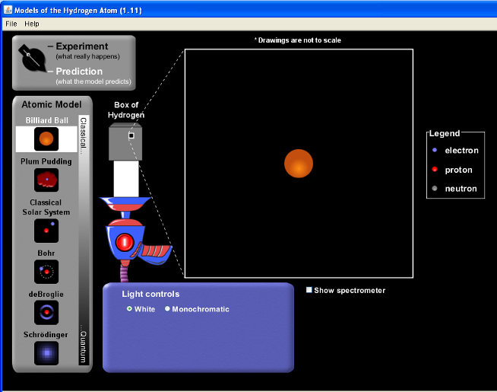
- Does one or more of the above models match the results of the experiment in the first part of this activity? Does one or more of the above models have similar components to your model? Which ones?

- Based on your observations in the first part of the experiment, are any of the above models highly unlikely to match the actual hydrogen atom? Which one(s)? Why?

- What can you definitely conclude about the make-up of the hydrogen atom based on this simulation?

