**Name______________________________________Period_______Date____________**

**Unit 7 Guided Notes: The Atom**

History of Atomic Models

* __________________________(~400 BC)
  + Proposed that _________ was composed of tiny __________________ particles
  + ______________=small, solid, indestructible particles of different shapes and sizes
  + These were just ideas, not truly science
* **_________________**(next 2000 years)
  + Mixture of science and mysticism
  + Lab procedures were developed, but did not perform control experiments like real scientists
* ____________________________
  + __________________________Model
    - Atom is a small __________________________________________
  + Developed notion of conservation of ___________ and that atoms combine in _____________________
* 5 Main Points of Dalton’s Atomic Theory
  1. Elements are made of __________________________________________ ___________________________________________
  2. Al atoms of a given element are ______________________
  3. Atoms of a given element are ___________________ than those of any other ________________
  4. Atoms of one element can ____________ with atoms of other elements to give ____________________
  5. Atoms cannot be ____________________________________________________ ___________________________________________________________________ _________________________________________________
* Problems with Dalton’s atomic theory
  + Problem with #1: Atoms can be ___________________, but only in a _______________ reaction
  + Problem with #2: does not account for _______________ (atoms of the same element but different ________ due to different number of ________________)
  + Problem with #3&4: NONE
  + Problem with #5: NONE, except for nuclear reactions that can change atoms of one element to a ______________________________________
* ______________________________(1896)
  + Discovered ________________________________
    - Spontaneous emission of radiation from the _______________
    - Three types:
      * ______________________
      * ______________________
      * ______________________
* 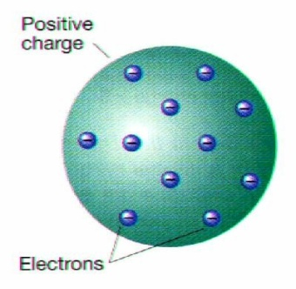_______________________________(1903)
  + ____________________________________Experiments
  + Discovered ____________________________
    - ___________________particles of _____________ the atom
  + ___________________________________Model
    - _________________sphere (Pudding) with ________________ _______________________(plums) dispersed throughout
* Ernest __________________________________(1911)
  + _______________________Experiment
  + Discovered the ____________________________
    - 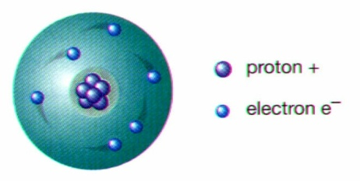___________________________________________________ of the atom
  + _________________Model
    - Dense positive nucleus surrounded by negative electrons
* Niels _______________(1913)
  + Bright Line Spectrum
    - Tried to explain the presence of specific colors in hydrogen’s spectrum
  + 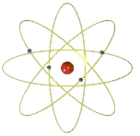________________________
    - _______________ can only exists in _______________________________
  + ________________________Model
    - Electrons move in ___________________________________

__________________________________________________

* Erwin ____________________________(1926)
* Quantum Mechanics: Electrons can only exist in specified energy states
* _____________________________________Model**:** _____________: region around the nucleus where electrons are __________________ to be found
* James _____________________(1932)**:**  discovered ___________________

Atomic Structure

**Chemical Symbols**

* Capitals matter!!!
* Element symbols contain _______ capital letter followed by ______________ letter(s) if necessary.
* Example:

**Atomic Structure Basics**

* Remember, the atom is the ______________________ unit of ___________ and is made up ____________________________________: ___________________________________ _____________________________
* **Subatomic Particles**



* Electrons
  + _________ compared electrons to ______________, saying that electrons ____________ the ________________ in specific and ______________ paths
  + However, an electron’s _____________ location _________________ be determined
  + Electrons exist in energy levels called ________________________
  + The number of ____________ orbitals depends on how many _________________ an atom has
  + Electrons occupy the orbitals that have the _______________________________ __________________________________________
  + Four different kinds of orbitals: ______________________________
  + ______________: region where there is a ___________probability of finding an ___________________
  + Electrons located in the __________________ orbital are called ______________ _______________________
  + These electrons determine the atom’s ______________________ and its abilities to form ______________________________
  + Atoms with the ___________________ of valence electrons have ____________________________________________
* Bohr Model Diagrams

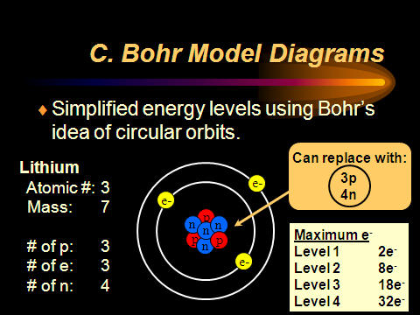

* _________________________
  + Equals the # of _______________________
  + Equals the # of ___________________ in a NEUTRAL atom
  + Always a ______________ number
* _________________________
  + Atomic mass unit: _________
  + 1 proton=_______________
  + 1 neutron=______________
  + 1 electron=______________
  + Lightest subatomic particle is an _______________________
* ___________________________
  + Equals the ____________________________________________
  + Measured in ___________________________________________
  + ______________________: atoms of the __________ element with different ____________________
    - Differ in number of _________________
    - Examples: Carbon-13, Carbon-14, Boron-10, Boron-11

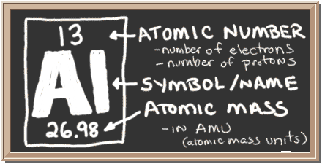

* Calculating # of Neutrons
  + __________________________________
  + Example: Aluminum
    - 13 protons
    - ___________________________=___________ neutrons
* Isotopes
  + Elements of the same element with _____________________________________
  + Hyphen Notation=_________________
* Chlorine-37
  + Atomic #=
  + Mass #=
  + # P=
  + #E=
  + #N=
* Average Atomic Mass
  + Weighted ____________ of all __________________
  + This is the mass on the periodic table
  + Round to ________ decimal places
  + Example: calculate the average atomic mass of oxygen if its abundance in nature is 99.76% O-16, 0.4% O-17, and 0.20% O-18
  + Find the chlorine’s average atomic if approximately 8 of every 10 atoms are chlorine-35 and 2 are chlorine-37
* Average Mass of Compounds
  + Use the periodic table to find the masses of the elements present.
  + Add them up appropriately accounting for the number of each element.
  + Example: Hydrogen gas, H2
  + Example: ammonia, NH3

* + Example: Potassium sulfate, K2SO4