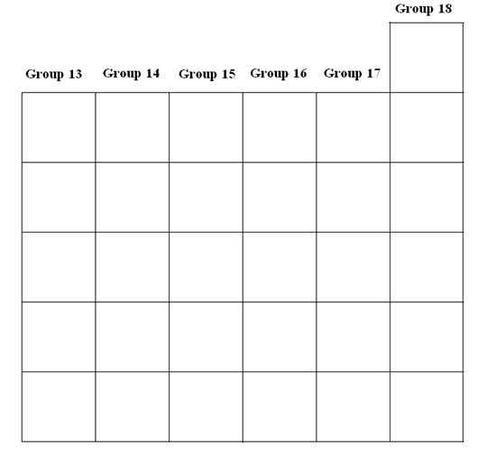
Group Name________________
Valence Electrons__________
Occur as Element or Compound__________
Special Properties?
Group Name________________
Valence Electrons__________
Occur as Element or Compound__________
Special Properties?
Group Name________________
Valence Electrons__________
Occur as Element or Compound__________
Special Properties?
Group Name________________
Valence Electrons__________
Occur as Element or Compound__________
Special Properties?
Group Name________________
Valence Electrons__________
Occur as Element or Compound__________
Special Properties?
DIRECTIONS:
- Fill out the information for each group
- Color the metal section, nonmetal
section, and metalloid section in
different colors
- Write in the metalloid elements on the
chart below

