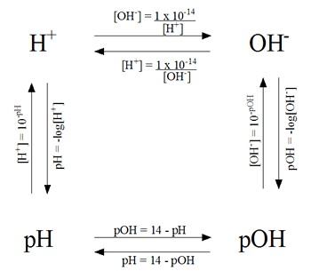
pH Problem Solving Diagram

Name_________________________________Period____Date________

Problems for pH and pOH

1. Calculate the pH of the following solutions:
a) [H⁺] = 3.95 × 10⁵ M
b) [OH ] = 8.74 × 10² M
c) pOH = 3.6
d) [H⁺] = 8.74 ×10¹² M
e) [H⁺] = 1.00 ×10⁷ M
f) [OH⁻]= 1.00 ×10⁷M
g) pOH = 12.5

2. Calculate the pOH of the following solutions:
a) [OH⁻]= 4.7 ×10³ M
b) [H⁺] = 2.79 × 10⁹ M
c) pH = 3.8
d) [OH⁻] = 1.05 × 10⁴M
e) [H⁺] = 9.5 × 10¹¹ M

3. Calculate the [H⁺] for the following solutions:
a) pH = 7.0
b) pOH = 2.59
c) pH = 12.6
d) pOH = 1.46

4. Calculate the [OH⁻]for the following solutions:
a) pH = 3.58
b) pOH= 9.47
c) pH= 11.45
d) pOH = 1.34

