Name____________________________Period____Date________
Phase Change of Water Lab
Physical Science

Purpose: A laboratory activity investigating the phase changes of H₂O and constructing a heating curve of water graph.

Materials:

- 100 mL beaker
- Hot Plate
- Ice
- Water
- Thermometer
- Stop Watch
- Stir Bar

SAFETY NOTES:
- Students should wear goggles and avoid contact with the hot plate and beaker.

Procedure:
- Fill the beaker half full with crushed ice and a little water
- Record the temperature of the ice water in the table below. This is the temperate at 0 seconds. (Your beaker should NOT be on the hot plate yet)
- Place beaker on hot plate, add a stir bar to your beaker (already warm)
- Measure the temperature (in degrees Celsius) every 30 seconds until the water begins to boil. BE SURE to watch carefully and mark on your data table when all the ice has melted and when water begins to boil.
- Continue to take the temperature until most of the water has been boiled off.
- TURN OFF YOUR HOT PLATE & DO NOT TOUCH YOUR BEAKER!!!

Data Table:

Time (sec) | Temperature (ºC)
0
30
60
90
120
150
180
210
240
270
300
330
Time (sec) | Temperature (ºC)
360
390
420
450
480
510
540
570
600
630

Graphing:
- Use your data to make a graph below. You should graph temperature on the y axis, and time (seconds) on the x axis.
- Make a line connecting your points
- DON’T FORGET TO TITLE YOUR GRAPH!!

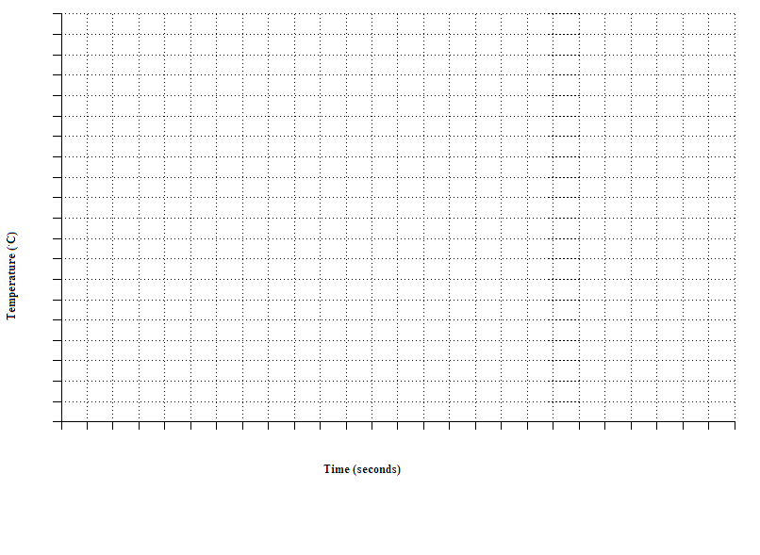

Analyzing:
- Describe the temperature vs time graph. Is the slope the same everywhere or does it change in places?

- Label 5 areas on your graph. Solid (S), liquid (L), gas (G), freezing point/melting point (FP/MP), condensation/boiling point (CP/BP)

- Trace with colored pencils on your graph: slowest molecular motion (in red), fastest motion (in green), medium motion (in blue)

- A chemistry book, writes H₂O(s), H₂O(l), H₂O(g). What do the letters in the parentheses mean?

Conclusions:
- Explain what is happening to the water molecules in the flat areas on your graph during changes from solid to liquid and liquid to gas.

- According the kinetic molecular theory, which state of matter moved the fastest? EXPLAIN

- Which state of matter had the most energy? Solid, liquid or gas? EXPLAIN.

