Name__________________________________________Period________Date___________

Chapter 22-Phases of the Moon Practice

Directions: Fill in the diagram below with the phases of the moon. After filling it in, answer the questions below.

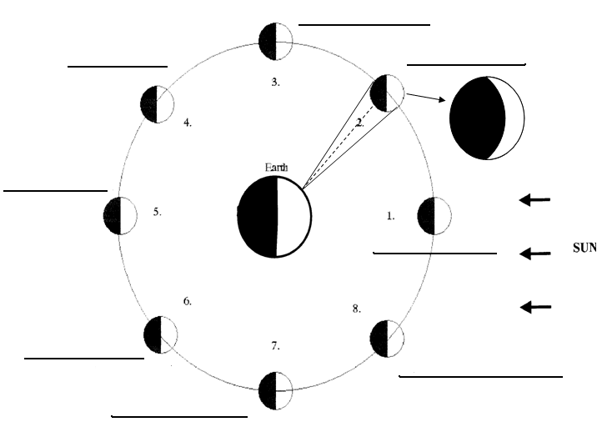

Questions: Predict the next moon phase for the following 4 diagrams:

