Name________________________________Period_____Date_______

Physical Science Semester Review #1
Measurement, Metrics, Graphing

- Experiment: Kevin has a leak in the roof of his house every time it rains. He thinks that it is leaking where his chimney pipe comes up through the roof. On a dry day, he reseals the chimney by using a roofing sealant around the chimney. That night, it rained and Kevin could not find any more leaks in the house.

From this experiment, identify
  - Independent Variable ______________________________________
  - Dependent Variable________________________________________
  - Hypothesis_______________________________________________
  - Conclusion_______________________________________________

- Use the graph to the right to answer the questions below.
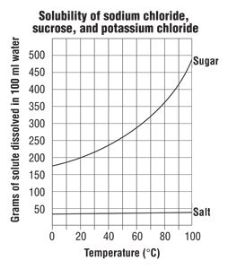
- How many grams of sugar dissolve in water at 80°C? _____________
- At what temperature will 300 g of sugar dissolve? ____________
- How many KILOGRAMS of sugar can be dissolved in water at 100°C? _________
- Name the dependent variable. ______________________________
- Name the independent variable. ______________________________

- Explain the difference between accuracy and precision.

- Explain the difference between a theory and a law.

- Complete the metric chart below

10⁰
Meter
Liter
Gram
Base

- Perform the following conversions

  - 2000 dm=________cm
  - 46 m=___________dm
  - 12 kg=__________dag
  - 102 cm=_________m
  - 100 g=___________hg
  - 0.5 cL=_________mL
  - 864 m=__________mm
  - 200 mg=__________kg

- Write in Scientific Notation:
  - 2500000_____________
  - 32000_______________
  - 0.0000029____________
  - 0.0000034____________

- Write in standard form:
  - 5.61 x 10⁻²____________
  - 2.4 x 10⁵_____________
  - 6.21 x 10⁻³____________
  - 7.14 x 10¹____________

- Perform the following unit conversions using the train track method.
  - 38.7 inches into centimeters (1 in=2.54 cm)

  - 962 minutes into hours (60 minutes=1 hour)

  - 0.25 days into seconds (1 day=24 hours, 1 hour=60 minutes, 1 minute=60 seconds)

  - 24.9 inches into meters (1 in=2.54 cm)

