Name_______________________________Period____Date_________

Physical Science Semester Review #2
Motion & Force

Concept Questions

- What is a force?

- What is the difference between mass and weight?

- Where will you weigh more Jupiter or the moon? Why?

- Give an example of each of the following:

  - Distance unit__________
  - Time unit____________
  - Velocity unit__________
  - Acceleration unit_______
  - Force unit____________
  - Mass Unit____________
  - Momentum Unit________

- What question will be asked in a problem if you are wanting to solve for:
  - Time__________________
  - Distance_________________

- What is the difference between distance and displacement?

- What is the difference between speed and velocity?

- What does it mean if your acceleration is negative?

- True or False: a car sitting still does not have acceleration.

- True or False: a car sitting still does not have inertia.

- Which has more inertia: a big truck or a bicycle? WHY?

- If we had no air resistance, which would hit the ground first: a piece of paper or a hammer?
- State Newton’s Three laws of motion:
  - First Law:

  - Second Law:

  - Third Law:

- If you have 1300 units of momentum before a process, how many will you have to have after the process is complete?

- What is the different between an elastic and inelastic collision?

- What is impulse?

- Graphing Skills. Use each graph’s letter to answer the following:
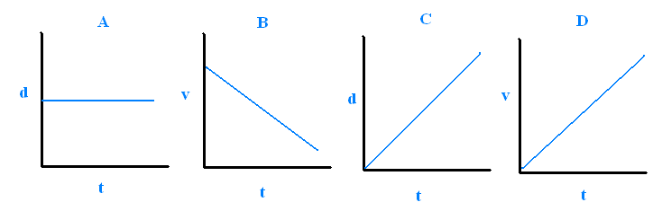
  - Which graph represents a car moving with constant speed? ______
  - Which graph represents a car moving with negative acceleration? ___
  - Which graph represents a car standing still? ______
  - Which graph represents a car with positive acceleration? _______

- Complete the chart below:
Forces Present: | Resulting Amount of Force? | Will there be motion? | If Yes, What direction?
Math Questions

- A horse runs 300 meters in 10 seconds. What is its speed?

- A car travels 340 km at a speed at 20 km/hr. How long does it take the car to arrive?

- A car travels 45 m/s for 5 seconds. How far has it gone?

- Billy travels from 30 m/s to 65 m/s in 7 seconds. What is his acceleration?

- Emily goes from 60 mi/hour to a stop in 6 seconds. What is her acceleration?

- What is the mass of an object if it exerts a force of 300 N and is accelerating at a rate of 3 m/s²?

- What force is exerted if you have an object that has a mass of 25 kg and an acceleration of 5 m/s²?

- A force of 1775 N is exerted on a motorcycle weighing 900 kg and its passenger weighing 95 kg. What is the acceleration?

- What is the momentum of an object if its mass is 40 kg and its velocity is 5 m/s?

- What is the mass of an object that has a momentum of 1275 kg* m/s and a velocity of 3.25 m/s?

- What is the impulse of 40 kg runner that travels from 5 m/s to 11 m/s?

- An object travels from 50 m/s to 75 m/s with an impulse of 500 kg * m/s. What is the mass of this object?

- A baseball pitcher throws a fast ball with 100 kg*m/s impulse. If he applied the force in 0.15 seconds, what force did he apply?

HONORS ONLY:
- A loaded freight train (20,000 kg) rolls at 3 m/s towards a resting car (1000 kg). Upon collision, the two cars lock together. What is the speed of the cars after the collision?

- Two cars collide head on. Car A has a mass of 100 kg; car B has a mass of 2000 kg. If before the collision A was traveling at 8 m/s and B was traveling at 3 m/s, What is the speed of car B after the collision if car A travels at 4 m/s after the collsion?

